Pastoral Staff  Fr. Raymond LaFontaine E.V.  Parochial Administrator  Parish Wardens  Aldo Piccioni  514-769-6369  Divya Siby  514-655-6442 | Holy Cross Parish  1960 Jolicoeur street  Montreal, Quebec H4E 1X5  TEL.: 514-769-2717; FAX: 514-769-8852  Email: holycross.montreal60@gmail.com  Parish Office Hours  Wednesdays |  | Parish Wardens  Genfu Sun  514-568-9866  James Potter  514-733-7016  Norlita Galdones  514-733-7016  Ruby Johnson  514-761-3242
The Saint for Sunday September 3rd, 2023 is Saint Gregory the Great.
September is the month of Our Lady of Sorrows.

THOUGHT OF THE DAY:
“One day, in retrospect, the years of struggle will strike you as the most beautiful.”
Sigmund Freud
The Grapevine is a good informative weekly Newsletter to keep you up to date on what is happening within and around our communities.

thegrapevine@diocesemontreal.org
POPE’S MONTHLY PRAYER INTENTION FOR THE MONTH OF SEPTEMBER 2023:
FOR PEOPLE LIVING ON THE MARGINS
“We pray for those persons living on the margins of society, in inhumane life conditions; may they not be overlooked by institutions and never considered of lesser importance.”
IMPORTANT NOTICE:
Please sit in the pews with blue tape.
Please keep social distance when you are receiving communion.
Please use hand sanitizer on entering and leaving the church. Thank you!
REMINDER:
“CELEBRATE OUR LORD”
Please join us at 8:00PM on Sundays at
ST. WILLIBRORD PARISH
351 WILLIBRORD ST
VERDUN, QC.
VOLUNTEERS NEEDED:
We are searching for someone to takeover the input of our parish bulletin. Please contact the office.

Please note that we are in need of someone to take care of the candles in the church.
(Altar candles and vigil candles)
Contact the office if you are able to help.

Thank you!
IMPORTANT DATES IN SEPTEMBER 2023
Thursday September 7th, 2023 – 40th Anniversary of the Priestly Ordination of Archbishop Christian Lepine.

Thursday September 14th, 2023 – The Exaltation of the Holy Cross.

Monday September 24th, 2023 – 109th World Day of Migrants and Refugees.

Sunday September 26th, 2023 – St John de Brebeuf and St Issac Joques, Priests and Companions martyrs the Feast.

Thank you!
SUNDAY COLLECTION
August 27th, 2023 |  | Amount in CAD
TOTAL |  | $ 442.10
Thank you for your generosity!
Please remember to write your name on your church support envelope.
PLEASE TURN OFF CELL PHONES
THIS CHURCH MAY BE USED AS A RESTING VISITATION LOCALE FOR YOUR DEARLY
DEPARTED.
IF YOU DESIRE THIS SERVICE, PLEASE CALL 514-769-2717

“Prayer makes us understand our vulnerability”, but the Lord “gives us strength and closeness”
MASS INTENTIONS
September 3rd, 2023  RAYMONDE FOURNIER  Req’d by The Fournier Family  GUY CARON  Req’d by Anna and John  KATHLEEN SENCHEY  Req’d by The Senchey Family | September 10th, 2023  SR. IMELDA STRACHAN CN  Req’d by Ada Hainey
Pope Francis

Holy Cross Parish Church
1960 Jolicoeur Street
Montreal, QC H4E 1X5
Tel: 514-769-2717
holycross.montreal60@gmail.com
https://holycrossmontreal.weebly.com/
Facebook: HOLY CROSS PARISH MONTREAL
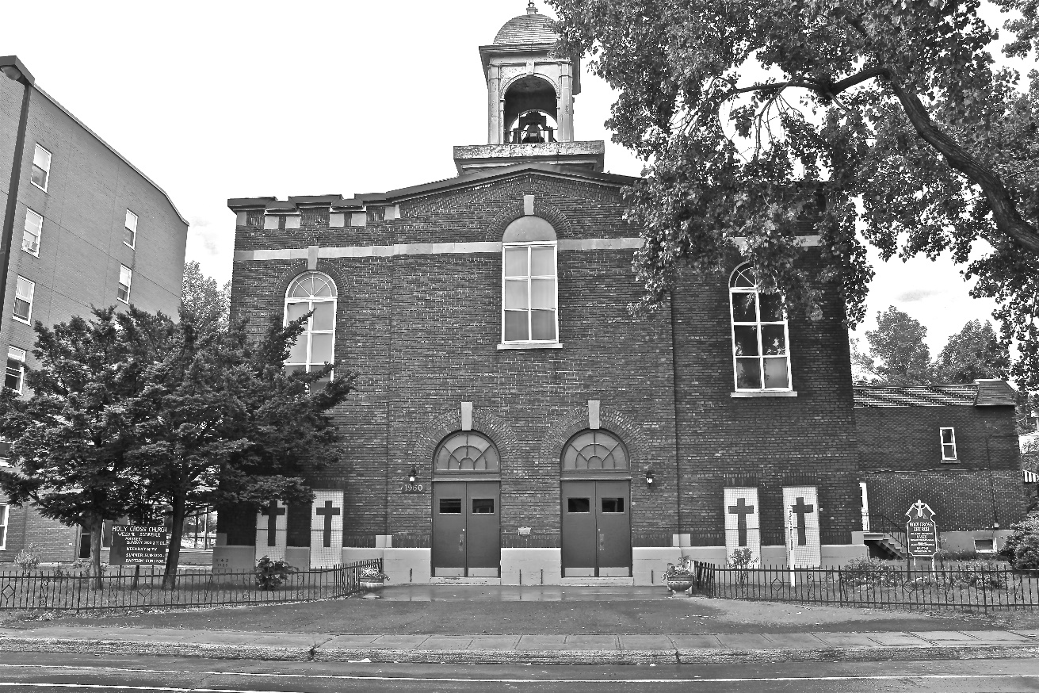
Holy Cross Parish Church
“The cross stands before us in these days as an eloquent symbol of God’s love for humanity.”
John Paul II

*9am mass is cancelled until further notice

