Pastoral Staff  Fr. Raymond LaFontaine E.V.  Parochial Administrator  Parish Wardens  Aldo Piccioni  514-769-6369  Divya Siby  514-655-6442 | Holy Cross Parish  1960 Jolicoeur street  Montreal, Quebec H4E 1X5  TEL.: 514-769-2717; FAX: 514-769-8852  Email: holycross.montreal60@gmail.com  Parish Office Hours  Wednesdays |  | Parish Wardens  Genfu Sun  514-568-9866  James Potter  514-733-7016  Norlita Galdones  514-733-7016  Ruby Johnson  514-761-3242
Saint for October 15th, 2023 is Saint Teresa of Avilia
October is the month of the Most Holy Rosary
October is also Clergy Appreciation Month

THOUGHT OF THE DAY:
“Attitude is the “little” thing that makes a big difference.”
Winston Churchill
The Grapevine is a good informative weekly Newsletter to keep you up to date on what is happening within and around our communities.

thegrapevine@diocesemontreal.org
POPE’S MONTHLY PRAYER INTENTION FOR THE MONTH OF OCTOBER 2023:
FOR THE SYNOD
“We pray for the Church, that she may adopt listening and dialogue as a lifestyle at every level, and allow herself to be guided by the Holy Spirit towards the peripheries of the World.”
IMPORTANT NOTICE:
Please sit in the pews with blue tape.
Please keep social distance when you are receiving communion.
Please use hand sanitizer on entering and leaving the church. Thank you!
REMINDER:  “CELEBRATE OUR LORD”  Please join us at 8:00PM on Sundays at ST. WILLIBRORD PARISH  351 WILLIBRORD ST  VERDUN, QC. |  | Save the Date:  Luncheon on October 29th, 2023 / Tickets $15.00  See notice on Bulletin Board
WHAT’S HAPPENING:
Women’s Retreat Starting October 18th, 2023 (see Grapevine for all details)
Arts and Craft Fair October 21st, and October 22nd, 2023…. St Thomas of Becket Parish
Church Bazaar October 21st, 2023…. St John Fisher Parish
Thank you!
SUNDAY COLLECTION
October 8th, 2023 |  | Amount in CAD
TOTAL |  | $ 375.50
Thank you for your generosity!
Please remember to write your name on your church support envelope.
PLEASE TURN OFF CELL PHONES
THIS CHURCH MAY BE USED AS A RESTING VISITATION LOCALE FOR YOUR DEARLY
DEPARTED.
IF YOU DESIRE THIS SERVICE, PLEASE CALL 514-769-2717

“Prayer makes us understand our vulnerability”, but the Lord “gives us strength and closeness”
MASS INTENTIONS
October 15th, 2023  KATHLEEN SENCHEY  Req’d by Raymond Senchey | October 22nd, 2023  Parishioners of Holy Cross
Pope Francis

Holy Cross Parish Church
1960 Jolicoeur Street
Montreal, QC H4E 1X5
Tel: 514-769-2717
holycross.montreal60@gmail.com
https://holycrossmontreal.weebly.com/
Facebook: HOLY CROSS PARISH MONTREAL
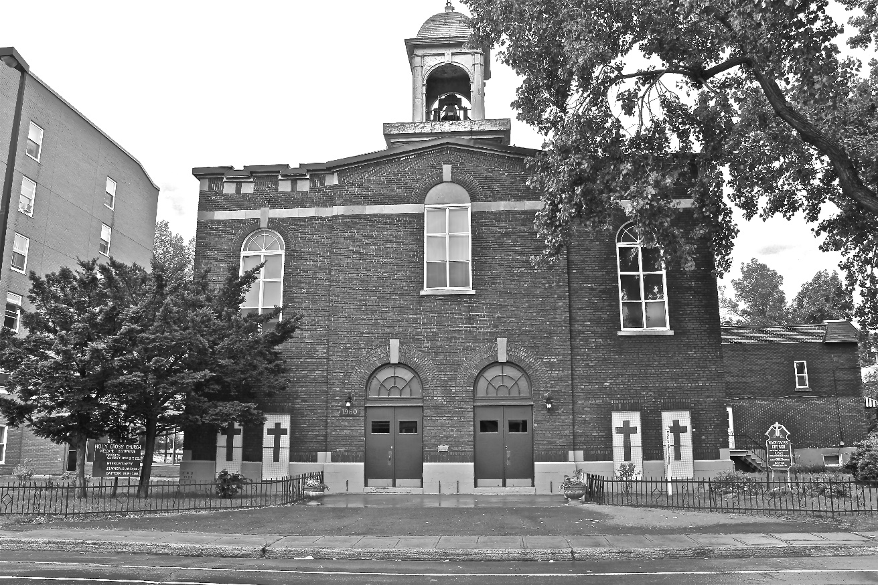
Holy Cross Parish Church
“The cross stands before us in these days as an eloquent symbol of God’s love for humanity.”
John Paul II

*9am mass is cancelled until further notice

