Pastoral Staff  Fr. Raymond LaFontaine E.V.  Parochial Administrator  Parish Wardens  Aldo Piccioni  514-769-6369 | Holy Cross Parish  1960 Jolicoeur street  Montreal, Quebec H4E 1X5  TEL.: 514-769-2717; FAX: 514-769-8852  Email: holycross.montreal60@gmail.com  Parish Office Hours  Wednesdays |  | Parish Wardens  Divya Siby  514-655-6442James Potter  514-733-7016  Norlita Galdones  514-733-7016  Ruby Johnson  514-761-3242
The saint for November 5th, 2023 is Saint Zachary, Father of John the Baptist.
The month of November is dedicated to the souls in purgatory.
November is traditionally a time in which the catholic community remembers those who have died.

THOUGHT OF THE DAY:
“Never give in except to convictions of honor and good sense.”
Winston Churchill
The Grapevine is a good informative weekly Newsletter to keep you up to date on what is happening within and around our communities.

thegrapevine@diocesemontreal.org
POPE’S MONTHLY PRAYER INTENTION FOR THE MONTH OF NOVEMBER 2023:
FOR THE POPE:
“We pray for the Holy Father, as He fulfills his mission, may He continue to accompany the flock entrusted to him, with the help of the Holy Spirit.”
IMPORTANT NOTICE:
Please sit in the pews with blue tape.
Please keep social distance when you are receiving communion.
Please use hand sanitizer on entering and leaving the church. Thank you!
REMINDER:  “CELEBRATE OUR LORD”  Please join us at 8:00PM on Sundays at ST. WILLIBRORD PARISH  351 WILLIBRORD ST  VERDUN, QC. |  | NOTE:  Parish support envelopes for the year 2024-2025 are available at the back of the church.  Thank you!
WHAT’S HAPPENING:
Conference: Come Forth! The Promise of Jesus’ Greatest Miracle

November 11th from 7:00 pm to 8:30 pm (zoom)

https://diocesemontreal.org/en/lets-connect/coming-events/come-forth-promise-jesus-greatest-miracle

Bazaar and Craft Sale at St. John Brebeuf Nov 10th + 11th
Please enter by the Parish Hall at 855 Bishop Power, LaSalle on Friday Nov. 10th from 3:00 pm to 7:00 pm and Saturday Nov. 11th from 9:00 am to 4:00 pm.
Christmas items, handmade crafts, homemade baked goods and preserves, new-to-you table, small appliances, jewellery, books, plants.
There will be raffles with great prizes as well!

Thank you!
SUNDAY COLLECTION
October 29th, 2023 |  | Amount in CAD
TOTAL |  | $ 2 041.75
Thank you for your generosity!
Please remember to write your name on your church support envelope.
PLEASE TURN OFF CELL PHONES
THIS CHURCH MAY BE USED AS A RENTING VISITATION LOCALE FOR YOUR DEARLY
DEPARTED.
IF YOU DESIRE THIS SERVICE, PLEASE CALL 514-769-2717

“Prayer makes us understand our vulnerability”, but the Lord “gives us strength and closeness”
MASS INTENTIONS
November 5th, 2023  RAYMONDE FOURNIER  Req’d by The Fournier Family  KATHLEEN SENCHEY  Req’d by Raymond Senchey  GERALD POTTER  Req’d by James Potter | November 12th, 2023  RAYMONDE FOURNIER  Req’d by The Fournier Family
Pope Francis

Holy Cross Parish Church
1960 Jolicoeur Street
Montreal, QC H4E 1X5
Tel: 514-769-2717
holycross.montreal60@gmail.com
https://holycrossmontreal.weebly.com/
Facebook: HOLY CROSS PARISH MONTREAL

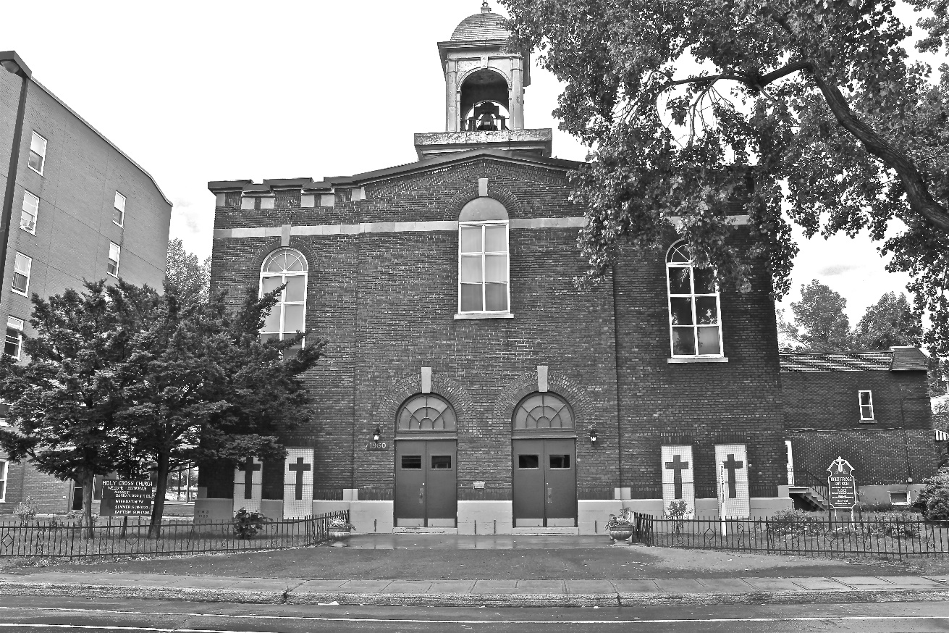
Holy Cross Parish Church
“The cross stands before us in these days as an eloquent symbol of God’s love for humanity.”
John Paul II

*9am mass is cancelled until further notice

