Pastoral Staff  Fr. Raymond LaFontaine E.V.  Parochial Administrator  Parish Wardens  Aldo Piccioni  514-769-6369  Divya Siby  514-655-6442 | Holy Cross Parish  1960 Jolicoeur street  Montreal, Quebec H4E 1X5  TEL.: 514-769-2717; FAX: 514-769-8852  Email: holycross.montreal60@gmail.com  Parish Office Hours  Wednesdays |  |  | Parish Wardens  Genfu Sun  514-568-9866  James Potter  514-733-7016  Norlita Galdones  514-733-7016  Ruby Johnson  514-761-3242
The month of May is dedicated to The Blessed Virgin Mary.
The saint for May 14th, is Saint Matthais.
May 14th, is the sixth Sunday of Easter

THOUGHT OF THE DAY:
“Our greatest glory is not in never falling, but in rising when we fall.”
Confucius

HAPPY MOTHER’S DAY

A POEM FOR ALL TO ENJOY:

Dear Mom

Dear Mom, I said a prayer for you

To thank the Lord above

For blessing me with a lifetime

Of your tenderhearted love.

I thank God for caring

You’ve shown me through the years,

For the closeness we’ve enjoyed

In laughter and of tears.

And so, I thank you from the heart

For all you’ve done for me

And I bless the Lord for giving me

The best Mother there could be.
The Grapevine is a good informative weekly Newsletter to keep you up to date on what is happening within and around our communities.

thegrapevine@diocesemontreal.org
POPE’S MONTHLY PRAYER INTENTION FOR MAY 2023:
FOR THE CHURCH MOVEMENTS AND GROUPS
“We pray that church movements and groups may rediscover their mission of evangelication each day, placing their own charisma at the service of the needs in the world.”
IMPORTANT NOTICE:
Please sit in the pews with blue tape.
Please keep social distance when you are receiving communion.
Please use hand sanitizer on entering and leaving the church. Thank you!
REMINDER:  “CELEBRATE OUR LORD”  Please join us at 8:00PM on Sundays at  ST. WILLIBRORD PARISH  351 WILLIBRORD ST  VERDUN, QC. |  | FAMILY & LIFE WEEK:  May 7th – 14th 2023  MORE INFO: Karolina Bozelko  (514) 925-4300 #206  CentreDMVF@diocesemontreal.org
FAMILY MASS AND PICNIC  On May 27th, 2023  Mary Queen of the World Cathedral  Info: Karolina Bogelka  514 925-4300 #233 |  | VOLUNTEERS NEEDED:  We are searching for someone to takeover the input of our parish bulletin. Please contact the office.  Thank you!
SUNDAY COLLECTION
May 7th, 2023 |  |  | Amount in CAD
TOTAL |  |  | $402.95
Thank you for your generosity!
Please remember to write your name on your church support envelope.
PLEASE TURN OFF CELL PHONES
THIS CHURCH MAY BE USED AS A RESTING VISITATION LOCALE FOR YOUR DEARLY
DEPARTED.
IF YOU DESIRE THIS SERVICE, PLEASE CALL 514-769-2717

“Prayer makes us understand our vulnerability”, but the Lord “gives us strength and closeness”
MASS INTENTIONS
May 14th, 2023  MARY AND EVA HAINEY  Req’d by Ada Hainey  KATHLEEN SENCHEY  Req’d by The Senchey Family | May 21st, 2023  THE PARISHIONERS OF HOLY CROSS PARISH
Pope Francis

Holy Cross Parish Church
1960 Jolicoeur Street
Montreal, QC H4E 1X5
Tel: 514-769-2717
holycross.montreal60@gmail.com
https://holycrossmontreal.weebly.com/
Facebook: HOLY CROSS PARISH MONTREAL
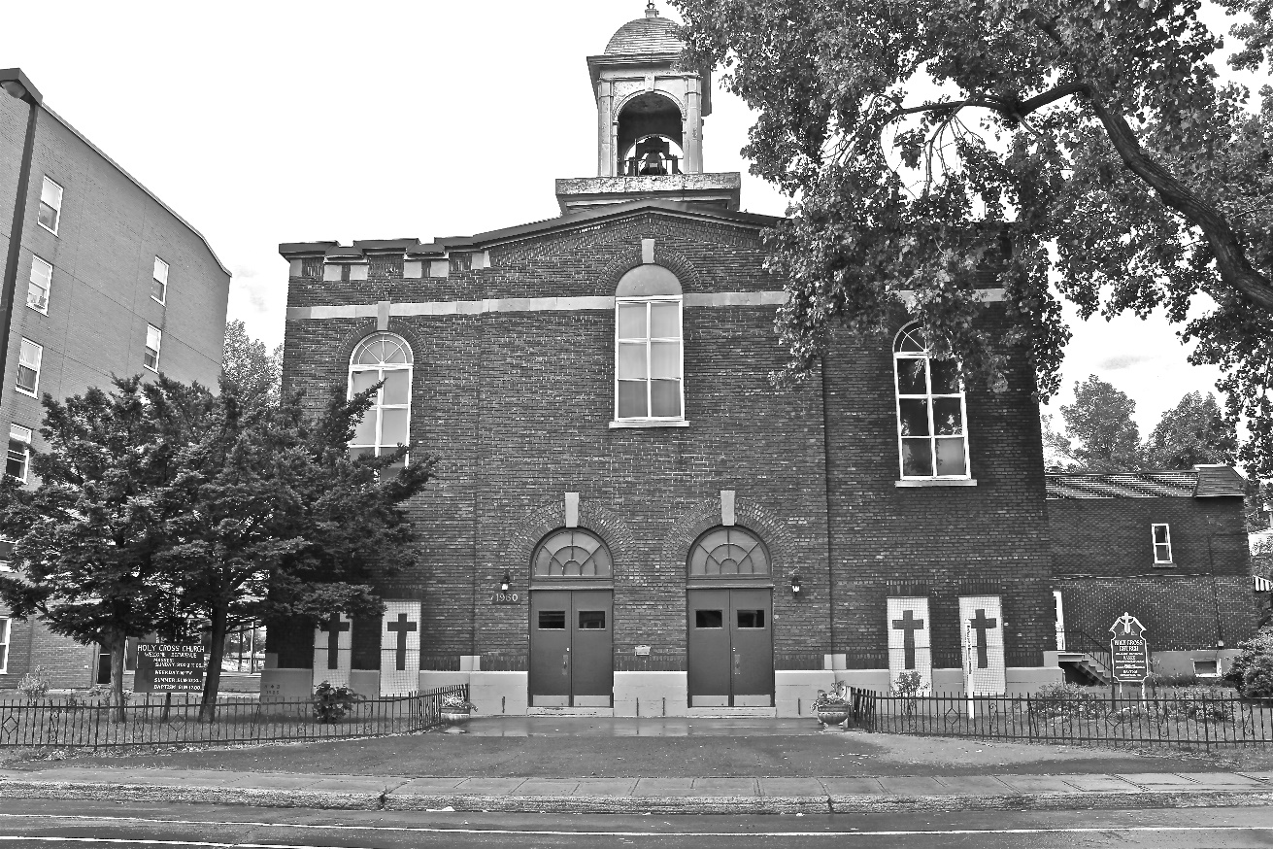
Holy Cross Parish Church
“The cross stands before us in these days as an eloquent symbol of God’s love for humanity.”
John Paul II

*9am mass is cancelled until further notice

