Pastoral Staff  Fr. Raymond LaFontaine E.V.  Parochial Administrator  Parish Office Hours  Wednesdays |  | Holy Cross Parish  1960 Jolicoeur street  Montreal, Quebec H4E 1X5  TEL.: 514-769-2717; FAX: 514-769-8852  Email: holycross.montreal60@gmail.com  https://holycrossmontreal.weebly.com/  Facebook: HOLY CROSS PARISH MONTREAL |  | Parish Wardens  Divya Siby: 514-655-6442  James Potter: 514-733-7016  Norlita Galdones: 514-733-7016  Ruby Johnson: 514-761-3242  Aldo Piccioni: 514-769-6369  Francis Van Oordt: 438-226-2126

MONTH OF MARCH 2024

So they took branches of palm trees and went out to meet him, crying, "Hosanna! Blessed is he who comes in the name of the Lord, even the King of Israel!" And Jesus found a young ass and sat upon it; as it is written, "Fear not, daughter of Zion; behold, your king is coming, sitting on an ass's colt (Jn 12:13-15)!"

EASTER SUNDAY- MARCH 31st,2024

Easter is the Solemnity of Solemnities, the center and climax of the Church year. All the mysteries that we have commemorated from Advent until now have pointed toward Easter; all that we shall yet celebrate in the weeks that follow has its foundation in the mystery of Easter, and receives its meaning and importance from this mystery. Easter means, then, Redemption obtained — sin destroyed, death overcome, divine life brought back to us, the resurrection of our body which is promised immortality. With such a certitude, we should banish all trace of sadness.

Mass Readings for Easter Sunday of the Resurrection of the Lord, Cycle B:

The First Reading is taken from Acts 10:34; 37-43. He message of Peter to Cornelius and his household, in which he proclaims the good news of Jesus Christ, his life, teachings, death, and resurrection. Peter affirms that Jesus is the Lord of all, and that those who believe in Him receive forgiveness of sins and new life.

The Second Reading is letter from the letter of St. Paul to the Colossians 3:1-4. Christians should focus on the things above, where Christ is seated at the right hand of God, and to set their minds on heavenly things rather than earthly things.

The Gospel is from John 20:1-9. Mary Magdalene discovered Jesus' tomb open and empty, leading Peter and the beloved disciple to investigate. They found only linen wrappings and the head cloth folded, sparking belief in Jesus' resurrection despite not fully understanding the prophecy. The accounts of the resurrection of Christ differ in many details in the different writings of the New Testament, but the fact of the resurrection stressed in all of them, was the basis of the new Christian Faith.
Dear Parishioners,
Welcome to this extraordinary Easter season! Our Lent journey began with the story of Jesus' temptations in the desert, reminding us to remain faithful to God's word and grace. As we approach this Easter, we are met with uncertainties and fears amidst the global tragedy we are facing. However, Jesus has continuously urged us to remain in the God of life throughout Lent.
Easter isn't just a one-day celebration; it spans fifty days, symbolizing the triumph of life over death through Jesus' resurrection. It signifies a new dawn, a new creation, and a renewed hope. Just as the disciples emerged from hiding to meet the Risen Lord in Galilee, this Easter calls us to live by His teachings and example, taking courage in His presence. Though we may not physically gather, our spiritual encounter with the Risen Christ during this time of reflection can deeply transform us. Let us embrace this opportunity for personal growth and renewal, becoming the best versions of ourselves as Easter People. I extend my heartfelt gratitude to all who have contributed their time, talent, and resources to make our Holy Week celebrations meaningful, despite the challenges. To our volunteers, staff, choir, and donors—thank you for your dedication and support. Though we couldn't welcome visitors physically, I invite you to join our Parish community in-person when circumstances allow.
Wishing you all a joyous and blessed Easter season.

Warm regards,
Secretary of Holy Cross
Your Voice Matters: Imagining new ways of “being” church starts with your voice.
Pope Francis initiated a worldwide three-year process in 2021 dedicated to listening and dialogue, calling all faithful to take part in discerning the path forward for the Church. In this process, we intend to create space for diverse voices here in Montreal, encouraging teamwork and wider consultation. Your input is vital as we address challenges and spiritual growth in changing times. Join your local network of faith communities and organizations for a Saturday morning dedicated to consultation and shared leadership.
Open to all; admission is free.
When: Saturday, April 6th, 2024, from 9 a.m. to 12 noon
Location: St. Thomas à Becket Parish, Pierrefonds
Please see the secretary for more details or visit https://bit.ly/Your_Voice_Matters_PVC2024
You can also fill up a questionnaire that would be beneficial so that they can have the feedback from all parishes.
 | SUNDAY COLLECTION
 | March 24th, 2024 |  | Amount in CAD
 | TOTAL |  | 8510.95$
 | Thank you for your generosity!
MASS INTENTIONS
March 31st, 2024  THE HAINEY FAMILY  Req’d by Ada Hainey  RAYMONDE FOURNIER  Req’d by the Fournier Family | April 7th, 2024  THE PARISHIONERS OF HOLY CROSS
“Prayer makes us understand our vulnerability”, but the Lord “gives us strength and closeness” Pope Francis
THIS CHURCH MAY BE USED AS A RESTING VISITATION LOCALE FOR YOUR DEARLY
DEPARTED.
IF YOU DESIRE THIS SERVICE, PLEASE CALL 514-769-2717

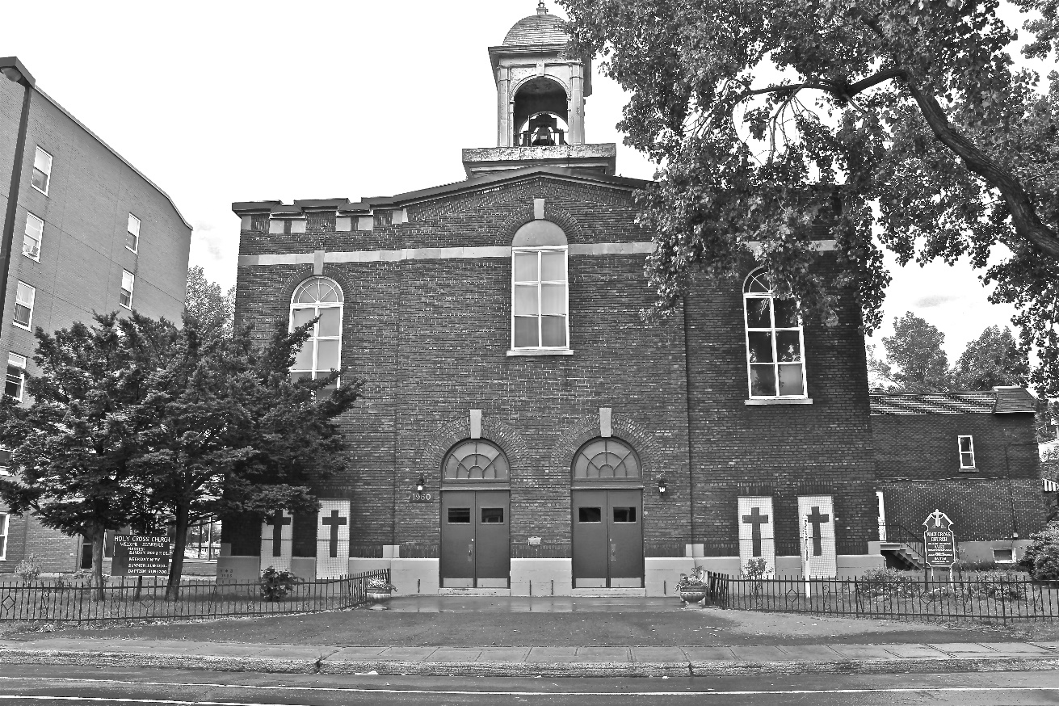
Holy Cross Parish Church
“The cross stands before us in these days as an eloquent symbol of God’s love for humanity.”
John Paul II

*9am mass is cancelled until further notice

