Pastoral Staff  Fr. Raymond LaFontaine E.V.  Parochial Administrator  Parish Office Hours  Wednesdays |  | Holy Cross Parish  1960 Jolicoeur street  Montreal, Quebec H4E 1X5  TEL.: 514-769-2717; FAX: 514-769-8852  Email: holycross.montreal60@gmail.com  https://holycrossmontreal.weebly.com/  Facebook: HOLY CROSS PARISH MONTREAL |  | Parish Wardens  Divya Siby: 514-655-6442  James Potter: 514-733-7016  Norlita Galdones: 514-733-7016  Ruby Johnson: 514-761-3242  Aldo Piccioni: 514-769-6369  Francis Van Oordt: 438-226-2126

MONTH OF MARCH 2024

So they took branches of palm trees and went out to meet him, crying, "Hosanna! Blessed is he who comes in the name of the Lord, even the King of Israel!" And Jesus found a young ass and sat upon it; as it is written, "Fear not, daughter of Zion; behold, your king is coming, sitting on an ass's colt (Jn 12:13-15)!"

PALM SUNDAY OF THE LORD’S PASSION- MARCH 24TH,2024

With Palm Sunday, the Catholic Church begins the celebration of Holy Week, which has its culmination in the Paschal Triduum, This is where we celebrate, the crucifixion, death and resurrection of our Lord Jesus Christ. Holy Week is a time, where we reflect and deepen our faith, about what we believe and especially what we celebrate. We celebrate that we have a God, who is one, and triune, that the second person of the Holy Trinity, became man and gave his life for the salvation of the world. Being God, He got over and humiliated himself.

Mass Readings for Palm Sunday of the Lord's Passion, Cycle B:

The First Reading is taken from the Book Isaiah 50:4-7. Isaiah speaks to the exiles in Babylon. He tells of One Who will suffer for the sake of the people. Scholars are not sure if the “suffering servant” was an individual or the people of Israel as a whole who experience persecution during their time in exile. The Christians have seen the prefigurement of Jesus in these passages from Isaiah.

The Second Reading is letter from St. Paul’s to the Philippians 2:6-11. He uses an early Christian profession of faith in Who Jesus is. He inspires his readers (including us) to put on the mind of Jesus the Christ – the One Who was willing to let go of His equality with GOD, in order to humble Himself to share in our humanity.

The Gospel is from Mark 15:1-39. It records an event included in all four Gospels: that several days before the crucifixion, Jesus enters Jerusalem, welcomed by the people as the Messiah who will free them from Roman rule. Jesus enters on a donkey, fulfilling prophecy and symbolizing the peaceful nature of His first coming.
 | Way of the cross, March 29, 2024: On the occasion of Good Friday, Communion and Liberation (CL Canada) organizes the Way of the Cross procession led by Mgr Christian Lépine, Archbishop of Montreal through the streets of Old Montreal. The procession starts at 9:30 a.m. at Chapel of Notre-Dame-de-Bon-Secours to continue to the Notre-Dame Basilica, followed by Saint Patrick Basilica and Church of the Gesù, then passing through Place Ville Marie to arrive around noon at Mary Queen of the World Cathedral.
 | Good Friday Blood Drive: We invite you to a blood drive which will take place on Friday, March 29th, from 9:30 a.m. to 3:00 p.m. at Mary Queen of the World Cathedral, located at 1110 Mansfield Street, Montreal. We aim to welcome at least 50 donors at this event held under the honorary chairmanship of Mgr Christian Lépine, Archbishop of Montreal.
Holy Week 2024 schedule - Mary Queen of the World Cathedral
Sunday, March 24th: Palm Sunday – Masses 5:00 pm
Wednesday March 27th: 7:30 pm: Chrism Mass, by Mgr Lépine. The Holy Oils used throughout the year will be consecrated during this celebration.
Thursday, March 28th: 8:00 pm: Solemn Mass of the Lord’s Supper. One hour of Adoration will follow before the Repository.
Friday, March 28th: 3:00 pm: Celebration of the Passion of the Lord, 5:00 pm: The Way of the Cross – Communion and Liberation by Mgr Lépine, 7:00 pm: Concert – The Seven Last Words of Christ, Théodore Dubois
Saturday, March 30th: 8:00 pm: Vigil Service by Mgr Lépine
Sunday, March 31st: 9:30 am: in English,
11:00 am (presided over by Mgr Lépine) / 12:10 pm / 5:00 pm: in French
 | GOOD FRIDAY, MARCH 29TH 2024: There will be a Holy Land Collection on Good Friday. The monies collected brings an indispensable support to the Christian minority throughout the Middle East, not only in Israel and Palestine but in Jordan, Lebanon, Syria, Iraq and Iran and other regions. The Franciscan Custody undertakes numerous initiatives for the people and assures the continued possession and care of Christian shrines. Please give generously to support the Church of the Holy Land.
 | LENT SEASON SCHEDULE FOR 2024  GOOD FRIDAY IS ON MARCH 29TH AT 3PM  EASTER SUNDAY IS ON MARCH 31ST AT 11AM  You may attend Holy Thursday and Easter Vigil at St-Willibroard or St-John-Bosco. |  | NOTE:  Please remember to write your name on your church support envelope.  There are only a few Sunday missals left for sale. Hurry up and get yours. The price is $7.00. Exact change is required please!
 | SUNDAY COLLECTION
 | March 17th, 2024 |  | Amount in CAD
 | TOTAL |  | 9223.40$
 | Thank you for your generosity!
MASS INTENTIONS
March 24th, 2024  JOHN CORSTON  Req’d by Lisa Potter | March 31st, 2024  THE HAINEY FAMILY  Req’d by Ada Hainey  RAYMONDE FOURNIER  Req’d by the Fournier Family
“Prayer makes us understand our vulnerability”, but the Lord “gives us strength and closeness” Pope Francis
THIS CHURCH MAY BE USED AS A RESTING VISITATION LOCALE FOR YOUR DEARLY
DEPARTED.
IF YOU DESIRE THIS SERVICE, PLEASE CALL 514-769-2717

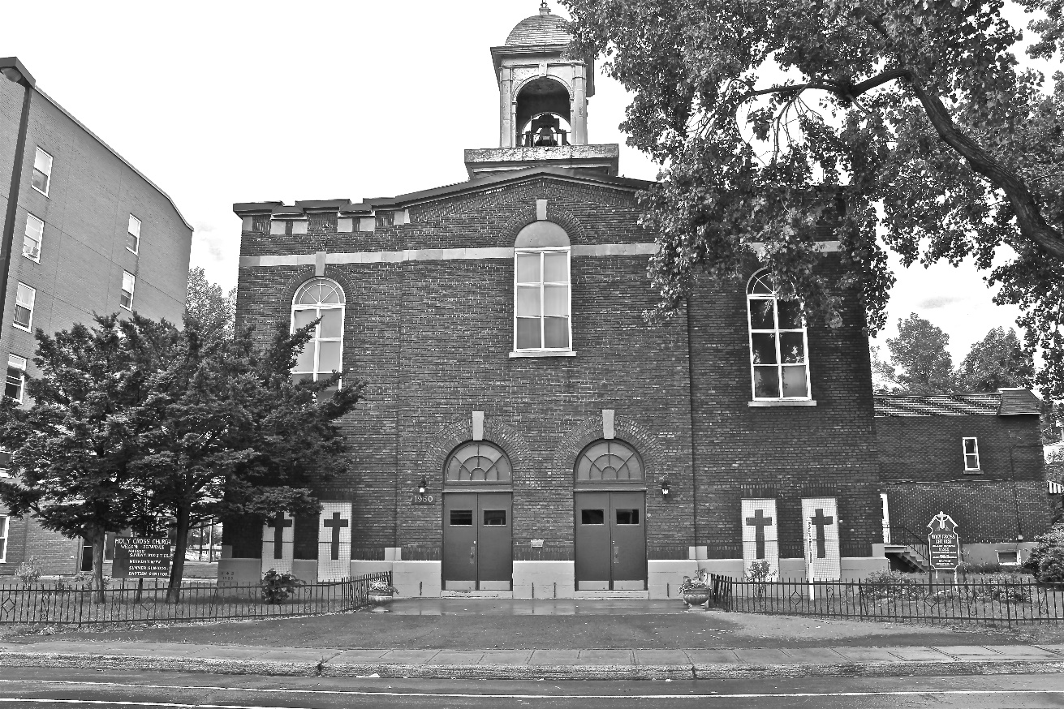
Holy Cross Parish Church
“The cross stands before us in these days as an eloquent symbol of God’s love for humanity.”
John Paul II

*9am mass is cancelled until further notice

