Pastoral Staff  Fr. Raymond LaFontaine E.V.  Parochial Administrator  Parish Office Hours  Wednesdays |  | Holy Cross Parish  1960 Jolicoeur street  Montreal, Quebec H4E 1X5  TEL.: 514-769-2717; FAX: 514-769-8852  Email: holycross.montreal60@gmail.com  https://holycrossmontreal.weebly.com/  Facebook: HOLY CROSS PARISH MONTREAL |  | Parish Wardens  Divya Siby: 514-655-6442  James Potter: 514-733-7016  Norlita Galdones: 514-733-7016  Ruby Johnson: 514-761-3242  Aldo Piccioni: 514-769-6369  Francis Van Oordt: 438-226-2126

MONTH OF MARCH 2024

2024 has been marked as the “Year of Prayer” by Pope Francis.

The month of March is dedicated to St. Joseph. The entire month falls during the liturgical season of Lent which is represented by the liturgical color purple — a symbol of penance, mortification and the sorrow of a contrite heart.

FIFTH SUNDAY OF LENT- MARCH 17TH,2024

March 17th is feast day of St. Patrick, patron saint of Ireland. He established the Catholic Church throughout Ireland on lasting foundations. He traveled all over the country preaching, teaching, building churches, opening schools and monasteries, converting chiefs and bards, and everywhere supporting his preaching with miracles. This weekend will mark the 199th St. Patrick's Day Parade in Montreal. It will take place on de Maisonneuve Blvd. Sunday, March 17th, starting at 12 p.m. at the corner of Fort and will end at Jeanne-Mance. HAPPY ST-PATRICK’S DAY! WEAR GREENS, BE IRISH FOR A DAY AND ENJOY THE BEAUTIFUL WEATHER!

Mass Readings for the fifth Sunday of lent, Cycle B:

The First Reading is taken from the Book of the Prophet Jeremiah 31:31-34. In today's extract, the prophet is foretelling the setting up of a New Covenant, to replace the Old Covenant made between God and his Chosen People on Mt. Sinai, a covenant which the Chosen People had not kept. The New Covenant would not be written on tablets of stone but on each individual's heart. It would be a covenant of love rather than one of obligation.

The Second Reading is from the Letter of St. Paul to the Hebrews 5:7-9. The purpose of this letter is to confirm the converts in the Christian faith which they have accepted.

The Gospel is from St. John 12:20-33. The arrival of some Gentiles revealed to Jesus that His time had come; His purpose for coming to earth had always been to give His life for the "many". And now we must ask if we are willing to follow Him there. But if it dies, it produces much fruit.
 | There will be a SECOND COLLECTION TODAY for Development and Peace Caritas Canada. They help marginalized populations on a daily basis by supporting our partners in developing countries. The funds received during this collection will be donated to fight against hunger and poverty, for access to education and health care. Donate for democracy, the defense of human rights and social justice which aims at both the protection of territories and the environment.
 | Novena and Feast of Saint Joseph from March 10th-19th, 2024 at Saint Joseph’s Oratory of Mont Royal. Saint Joseph, companion across our history: preaching, solemn mass and suggested pilgrimage days are listed in the bulletin board near the right staircase.
 | The Palm Saturday Walk, is making its grand return this year, organized by Mission Jeunesse MTL on March 23rd, 2024, starting at 2:30pm. The blessing of the Palms at the Mount Royal Cross will mark the 100th anniversary of the current cross. Youth, proudly carrying their Palms, will walk through the streets to conclude this memorable event at the Cathedral for the Palm Saturday Mass, animated by the youth and for the youth. This event will mark the beginning of Holy Week, highlighting Jesus’ triumphant entry into Jerusalem and anticipating the crucial moments of the Passion leading up to Good Friday. For more info contact the office.
IRISH JOKES OF THE DAY:
1)How should you greet someone on March 17th? Irish you a happy St. Patrick’s Day.
2) How can you tell if a potato is not from Ireland? When it’s a French fry.
3) What do Irishmen say when you tell them Bono is your favorite musician? “You too?”
 | GOOD FRIDAY, MARCH 29TH 2024: There will be a Holy Land Collection on Good Friday. The monies collected brings an indispensable support to the Christian minority throughout the Middle East, not only in Israel and Palestine but in Jordan, Lebanon, Syria, Iraq and Iran and other regions. The Franciscan Custody undertakes numerous initiatives for the people and assures the continued possession and care of Christian shrines. Please give generously to support the Church of the Holy Land.
 | LENT SEASON SCHEDULE FOR 2024  PALM SUNDAY IS ON MARCH 24TH AT 11AM  GOOD FRIDAY IS ON MARCH 29TH AT 3PM  EASTER SUNDAY IS ON MARCH 31ST AT 11AM  You may attend Holy Thursday and Easter Vigil at St-Willibroard or St-John-Bosco. |  | NOTE:  Please remember to write your name on your church support envelope.  There are only a few Sunday missals left for sale. Hurry up and get yours. The price is $7.00. Exact change is required please!
 | SUNDAY COLLECTION
 | March 10th, 2024 |  | Amount in CAD
 | TOTAL |  | 3970.40$
 | Thank you for your generosity!
MASS INTENTIONS
March 17th, 2024  RAYMONDE FOURNIER  Req’d by The Fournier Family | March 24th, 2024  THE PARISHIONERS OF HOLY CROSS
“Prayer makes us understand our vulnerability”, but the Lord “gives us strength and closeness” Pope Francis
THIS CHURCH MAY BE USED AS A RESTING VISITATION LOCALE FOR YOUR DEARLY
DEPARTED.
IF YOU DESIRE THIS SERVICE, PLEASE CALL 514-769-2717

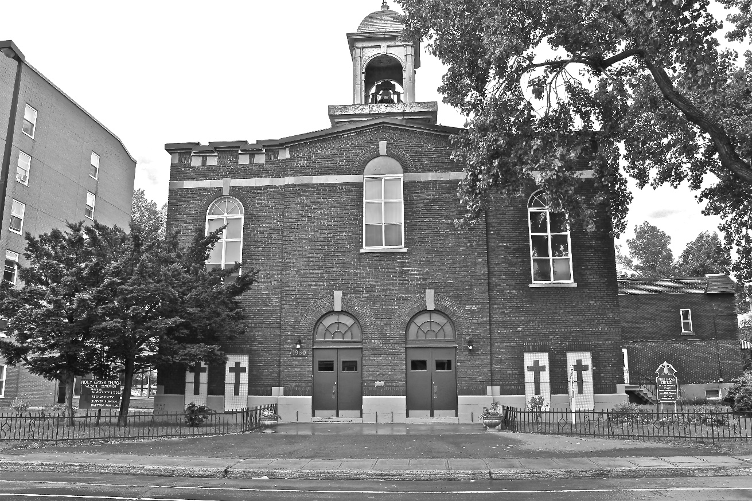
Holy Cross Parish Church
“The cross stands before us in these days as an eloquent symbol of God’s love for humanity.”
John Paul II

*9am mass is cancelled until further notice

