Pastoral Staff  Fr. Raymond LaFontaine E.V.  Parochial Administrator  Parish Office Hours  Thursday |  | Holy Cross Parish  1960 Jolicoeur street  Montreal, Quebec H4E 1X5  TEL.: 514-769-2717; FAX: 514-769-8852  Email: holycross.montreal60@gmail.com  https://holycrossmontreal.weebly.com/  Facebook: HOLY CROSS PARISH MONTREAL |  | Parish Wardens  Divya Siby: 514-655-6442  James Potter: 514-733-7016  Norlita Galdones: 514-733-7016  Ruby Johnson: 514-761-3242  Aldo Piccioni: 514-769-6369  Francis Van Oordt: 438-226-2126

MONTH OF MARCH 2024

2024 has been marked as the “Year of Prayer” by Pope Francis.

The month of March is dedicated to St. Joseph. The entire month falls during the liturgical season of Lent which is represented by the liturgical color purple — a symbol of penance, mortification and the sorrow of a contrite heart.

FOURTH SUNDAY OF LENT- MARCH 10TH,2024

March 10th is the liturgical memorial of Saint John Ogilvie, a 16th- and 17th-century Scotsman who converted from Protestantism to Catholicism, served as a Jesuit priest, and died as a martyr at the hands of state officials. St. John was executed for treason, refusing to accept King James I’s claim of supremacy over the Church. Pope Paul VI canonized him in 1976. A Catholic priest, he is the only post-Reformation Scottish saint.

Mass Readings for the fourth Sunday of lent, Cycle B:

The First Reading is taken from the Second Book of Chronicles 36:14-16, 19-23. It refers to the edict of Cyrus, the king of Persia, permitting the exiles to return to Jerusalem and rebuild the temple, which had been burned by the Chaldeans as a punishment from God for the infidelities of the Chosen People.

The Second Reading is from the Letter of St. Paul to the Ephesians 2:4-10. In today's extract, St. Paul is emphasizing the gratuitousness of the gift of faith which the Ephesian converts have received. This gift which God gave them, even when they were sinners, had united them to Christ, and has given them the right to share in His glorious resurrection and inherit heaven with Him and through Him.

The Gospel is from St. John 3:14-21. Just as Moses lifted up the snake in the wilderness, so the Son of Man must be lifted up, that everyone who believes may have eternal life in him.” For God so loved the world that he gave his one and only Son, that whoever believes in him shall not perish but have eternal life.
 | Consider spending your Lenten season with THE CHOSEN over four Friday evenings Mar. 8th – Mar. 15th, 7 p.m. EST online via Zoom. Register!
Lenten Activities at Mary Queen of the World Cathedral – 2024
1) Way of the Cross: Every Friday during Lent at 5:30 p.m. (after the 5 p.m. mass)

2) Lenten retreat 2024 on the theme "FOLLOWING JESUS": preaching, confessions, solemn vespers, rosary and Sunday mass on March 10th at 3:30 p.m.
 | Novena and Feast of Saint Joseph from March 10th-19th, 2024 at Saint Joseph’s Oratory of Mont Royal. Saint Joseph, companion across our history: preaching, solemn mass and suggested pilgrimage days are listed in the bulletin board near the right staircase.
 | The Palm Saturday Walk, is making its grand return this year, organized by Mission Jeunesse MTL on March 23rd, 2024, starting at 2:30pm. The blessing of the Palms at the Mount Royal Cross will mark the 100th anniversary of the current cross. Youth, proudly carrying their Palms, will walk through the streets to conclude this memorable event at the Cathedral for the Palm Saturday Mass, animated by the youth and for the youth. This event will mark the beginning of Holy Week, highlighting Jesus’ triumphant entry into Jerusalem and anticipating the crucial moments of the Passion leading up to Good Friday. For more info contact the office.
POPE’S MONTHLY PRAYER INTENTION FOR THE MONTH OF MARCH 2024:
FOR THE MARTYRS OF OUR DAY, WITNESSES TO CHIRST:
“Let us pray to those who risk their lives for the Gospel in various parts of the world might imbue the Church with their courage and missionary drive."
 | Mass to Ask for the Grace of a Happy Death: In anticipation of the feast of St. Joseph, patron saint of a happy death, Archbishop Christian Lépine invites the faithful of the Montreal Diocese to a mass where one can entrust the moment of one’s death to God through the intercession of St. Joseph, known as the patron of a happy death.
 | LENT SEASON SCHEDULE FOR 2024  PALM SUNDAY IS ON MARCH 24TH AT 11AM  GOOD FRIDAY IS ON MARCH 29TH AT 3PM  EASTER SUNDAY IS ON MARCH 31ST AT 11AM  HOLY THURSDAY AND EASTER VIGIL WILL BE CELEBRATED AT ST-WILLIBROAD AND AT ST-JOHN BOSCO IF YOU WISH TO ATTEND. |  | NOTE:  Please remember to write your name on your church support envelope.  There are only a few Sunday missals left for sale. Hurry up and get yours. The price is $7.00. Exact change is required please!
 | SUNDAY COLLECTION
 | March 3rd, 2024 |  | Amount in CAD
 | TOTAL |  | 7587.06$
 | Thank you for your generosity!
MASS INTENTIONS
March 10th, 2024  JOSEFA PANES AND HELEN PANERIO  Req’d by the Handinero Family  FILEMON PANERIO AND JOSEFINA PALOMAR PANERIO  Req’d by Yolanda Panerio Jumeras  MARC PANERIO AND HELEN P. PANERIO  Req’d by Felix Panerio | March 17th, 2024  RAYMONDE FOURNIER  Req’d by The Fournier Family
“Prayer makes us understand our vulnerability”, but the Lord “gives us strength and closeness” Pope Francis
THIS CHURCH MAY BE USED AS A RESTING VISITATION LOCALE FOR YOUR DEARLY
DEPARTED.
IF YOU DESIRE THIS SERVICE, PLEASE CALL 514-769-2717

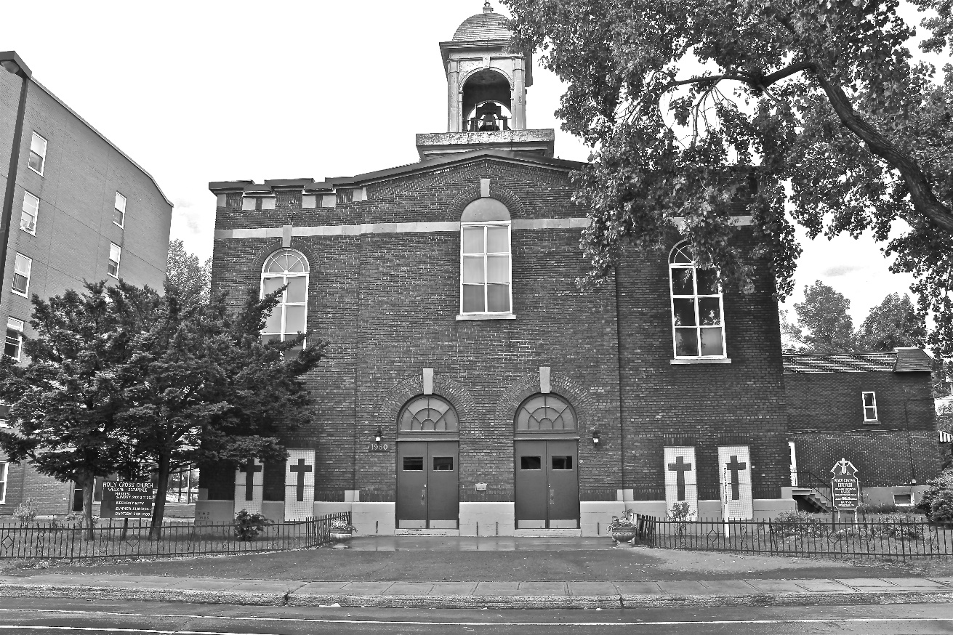
Holy Cross Parish Church
“The cross stands before us in these days as an eloquent symbol of God’s love for humanity.”
John Paul II

*9am mass is cancelled until further notice

