Pastoral Staff  Fr. Raymond LaFontaine E.V.  Parochial Administrator  Parish Wardens  Aldo Piccioni  514-769-6369  Divya Siby  514-655-6442 | Holy Cross Parish  1960 Jolicoeur street  Montreal, Quebec H4E 1X5  TEL.: 514-769-2717; FAX: 514-769-8852  Email: holycross.montreal60@gmail.com  Parish Office Hours  Wednesdays |  | Parish Wardens  Genfu Sun  514-568-9866  James Potter  514-733-7016  Norlita Galdones  514-733-7016  Ruby Johnson  514-761-3242
The Saint for June 11th, 2023 is Saint Barnabas The Apostle
The month of June is dedicated to the Sacred Heart of Jesus
PRAYER TO THE SACRED HEART OF JESUS:
O most holy Heart of Jesus, fountain of every blessing, I adore You, I love You, and with a lively sorrow for my sins, I offer You this poor heart of mine. Make me humble, patient, pure, and wholly obedient to Your will. Grant good Jesus, that I may live in You and for You.
Amen

THOUGHT OF THE DAY:
“It’s not what happens to you. But how you react to it that matters.”
Epictetus

PRAYER FOR THE PENTECOST SUNDAY:

We beseech you, O Lord, let the power of the Holy Spirit be always with us; let it mercifully purify our hearts, and safeguard us from all harm. Grant this through our Lord.

Amen
The Grapevine is a good informative weekly Newsletter to keep you up to date on what is happening within and around our communities.

thegrapevine@diocesemontreal.org
POPE’S MONTHLY PRAYER INTENTION FOR JUNE 2023:
FOR THE ABOLITION OF TORTURE
“We pray that international community may commit in a concrete way to ensure the abolition of torture and guarantee support to victims and their families.”
IMPORTANT NOTICE:
Please sit in the pews with blue tape.
Please keep social distance when you are receiving communion.
Please use hand sanitizer on entering and leaving the church. Thank you!
REMINDER:  “CELEBRATE OUR LORD”  Please join us at 8:00PM on Sundays at  ST. WILLIBRORD PARISH  351 WILLIBRORD ST  VERDUN, QC. |  | MASS TRIBUTE TO JEANNE MANCE  June 18th, 2023 @11AM to 12PM  Notre-Dame Basilica  110 Notre Dame St, MTL  Contact: Dominique Robb  514-849-2919  email/reservations@museedehospitalieres.qc.ca
VOLUNTEERS NEEDED:  We are searching for someone to takeover the input of our parish bulletin. Please contact the office.  Thank you! |  | NATIONAL INDIGENOUS DAY  June 21st, 2023 @0:15AM to 23:45PM  Social Pastoral Care  Contact: Louise Roy, 514-925-4300 ext 312  email/social@diocesemontreal.org
NOTICE:
THERE WILL BE NO BULLETIN FOR JUNE 18TH, 2023.
Bulletins for the summer months of July and August 2023 will be printed twice a month.
Thank you!
SUNDAY COLLECTION
JUNE 4TH, 2023 |  | Amount in CAD
TOTAL |  | $4 187.35
Thank you for your generosity!
Please remember to write your name on your church support envelope.
PLEASE TURN OFF CELL PHONES
THIS CHURCH MAY BE USED AS A RESTING VISITATION LOCALE FOR YOUR DEARLY
DEPARTED.
IF YOU DESIRE THIS SERVICE, PLEASE CALL 514-769-2717

“Prayer makes us understand our vulnerability”, but the Lord “gives us strength and closeness”
MASS INTENTIONS
June 11th, 2023  RAYMONDE FOURNIER  Req’d by The Fournier Family  RAYMONDE FOURNIER  Req’d by Laurette Zollo | June 18th, 2023  ALEX HAINEY SR. ALEX HAINY JR AND GLENN HAINEY  Req’d by Ada Hainey  RAYMONDE FOURNIER  Req’d by The Fournier Family
Pope Francis

Holy Cross Parish Church
1960 Jolicoeur Street
Montreal, QC H4E 1X5
Tel: 514-769-2717
holycross.montreal60@gmail.com
https://holycrossmontreal.weebly.com/
Facebook: HOLY CROSS PARISH MONTREAL
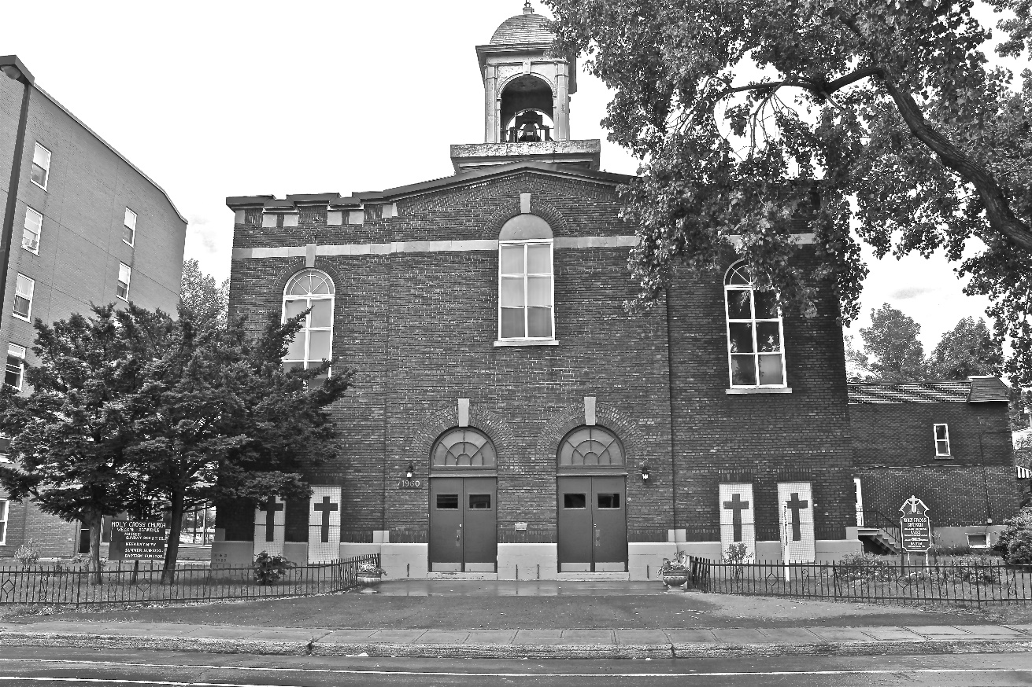
Holy Cross Parish Church
“The cross stands before us in these days as an eloquent symbol of God’s love for humanity.”
John Paul II

*9am mass is cancelled until further notice

