Pastoral Staff  Fr. Raymond LaFontaine E.V.  Parochial Administrator  Parish Wardens  Aldo Piccioni  514-769-6369  Divya Siby  514-655-6442 | Holy Cross Parish  1960 Jolicoeur street  Montreal, Quebec H4E 1X5  TEL.: 514-769-2717; FAX: 514-769-8852  Email: holycross.montreal60@gmail.com  Parish Office Hours  Wednesdays |  | Parish Wardens  Genfu Sun  514-568-9866  James Potter  514-733-7016  Norlita Galdones  514-733-7016  Ruby Johnson  514-761-3242
The Saint for July 30th, 2023 is Saint Peter Chrysologus.
The month of July is dedicated to The Most Precious Blood.
DEVOTION PRAYER TO THE PRECIOUS BLOOD:
Eternal father, I offer You the Most precious Blood of Your Divine Son, Jesus in the union with the Masses said throughout the world today, for all the Holy Souls in Purgatory, for all sinners everywhere, for sinners in the universal Church, those in my home, and within my family.
Amen

THOUGHT OF THE DAY:
“Principles are the silent architects of a meaningful life, shaping our decisions and defining our characters.”
Unknown Author
The Grapevine is a good informative weekly Newsletter to keep you up to date on what is happening within and around our communities.

thegrapevine@diocesemontreal.org
POPE’S MONTHLY PRAYER INTENTION FOR JULY 2023:
FOR EUCHARISTIC LIFE
“We pray that Catholics may place the celebrating Eucharistic at the heart of their lives, transforming human relationships in a very deep way, and opening to the encounter with God and all their brothers and sisters.”
IMPORTANT NOTICE:
Please sit in the pews with blue tape.
Please keep social distance when you are receiving communion.
Please use hand sanitizer on entering and leaving the church. Thank you!
REMINDER:  “CELEBRATE OUR LORD”  Please join us at 8:00PM on Sundays at  ST. WILLIBRORD PARISH  351 WILLIBRORD ST  VERDUN, QC. |  | VOLUNTEERS NEEDED:  We are searching for someone to takeover the input of our parish bulletin. Please contact the office.  Thank you!
NOTICE:
Please note that there is an insert with today’s bulletin.

There is also more info on the bulletin board.

Thank you!
SUNDAY COLLECTION
July 23rd, 2023 |  | Amount in CAD
TOTAL |  | $ 837.45
Thank you for your generosity!
Please remember to write your name on your church support envelope.
PLEASE TURN OFF CELL PHONES
THIS CHURCH MAY BE USED AS A RESTING VISITATION LOCALE FOR YOUR DEARLY
DEPARTED.
IF YOU DESIRE THIS SERVICE, PLEASE CALL 514-769-2717

“Prayer makes us understand our vulnerability”, but the Lord “gives us strength and closeness”
MASS INTENTIONS
July 30th, 2023  KATHLEEN SENCHEY  Req’d by Ray Senchey  DIEGO HANDINERO  Req’d by The Handinero Family | August 6th, 2023  THE PARISHIONERS OF HOLY CROSS PARISH
Pope Francis

Holy Cross Parish Church
1960 Jolicoeur Street
Montreal, QC H4E 1X5
Tel: 514-769-2717
holycross.montreal60@gmail.com
https://holycrossmontreal.weebly.com/
Facebook: HOLY CROSS PARISH MONTREAL
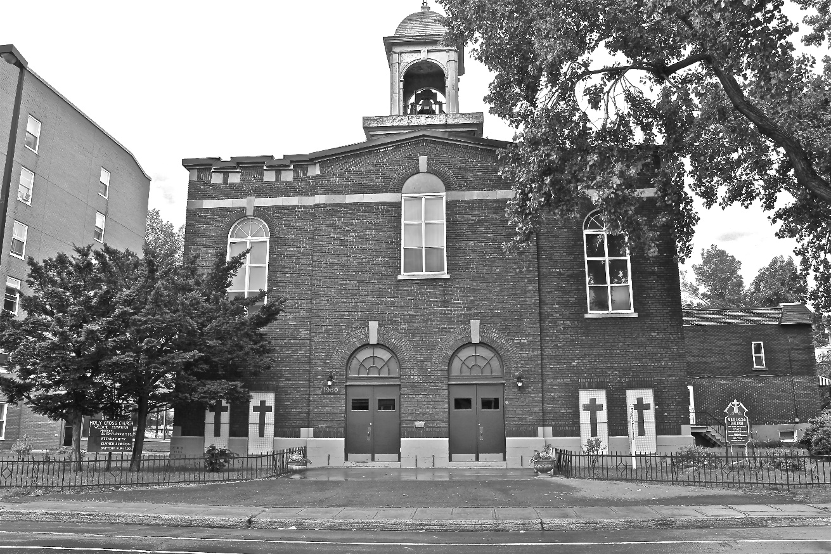
Holy Cross Parish Church
“The cross stands before us in these days as an eloquent symbol of God’s love for humanity.”
John Paul II

*9am mass is cancelled until further notice

