Pastoral Staff  Fr. Raymond LaFontaine E.V.  Parochial Administrator  Parish Office Hours  Wednesdays | Holy Cross Parish  1960 Jolicoeur street  Montreal, Quebec H4E 1X5  TEL.: 514-769-2717; FAX: 514-769-8852  Email: holycross.montreal60@gmail.com  https://holycrossmontreal.weebly.com/  Facebook: HOLY CROSS PARISH MONTREAL |  | Parish Wardens  Divya Siby  514-655-6442  James Potter  514-733-7016  Norlita Galdones  514-733-7016  Ruby Johnson  514-761-3242  Aldo Piccioni  514-769-6369

MONTH OF JANUARY 2024

2024 has been marked as the “Year of Prayer” by Pope Francis.
The month of January is dedicated to Holy Name of Jesus which was celebrated on January 3rd. In the name of Jesus, every knee should bow of those that are in heaven, on earth and under the earth”. (Phil 2:10)
FOURTH SUNDAY IN ORDINARY TIMES - JANUARY 28th, 2024
On January 28th, the Roman Catholic Church celebrates Saint Thomas Aquinas, the 13th century theologian who showed that the Catholic faith is in harmony with philosophy and all other branches of knowledge. His works have been seminal to the thinking of the Church ever since. They systematized her great thoughts and teaching and combined Greek wisdom and scholarship methods with the truth of Christianity. Pope Leo VIII commanded that his teachings be studied by all theology students. He was proclaimed a Doctor of the Church in 1567.

Mass Readings for the fourth Sunday in Ordinary Time, Cycle B:

The First Reading is taken from the Book of Deuteronomy 18:15-20. This central section of this book describes the various offices and officers of the theocratic society which Yahweh, through his servant Moses, is setting up for the Chosen People.

The Second Reading is from the First Letter of St. Paul to the Corinthians 7:32-35. He devotes chapter 7 to answering questions concerning marriage and virginity. In today's extract he emphasizes freedom to serve God fully, freedom from earthly cares which those who choose a life of celibacy have.

The Gospel is from St. Mark 1:21-28. it depicts to us that Jesus, the son of God has the authority to teach for he possesses truth, and he carries the words from God, there’d be no lie, deception or error in his words. Jesus’ words will always make sense because Jesus’ words can make a difference in people’s lives.

THOUGHT OF THE DAY:
“To convert somebody, go and take them by the hand and guide them.”
- St-Thomas Aquinas
The Grapevine is a good informative weekly Newsletter to keep you up to date on what is happening within and around our communities.

thegrapevine@diocesemontreal.org
POPE’S MONTHLY PRAYER INTENTION FOR THE MONTH OF JANUARY 2024:
FOR THE GIFT OF DIVERSITY IN THE CHURCH:
“Let us pray that the Spirit helps us recognize the gift of different cultures within the Christian community, and to discover the richness of different ritual traditions in the heart of the Catholic Church.”
IMPORTANT NOTICE:
Please sit in the pews with blue tape.
Please keep social distance when you are receiving communion.
Please use hand sanitizer on entering and leaving the church. Thank you!
REMINDER:  “CELEBRATE OUR LORD”  Please join us at 8:00PM on Sundays at ST. WILLIBRORD PARISH  351 WILLIBRORD ST, VERDUN, QC. |  | NOTE:  Last week to pick up Church support envelopes at the back of the church.  Please remember to write your name on your church support envelope.
There are only a few Sunday missals left for sale. Hurry up and get yours.
The price is $7.00. Exact change is required please!
Please join us after mass for jumbo hot dogs at 2$. Proceeds will be used for supplies for Sunday’ snacks (coffee, cups, etc.)
We are looking for individuals who can give their time for Sunday mass readings. You can serve the lord proclaiming the Word of God from the pulpit at Mass. If you are interested, please call the office or leave your name on the volunteer sheet by indicating “mass readings” next to your name.
SUNDAY COLLECTION
January 21st, 2024 |  | Amount in CAD
TOTAL |  | 355.50$
Thank you for your generosity!
“Prayer makes us understand our vulnerability”, but the Lord “gives us strength and closeness”
MASS INTENTIONS
January 28th, 2024  RAYMONDE FOURNIER  Req’d by The Fournier Family | February 4th, 2024  RAYMONDE FOURNIER  Req’d by The Fournier Family
Pope Francis
THIS CHURCH MAY BE USED AS A RESTING VISITATION LOCALE FOR YOUR DEARLY
DEPARTED.
IF YOU DESIRE THIS SERVICE, PLEASE CALL 514-769-2717

Holy Cross Parish Church
1960 Jolicoeur Street
Montreal, QC H4E 1X5
Tel: 514-769-2717
holycross.montreal60@gmail.com
https://holycrossmontreal.weebly.com/
Facebook: HOLY CROSS PARISH MONTREAL

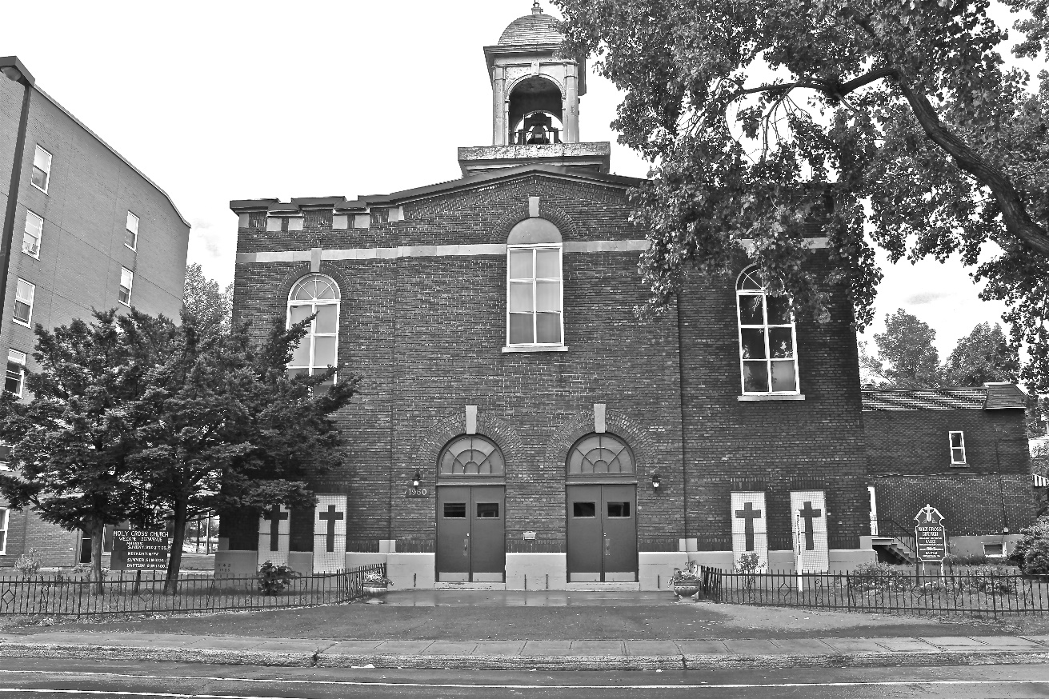
Holy Cross Parish Church
“The cross stands before us in these days as an eloquent symbol of God’s love for humanity.”
John Paul II

*9am mass is cancelled until further notice

