Pastoral Staff  Fr. Raymond LaFontaine E.V.  Parochial Administrator  Parish Office Hours  Wednesdays | Holy Cross Parish  1960 Jolicoeur street  Montreal, Quebec H4E 1X5  TEL.: 514-769-2717; FAX: 514-769-8852  Email: holycross.montreal60@gmail.com  https://holycrossmontreal.weebly.com/  Facebook: HOLY CROSS PARISH MONTREAL |  | Parish Wardens  Divya Siby  514-655-6442  James Potter  514-733-7016  Norlita Galdones  514-733-7016  Ruby Johnson  514-761-3242  Aldo Piccioni  514-769-6369

MONTH OF JANUARY 2024

2024 has been marked as the “Year of Prayer” by Pope Francis.
The month of January is dedicated to Holy Name of Jesus which was celebrated on January 3rd. In the name of Jesus, every knee should bow of those that are in heaven, on earth and under the earth”. (Phil 2:10)
THIRD SUNDAY IN ORDINARY TIMES- JANUARY 21st,2024
On this day, 21 January, the feast day of St. Agnes is commemorated, marking the anniversary of her martyrdom in 304. Similar to numerous early martyrs, Agnes hailed from a noble Roman family and embraced Christianity despite its illegality at the time. Opting for a life of chastity, her name, derived from the Greek word for chaste, symbolized her commitment. This choice irked many Roman suitors who were drawn to her, leading to their reported displeasure and her subsequent identification as a Christian to the authorities. Depicted with a lamb, a play on her name (agnus in Latin), the symbol reflects her virginal innocence and possibly alludes to Jesus as the sacrificial lamb of God

Mass Readings for the Third Sunday in Ordinary Time, Cycle B:

The First Reading is taken from the Book of the Prophet Jonah 3:1-5, 10 and tells the story of Jonah's call from God to go to a pagan city and preach repentance to the sinful people there.

The Second Reading is from the First Letter of St. Paul to the Corinthians. St. Paul admonishes his converts to do what our Lord himself advised his follower—always to be ready for the judgment.
The Gospel is from the Gospel of Mark 1:14-20. describes Jesus' call of the first disciples. First, Jesus approaches Simon—later named Peter—and Andrew, and then speaks to James and John. Both pairs of men choose to leave their fishing businesses behind, in order to follow Jesus.

THOUGHT OF THE DAY:
“We belong to Christ, we are joined to him in baptism; His presence is in us, His light is in us, His life is in us. Let us therefore walk joyfully in hope sustained by his word: it is the Word of life” -Pope Francis
The Grapevine is a good informative weekly Newsletter to keep you up to date on what is happening within and around our communities.

thegrapevine@diocesemontreal.org
POPE’S MONTHLY PRAYER INTENTION FOR THE MONTH OF JANUARY 2024:
FOR THE GIFT OF DIVERSITY IN THE CHURCH:
“Let us pray that the Spirit helps us recognize the gift of different cultures within the Christian community, and to discover the richness of different ritual traditions in the heart of the Catholic Church.”
IMPORTANT NOTICE:
Please sit in the pews with blue tape.
Please keep social distance when you are receiving communion.
Please use hand sanitizer on entering and leaving the church. Thank you!
REMINDER:  “CELEBRATE OUR LORD”  Please join us at 8:00PM on Sundays at ST. WILLIBRORD PARISH  351 WILLIBRORD ST, VERDUN, QC. |  | NOTE:  Last week to pick up Church support envelopes at the back of the church.  Please remember to write your name on your church support envelope.
There are only a few Sunday missals left for sale. Hurry up and get yours.
The price is $7.00. Exact change is required please!
Marriages: Contact the Parish Office 6 months in advance
Baptisms and funerals: You may call or email the office.
Hall rental: NEED excellent acoustics for a CONCERT, a warm and inviting venue for a RECITAL, or a gathering for a MEETING or RECEPTION? Our basement is available to rent. Please contact or email the office for more information.
SUNDAY COLLECTION
January 14th, 2024 |  | Amount in CAD
TOTAL |  | $ 407.25
Thank you for your generosity!
“Prayer makes us understand our vulnerability”, but the Lord “gives us strength and closeness”
MASS INTENTIONS
January 21st, 2024  MORGAN MACGILLIVRAY BRAY  Req’d by Laurell MacGillivray | January 28th, 2024  THE PARISHIONERS OF HOLY CROSS
Pope Francis
THIS CHURCH MAY BE USED AS A RESTING VISITATION LOCALE FOR YOUR DEARLY
DEPARTED.
IF YOU DESIRE THIS SERVICE, PLEASE CALL 514-769-2717

Holy Cross Parish Church
1960 Jolicoeur Street
Montreal, QC H4E 1X5
Tel: 514-769-2717
holycross.montreal60@gmail.com
https://holycrossmontreal.weebly.com/
Facebook: HOLY CROSS PARISH MONTREAL

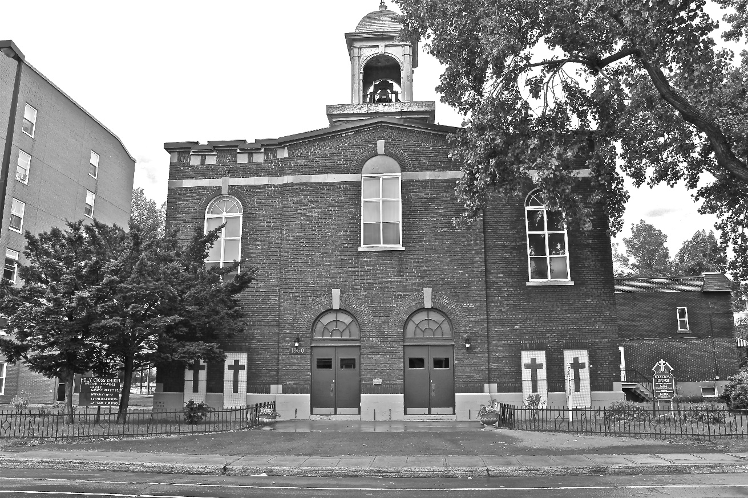
Holy Cross Parish Church
“The cross stands before us in these days as an eloquent symbol of God’s love for humanity.”
John Paul II

*9am mass is cancelled until further notice

