Pastoral Staff  Fr. Raymond LaFontaine E.V.  Parochial Administrator  Parish Wardens  Aldo Piccioni  514-769-6369  Divya Siby  514-655-6442 | Holy Cross Parish  1960 Jolicoeur street  Montreal, Quebec H4E 1X5  TEL.: 514-769-2717; FAX: 514-769-8852  Email: holycross.montreal60@gmail.com  Parish Office Hours  Wednesdays |  | Parish Wardens  Genfu Sun  514-568-9866  James Potter  514-733-7016  Norlita Galdones  514-733-7016  Ruby Johnson  514-761-3242
Sunday January 29th, 2023 is the fourth Sunday of Ordinary Time.
The month of January is dedicated to “The Holy Name Of Jesus”.
The Saint for January 29th, 2023 is ST. Sulpitius Severus

THOUGHT OF THE DAY:

“You are never too old to set another goal or dream a new dream.”

C.J.Lewis
POPE’S MONTHLY PRAYER INTENTION FOR JANUARY 2023:
FOR EDUCATORS
“We pray that educators may be credible witnesses, teaching fraternity rather than competition and helping the youngest and most vulnerable above all.”
REMINDER:
Income tax receipts are available on the table at the back of the church. If you do not find yours, please come to the office.
Thank you!
The Grapevine is a good informative weekly Newsletter to keep you up to date on what is happening within and around our communities.
thegrapevine@diocesemontreal.org
IMPORTANT NOTICE:
Please sit in the pews with blue tape.
Please keep social distance when you are receiving communion.
Please use hand sanitizer on entering and leaving the church.
Thank you!
SAVE THE DATE:
World Marriage Day Mass
Saturday February 22nd, 2023
Mary Queen of The World Cathedral @5pm
WELCOME NEW WARDENS:
Genfu Sun, Divya Siby and Aldo Piccioni
We thank them for their willingness to serve our Holy Cross community.
Ruby Johnson, James Potter and Norlita Galdones will continue their terms.
We thank them for their service.
SUNDAY COLLECTION
January 22nd, 2023 |  | Amount in CAD
Church Support Envelopes |  | $305.00
Basket |  | $47.00
Masses |  | $15.00
Donations |  | $5.00
Envelopes |  | $5.00
Vigil Lights |  | $11.00
Honorarium |  | (minus) $5.00
TOTAL |  | $383.00
Thank you for your generosity!
Please remember to write your name on your church support envelope.
Please turn off cell phones.
PLEASE REMEMBER THE CHURCH IN YOUR WILL
THIS CHURCH MAY BE USED AS A RESTING VISITATION LOCALE FOR YOUR DEARLY
DEPARTED.
IF YOU DESIRE THIS SERVICE, PLEASE CALL 514-769-2717

“Prayer makes us understand our vulnerability”, but the Lord “gives us strength and closeness”
MASS INTENTIONS
January 29th, 2023  JOSEFINA PANEIRO AND FILEMON PANEIRO  Req’d by Their Children | February 5th, 2023  MARY NOLAN  Req’d by Anna Mancini
Pope Francis

Holy Cross Parish Church
1960 Jolicoeur Street
Montreal, QC H4E 1X5
Tel: 514-769-2717
holycross.montreal60@gmail.com
https://holycrossmontreal.weebly.com/
Facebook: HOLY CROSS PARISH MONTREAL
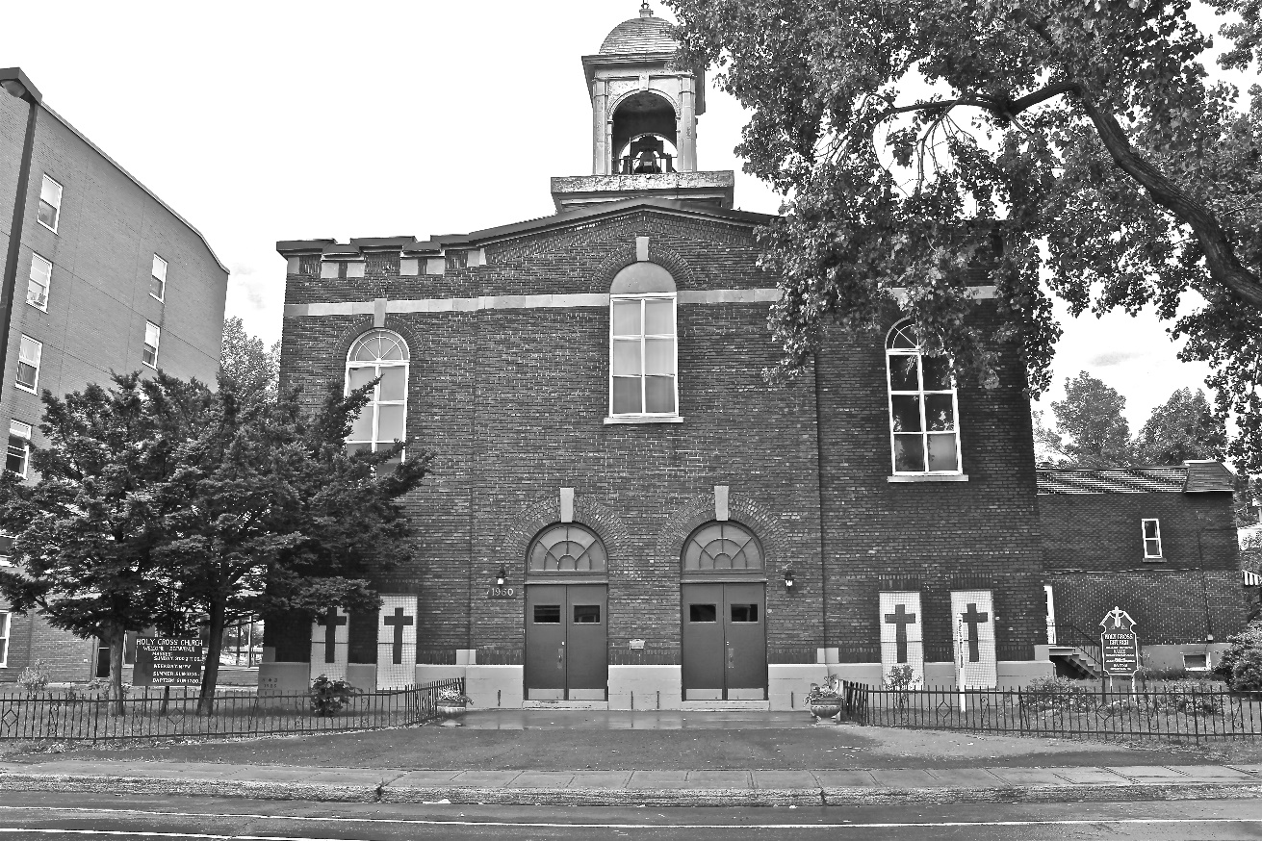
Holy Cross Parish Church
“The cross stands before us in these days as an eloquent symbol of God’s love for humanity.”
John Paul II

*9am mass is cancelled until further notice

