Pastoral Staff  Fr. Raymond LaFontaine E.V.  Parochial Administrator  Parish Wardens  James Potter  514-733-7016 | Holy Cross Parish  1960 Jolicoeur street  Montreal, Quebec H4E 1X5  TEL.: 514-769-2717; FAX: 514-769-8852  Email: holycross.montreal60@gmail.com  Parish Office Hours  Wednesdays |  | Parish Wardens  Norlita Galdones  514-733-7016  Ruby Johnson  514-761-3242  Aldo Piccioni  Divya Siby  Genfu Sun
Sunday January 22nd, 2023 is the third Sunday of Ordinary Time.
The month of January is dedicated to “The Holy Name Of Jesus”.
The Saint for January 22nd, 2023 is Saint Vincent of Saragossa.

THOUGHT OF THE DAY:

“A calm and modest life brings more Happiness than the pursuit of success combined with constant restlessness.”

Unknown
POPE’S MONTHLY PRAYER INTENTION FOR JANUARY 2023:
FOR EDUCATORS
“We pray that educators may be credible witnesses, teaching fraternity rather than competition and helping the youngest and most vulnerable above all.”
REMINDER: Please note if you have a church support envelope and have not completed a Parish Register Form, an income Tax receipt for 2022 can not be issued. We require your address. Thank you!
The Grapevine is a good informative weekly Newsletter to keep you up to date on what is happening within and around our communities.
thegrapevine@diocesemontreal.org
IMPORTANT NOTICE:
Please sit in the pews with blue tape.
Please keep social distance when you are receiving communion.
Please use hand sanitizer on entering and leaving the church.
Thank you!
WEEK OF PRAYER FOR CHRISTIAN UNITY
January 22nd, 2023 @3pm Saint-Gregoire Illuminateur Church
615 Stuart Ave, Mtl, Qc H2V 3H2
WHAT’S HAPPENING:
Book sale: THE FRANCISCANS OF MONTREAL
Contact: PIERRE BRUNET
(514)259-2542
January 14th, 2023 and January 15th, 2023
From 9:00AM – 5:00PM
5780 Boul. Rosemont (corner Lacordaire)
Montreal, QC. H1T 2H2
WELCOME NEW WARDENS:
Genfu Sun, Divya Siby and Aldo Piccioni
We thank them for their willingness to serve our Holy Cross community.
Ruby Johnson, James Potter and Norlita Galdones will continue their terms.
We thank them for their service.
SUNDAY COLLECTION
January 15th, 2023 |  | Amount in CAD
Church Support Envelopes |  | $220.00
Basket |  | $18.25
Certificate |  | $10.00
XMAS Brunch Tickets |  | $720
Honorarium |  | (minus) $10.00
TOTAL |  | $958.25
Thank you for your generosity!
Please remember to write your name on your church support envelope.
Please turn off cell phones.
PLEASE REMEMBER THE CHURCH IN YOUR WILL
THIS CHURCH MAY BE USED AS A RESTING VISITATION LOCALE FOR YOUR DEARLY
DEPARTED.
IF YOU DESIRE THIS SERVICE, PLEASE CALL 514-769-2717

“Prayer makes us understand our vulnerability”, but the Lord “gives us strength and closeness”
MASS INTENTIONS
January 22nd, 2023  DARLENE O’CONNOR  Req’d by Phyllis Brady  MORGAN MacGILLIVRAY-BRAY  Req’d by Laurell MacGillivray | January 29th, 2023  THE PARISHIONERS OF HOLY CROSS
Pope Francis

Holy Cross Parish Church
1960 Jolicoeur Street
Montreal, QC H4E 1X5
Tel: 514-769-2717
holycross.montreal60@gmail.com
https://holycrossmontreal.weebly.com/
Facebook: HOLY CROSS PARISH MONTREAL
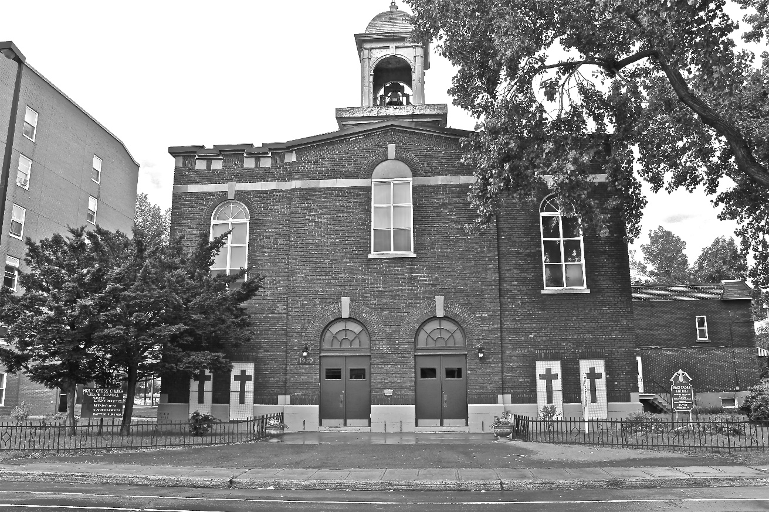
Holy Cross Parish Church
“The cross stands before us in these days as an eloquent symbol of God’s love for humanity.”
John Paul II

*9am mass is cancelled until further notice

