Pastoral Staff  Fr. Raymond LaFontaine E.V.  Parochial Administrator  Parish Office Hours  Wednesdays | Holy Cross Parish  1960 Jolicoeur street  Montreal, Quebec H4E 1X5  TEL.: 514-769-2717; FAX: 514-769-8852  Email: holycross.montreal60@gmail.com  https://holycrossmontreal.weebly.com/  Facebook: HOLY CROSS PARISH MONTREAL |  | Parish Wardens  Divya Siby  514-655-6442  James Potter  514-733-7016  Norlita Galdones  514-733-7016  Ruby Johnson  514-761-3242  Aldo Piccioni  514-769-6369

MONTH OF FEBRUARY 2024

2024 has been marked as the “Year of Prayer” by Pope Francis.
The month of February is traditionally dedicated to the Holy Family. The feast of the Presentation (February 2nd) or Candlemas forms a fitting transition from Christmas to Easter. Liturgical color is green as it is a symbol of hope.
FIFTH SUNDAY IN ORDINARY TIMES - FEBRUARY 4th, 2024
On Feb. 4th, we celebrate Saint Joseph of Leonissa who often offered to take the place of some slave who was being worked to death, but the authorities never accepted. He preached to any who would listen, brought lapsed Christians back to the Church and converted Muslims. Preached to and for the poor and spread the teachings of the Council of Trent. Helped establish hospitals, homeless shelters, and food banks. Ministered in prisons, to the sick, and the poor. With his crucifix in hand, he would wade into gang fights and brawls, praying, and preaching peace and good sense.

Mass Readings for the fifth Sunday in Ordinary Time, Cycle B:

The First Reading is taken from the Book of Job 7:1-4, 6-7. The author cries out in his misery, speaks of life and death, cites his restlessness and life’ struggle and notes that he will not see happiness again.

The Second Reading is from the First Letter of St. Paul to the Corinthians 9:16-19, 22-23. In this section of his letter, St. Paul is encouraging his Corinthian converts to be always ready to forgo their own rights when edification or spiritual welfare of a neighbor is at stake.

The Gospel is from St. Mark 1:29-39. He prays in an isolated place and eludes the crowds, but then he goes on to other areas, because he understands his purpose as “proclaiming.” Mark repeatedly indicates that “proclaiming” or “preaching” for Jesus goes beyond words and messages. It includes his exorcisms, healings, and legal controversies.

THOUGHT OF THE DAY:
“Every Christian must be a living book wherein one can read the teaching of the gospel.”
- Saint Joseph of Leonissa
The Grapevine is a good informative weekly Newsletter to keep you up to date on what is happening within and around our communities.

thegrapevine@diocesemontreal.org
POPE’S MONTHLY PRAYER INTENTION FOR THE MONTH OF FEBRUARY 2024:
FOR THE GIFT TERMINALLY ILL:
“Let us pray that the sick who are in the final stages of life, and their family, receive the necessary medical and human care and accompaniment.”
IMPORTANT NOTICE:
Please sit in the pews with blue tape.
Please keep social distance when you are receiving communion.
Please use hand sanitizer on entering and leaving the church. Thank you!
REMINDER:  “CELEBRATE OUR LORD”  Please join us at 8:00PM on Sundays at ST. WILLIBRORD PARISH  351 WILLIBRORD ST, VERDUN, QC. |  | NOTE:  Last week to pick up Church support envelopes at the back of the church.  Please remember to write your name on your church support envelope.
Celebrating 75 years of St. John Bosco parish on Sunday, February 4th, 2024. The festivities will open with a bilingual (Italian and English) Holy Mass. With Archbishop Christian Lépine as celebrant.
SPEND YOUR LENTEN SEASON WITH “THE CHOSEN”: A synodal discussion, inspired by the popular series based on the life of Jesus, continues with Season Three over four Friday evenings (Feb. 23rd – Mar. 15th), 7 p.m. EST online via Zoom. Register today!
10th WORLD DAY OF THE SICK on February 10th, 2024 at 9:30am. SASMAD invites you at Saint Issac-Jogues Parish in memory of Our Lady of Lourdes.
SUNDAY COLLECTION
January 28th, 2024 |  | Amount in CAD
TOTAL |  | 495.55$
Thank you for your generosity!
“Prayer makes us understand our vulnerability”, but the Lord “gives us strength and closeness”
MASS INTENTIONS
February 4th, 2024  RAYMONDE FOURNIER  Req’d by The Fournier Family | February 11th, 2024  THE PARISHIONERS OF HOLY CROSS
Pope Francis
THIS CHURCH MAY BE USED AS A RESTING VISITATION LOCALE FOR YOUR DEARLY
DEPARTED.
IF YOU DESIRE THIS SERVICE, PLEASE CALL 514-769-2717

Holy Cross Parish Church
1960 Jolicoeur Street
Montreal, QC H4E 1X5
Tel: 514-769-2717
holycross.montreal60@gmail.com
https://holycrossmontreal.weebly.com/
Facebook: HOLY CROSS PARISH MONTREAL

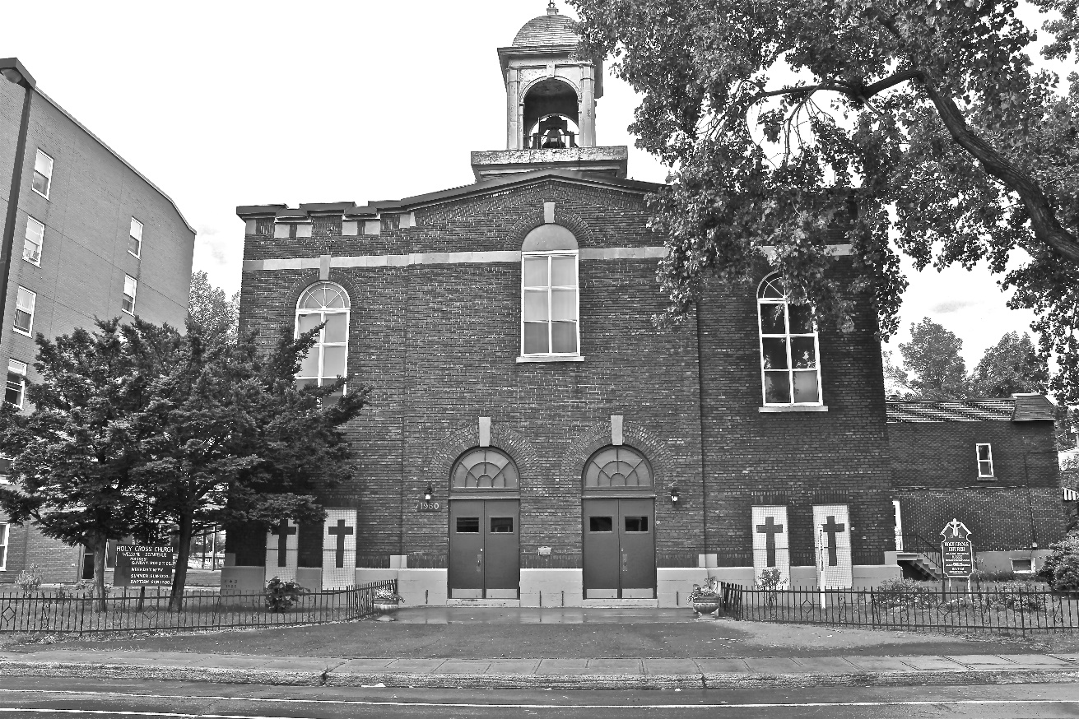
Holy Cross Parish Church
“The cross stands before us in these days as an eloquent symbol of God’s love for humanity.”
John Paul II

*9am mass is cancelled until further notice

