Pastoral Staff  Fr. Raymond LaFontaine E.V.  Parochial Administrator  Parish Office Hours  Wednesdays | Holy Cross Parish  1960 Jolicoeur street  Montreal, Quebec H4E 1X5  TEL.: 514-769-2717; FAX: 514-769-8852  Email: holycross.montreal60@gmail.com  https://holycrossmontreal.weebly.com/  Facebook: HOLY CROSS PARISH MONTREAL |  | Parish Wardens  Divya Siby  514-655-6442  James Potter  514-733-7016  Norlita Galdones  514-733-7016  Ruby Johnson  514-761-3242  Aldo Piccioni  514-769-6369

MONTH OF FEBRUARY 2024

2024 has been marked as the “Year of Prayer” by Pope Francis.

The month of February is traditionally dedicated to the Holy Family. The remaining days of February are the beginning of Lent. The liturgical color changes to violet or purple — a symbol of penance, mortification and the sorrow of a contrite heart.
FIRST SUNDAY OF LENT- FEBRUARY 18th,2024
On Feb. 18th, the Catholic Church celebrates the liturgical memorial of Saint Simon. In St. Matthew's Gospel, we read of St. Simon or Simeon who is described as one of our Lord's brethren or kinsmen. He was condemned to death and, after being tortured, was crucified. Although he was extremely old - tradition reports him to have attained the age of 120.

Mass Readings for the first Sunday of lent, Cycle B:

The First Reading is from the Book of Genesis 9:8-15 and is about the covenant between God and Noah not to destroy the world again by water.

The Second Reading is from the First Letter of St. Peter 3:18-22. In this passage St. Peter is exhorting the newly converted Christians to live according to the Christian faith, no matter what trials they may have to endure because of it.

The Gospel is from St. Mark 1:12-15. He was in the wilderness forty days, tested by Satan, and he was with the wild beasts, and the angels waited on him. Now after John was arrested, Jesus came to Galilee proclaiming the good news of God and saying, “The time is fulfilled, and the kingdom of God has come near; repent, and believe in the good news.”

SPEND YOUR LENTEN SEASON WITH “THE CHOSEN”: A synodal discussion, inspired by the popular series based on the life of Jesus, continues with Season Three over four Friday evenings (Feb. 23rd – Mar. 15th), 7 p.m. EST online via Zoom. Register!

It is with great sadness that we announce the death of Father Georges Lalande on February 7th 2024, at the age of 93. The funeral will be celebrated on February 20, 2024 at 1 p.m. at the chapel of the Appartements du Square Angus, 3300 rue William-Tremblay, Montréal. He will then be buried at Repos Saint-François-d'Assise, 6893 Sherbrooke St. East, Montréal. We extend our deepest condolences to his family, friends and colleagues.
Lenten Activities at Mary Queen of the World Cathedral – 2024
1) Way of the Cross: Every Friday during Lent at 5:30 p.m. (after the 5 p.m. mass)
2) Lenten retreat 2024 on the theme "FOLLOWING JESUS": preaching, confessions, solemn vespers, rosary and Sunday mass from 3:30 p.m.: February 25, March 3,
And March 10
POPE’S MONTHLY PRAYER INTENTION FOR THE MONTH OF FEBRUARY 2024:
FOR THE GIFT TERMINALLY ILL:
“Let us pray that the sick who are in the final stages of life, and their family, receive the necessary medical and human care and accompaniment.”
REMINDER:  “CELEBRATE OUR LORD”  Please join us at 7:00PM on Sundays at ST. WILLIBRORD PARISH  351 WILLIBRORD ST, VERDUN, QC. |  | NOTE:  Please remember to write your name on your church support envelope.  There are only a few Sunday missals left for sale. Hurry up and get yours. The price is $7.00. Exact change is required please!
Dear Holy Cross Parishioners,
Under Fabrique Law, we are under the obligation to fill two positions by the end of February at the very latest. Consequently, immediately following the 11:00 AM Mass on February 25th, 2024, a general assembly will be held for the purpose of electing two church wardens. Wardens assume responsibility for the temporal goods of the parish and oversee its buildings and finances. We hope you will be open to considering serving the parish in this most important way. Wardens are generally elected for a three-year term, and may be re-elected once. It is a great way to take responsibility for the future of our community. For further information or to indicate your interest, please speak to one of the currently serving wardens (James, Norlita, Divya, Aldo, and Rubina), our secretary Teresa, or myself.
Blessings in the Lord, Fr. Raymond
SUNDAY COLLECTION
February 11th, 2024 |  | Amount in CAD
TOTAL |  | 377.90$
Thank you for your generosity!
MASS INTENTIONS
February 18th, 2024  RAYMONDE FOURNIER  Req’d by the Fournier family  THE THANKSGIVING BIRTHDAY  Req’d by Elsie Ferrer  MARY HAINEY  Req’d by Ada Hainey  FRANCISCO RAMOS  Req’d by the Ramos family, Julie Rillera and Dalia Piccioni  THE MANINGAT AND RAMOS FAMILIES DECEASED MEMBERS  Req’d by the Ramos family | February 25th, 2024  ENRICO AND SANTINA PICCIONI  Req’d by the Piccioni family
“Prayer makes us understand our vulnerability”, but the Lord “gives us strength and closeness” Pope Francis
THIS CHURCH MAY BE USED AS A RESTING VISITATION LOCALE FOR YOUR DEARLY
DEPARTED.
IF YOU DESIRE THIS SERVICE, PLEASE CALL 514-769-2717

Holy Cross Parish Church
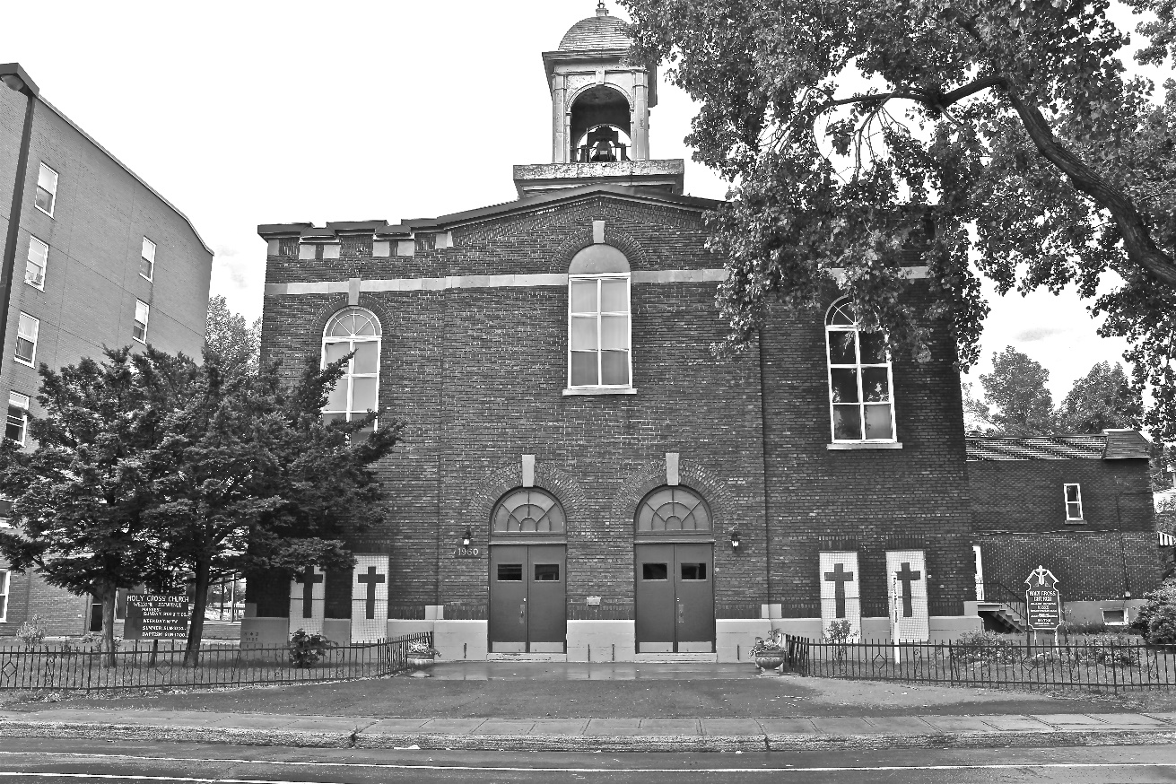

“The cross stands before us in these days as an eloquent symbol of God’s love for humanity.”
John Paul II

*9am mass is cancelled until further notice

