Pastoral Staff  Fr. Raymond LaFontaine E.V.  Parochial Administrator  Parish Wardens  Aldo Piccioni  514-769-6369  Divya Siby  514-655-6442 | Holy Cross Parish  1960 Jolicoeur street  Montreal, Quebec H4E 1X5  TEL.: 514-769-2717; FAX: 514-769-8852  Email: holycross.montreal60@gmail.com  Parish Office Hours  Wednesdays |  | Parish Wardens  Genfu Sun  514-568-9866  James Potter  514-733-7016  Norlita Galdones  514-733-7016  Ruby Johnson  514-761-3242
The month of February is dedicated to “The Holy Family”.
The Saint for February 26th, 2023 is Saint Andrew of Florence.
Sunday February 26th, 2023 is the First Sunday of Lent.
ANNOUNCEMENT: Ashes will be distributed today.
Ash Wednesday marked the beginning of the season of Lent. It is the season of penance, reflections and fasting, which prepares us for Christ’s Resurrection on Easter Sunday; through which we obtain redemption.
“REMEMBER THAT YOU ARE DUST AND TO DUST YOU SHALL RETURN”

THOUGHT OF THE DAY:

“During Lent, let us find concrete ways to overcome our indifference.”

Pope Francis
POPE’S MONTHLY PRAYER INTENTION FOR FEBRUARY 2023:
FOR EDUCATORS
“We pray that educators may be credible witnesses, teaching fraternity rather than competition and helping the youngest and most vulnerable above all.”
The Grapevine is a good informative weekly Newsletter to keep you up to date on what is happening within and around our communities.
thegrapevine@diocesemontreal.org
IMPORTANT NOTICE:
Please sit in the pews with blue tape.
Please keep social distance when you are receiving communion.
Please use hand sanitizer on entering and leaving the church.
Thank you!
VOLUNTEERS NEEDED: We are looking for parishioners to help out with various tasks within the church. There is a clip board on the table at the back of the church. We require help with maintenance of the candles, church linens, etc.
There are other areas where help is also needed. Please consider helping with your time! Thank you!
SAVE THE DAY:
Tuesday March 4th, 2023 @5:00PM-6:00PM
Mary Queen of the World Cathedral
A goodbye Mass for Archbishop Frank Leo presided over by Archbishop Christian Lepine.

“THE CHOSEN”
Fr Raymond is hosting ZOOM sessions to discuss this series.
It gives the New Testament a human feel for us to understand.
The sessions will be on Friday evenings from 7:00PM-9:3PM on March 10th, 17th, 24th, and 31st. If you would like to participate contact:
parishvitality@diocesemontreal.org
SUNDAY COLLECTION
February 19th, 2023 |  | Amount in CAD
Church Support Envelopes |  | $520.00
Charities |  | $9.75
Basket |  | $78.00
Masses |  | $30.00
Vigil Lights |  | $23.00
Missals |  | $10.00
TOTAL |  | $670.75
Thank you for your generosity!
Please remember to write your name on your church support envelope.
THIS CHURCH MAY BE USED AS A RESTING VISITATION LOCALE FOR YOUR DEARLY
DEPARTED.
IF YOU DESIRE THIS SERVICE, PLEASE CALL 514-769-2717

“Prayer makes us understand our vulnerability”, but the Lord “gives us strength and closeness”
MASS INTENTIONS
February 26th, 2023  GINO MILING GALDONES  Req’d by Norlita Galdones | March 5th, 2023  PARISHIONERS OF HOLY CROSS
Pope Francis

Holy Cross Parish Church
1960 Jolicoeur Street
Montreal, QC H4E 1X5
Tel: 514-769-2717
holycross.montreal60@gmail.com
https://holycrossmontreal.weebly.com/
Facebook: HOLY CROSS PARISH MONTREAL
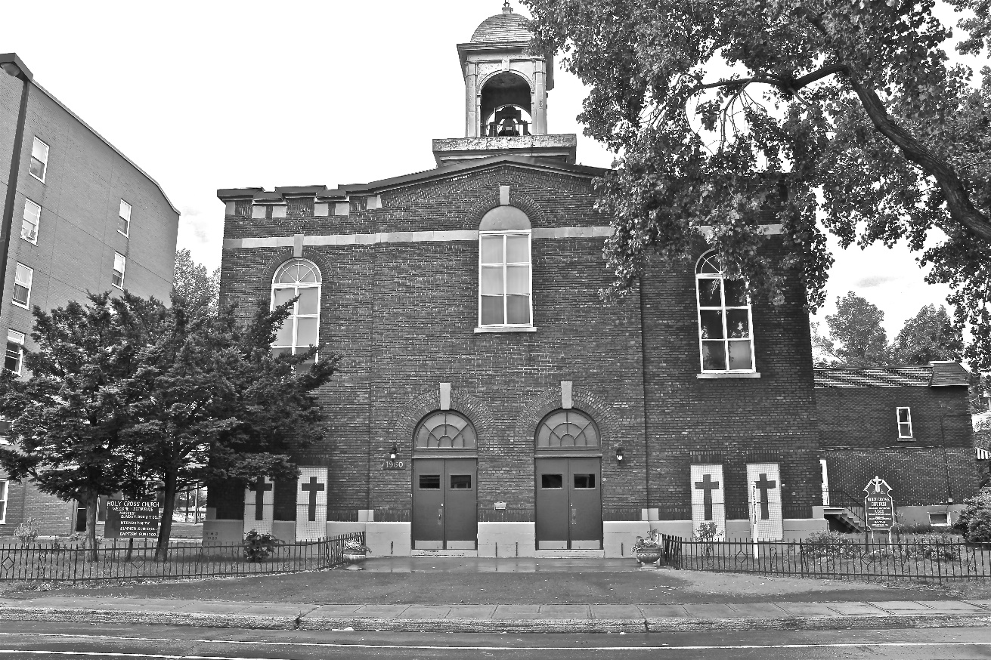
Holy Cross Parish Church
“The cross stands before us in these days as an eloquent symbol of God’s love for humanity.”
John Paul II

*9am mass is cancelled until further notice

