Pastoral Staff  Fr. Raymond LaFontaine E.V.  Parochial Administrator  Parish Wardens  Aldo Piccioni  514-769-6369  Divya Siby  514-655-6442 | Holy Cross Parish  1960 Jolicoeur street  Montreal, Quebec H4E 1X5  TEL.: 514-769-2717; FAX: 514-769-8852  Email: holycross.montreal60@gmail.com  Parish Office Hours  Wednesdays |  | Parish Wardens  Genfu Sun  514-568-9866  James Potter  514-733-7016  Norlita Galdones  514-733-7016  Ruby Johnson  514-761-3242
The month of February is dedicated to “The Holy Family”.
The Saint for February 19th, 2023 is Saint Beatus.
Sunday February 19th, 2023 is the Seventh Sunday of Ordinary Time.

THOUGHT OF THE DAY:

“The more man meditates upon good thoughts, the better will be his world and the world at large.”

Confucius
POPE’S MONTHLY PRAYER INTENTION FOR FEBRUARY 2023:
FOR EDUCATORS
“We pray that educators may be credible witnesses, teaching fraternity rather than competition and helping the youngest and most vulnerable above all.”
REMINDER:
All income tax receipts have now been mailed to Parishioners.
If you have not received your receipt, please contact the office.
Thank you!
The Grapevine is a good informative weekly Newsletter to keep you up to date on what is happening within and around our communities.
thegrapevine@diocesemontreal.org
IMPORTANT NOTICE:
Please sit in the pews with blue tape.
Please keep social distance when you are receiving communion.
Please use hand sanitizer on entering and leaving the church.
Thank you!
VOLUNTEERS NEEDED: We are looking for parishioners to help out with various tasks within the church. There is a clip board on the table at the back of the church. We require help with maintenance of the candles, church linens, etc.
There are other areas where help is also needed. Please consider helping with your time! Thank you!
SAVE THE DAY: TICKETS ARE NOW AVAILABLE!
“A DAY OF HOPE” WOMEN’S RETREAT
Saturday March 18th, 2023, 9AM – 3:30PM
This day -long women’s retreat will be a day to recharge, renew and restore through prayer, music, talks, and reflection, organized by women from the Montreal area for women, with the support of the Office of English Pastoral Services of the Archdiocese of Montreal.
It will held at the Sacred Heart School (3635 Atwater Ave. Montreal, QC, H3H 1Y4)
The event will be English. All women 16+ are welcome. To be notified once registration opens, please sign up here:
https://forms.gle/4Dt9s4pupXQ4NJcB6
For more information about the day, please contact: esperanza.martinezperez@yahoo.com
SUNDAY COLLECTION
February 12th, 2023 |  | Amount in CAD
Church Support Envelopes |  | $385.00
Charities |  | $5.00
Basket |  | $73.15
Masses |  | $45.00
TOTAL |  | $508.15
Thank you for your generosity!
Please remember to write your name on your church support envelope.
THIS CHURCH MAY BE USED AS A RESTING VISITATION LOCALE FOR YOUR DEARLY
DEPARTED.
IF YOU DESIRE THIS SERVICE, PLEASE CALL 514-769-2717

“Prayer makes us understand our vulnerability”, but the Lord “gives us strength and closeness”
MASS INTENTIONS
February 19th, 2023  MARY HAINEY  Req’d by Ada Hainey  2ND ANNIVERSARY OF HIS PASSING FOR FRANCISCO RAMOS  Req’d by Grace Ramos  DOLORES FERRER  Req’d by Salve Ferrer  KATHLEEN SENCHEY  Req’d by Raymond Senchey | February 26th, 2023  PARISHIONERS OF HOLY CROSS
Pope Francis

Holy Cross Parish Church
1960 Jolicoeur Street
Montreal, QC H4E 1X5
Tel: 514-769-2717
holycross.montreal60@gmail.com
https://holycrossmontreal.weebly.com/
Facebook: HOLY CROSS PARISH MONTREAL
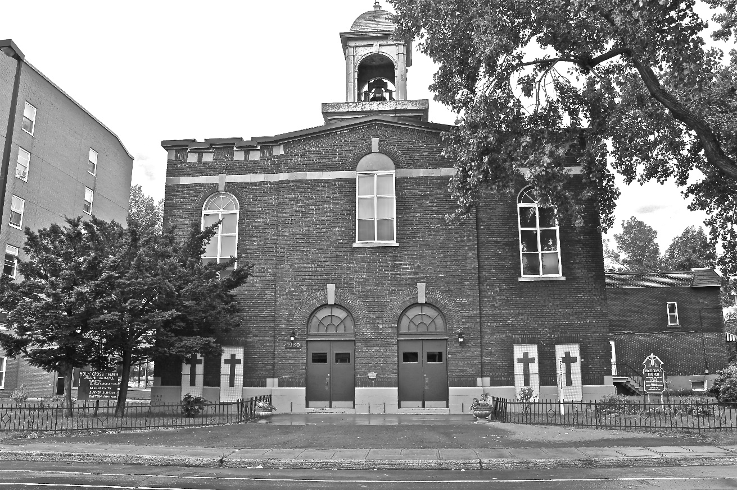
Holy Cross Parish Church
“The cross stands before us in these days as an eloquent symbol of God’s love for humanity.”
John Paul II

*9am mass is cancelled until further notice

