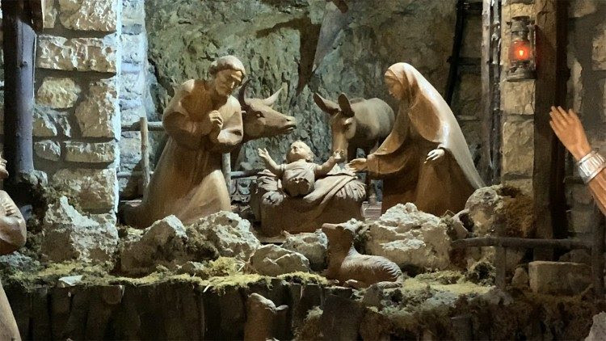
As we approach our Christmas celebrations this year, we may feel conflicted - or even guilty - about how to celebrate Christmas, with war and destruction ravaging the land in which our Saviour came to earth, including the “little town of Bethlehem” in which he was born.
This year also marks an important milestone: the 800th anniversary of the “presepio”, or as we have come to call it, the crèche, crib or manger, a reminder among our decorations of the Event which marks this special time of year.
St. Francis of Assisi is reputed to have begun this tradition of reenacting the birth of Jesus Christ in 1223, in a cave in Greccio, Italy. By using live animals and a manger, he hoped to bring the Gospel story to life, and thus closer to the lives of the people of his time.
In parts of the world, live reenactments of the manger scene continue to this day. In the Philippines, the “Panunuluyan” is performed. Actors go from house to house, seeking shelter, culminating in a display of the manger scene. In many of our faith communities, children participate in such live pageants either at or before the Christmas Mass.
Known by a variety of names, ornamental nativity scenes include nacimiento de Navidad in Mexico, presepio in Italy and Portugal, szopka in Poland, crib in Ireland, and Belénes in Spain. Around the world, in homes, offices, churches, even shopping malls and other public buildings, depictions of the Nativity are on display using materials, artistic styles, and even original characters that reflect the daily life and culture of the place. At St. Joseph’s Oratory, we can see many of these on display. Christ is the Lord of all nations.
The crèche stands as a symbol of hope as we look at our world in turmoil. At the same time, it challenges us to live more simply and to recognize that God works in the chaos of life and our lives, and that no matter what their circumstances, every life has infinite value. In its universal representation and appeal (who does not love a newborn?), the crèche is so much more than an ornament. It is a visual reminder of our belief that God took on human flesh to walk among us, with us and to remain in us. Jesus is the One who enables us to experience the Father’s infinite love, and to encourage us to learn to love as God does.
Let us spend quiet time in prayer and contemplation at the crèche this year, in wonder and awe at the gift of life itself, and in gratitude for the life God has gifted us.
No matter how we decide to celebrate Emmanuel, God with us, God with everyone, let us make room in our hearts for those less fortunate than us. Let us think especially of those suffering from the ravages of war, poverty, food insecurity, mental illness, loneliness, or fear, especially in Gaza, Palestine, Israel, Yemen and Sudan. Let us be bearers of hope in a humanity which is one because we are all God’s children. Let us implore Jesus, the Son of Righteousness and the Prince of Peace to light the way for those who walk in darkness.
May your Christmas be filled with peace and love as we look forward to a brighter 2024.
God bless you, your families, and your parish communities.
Fr. Raymond Lafontaine, E.V., Parochial Administrator
Fr. Peter Laviolette, Sunday ministry

SUNDAY COLLECTION
December 17th, 2023 | Amount in CAD
TOTAL | $ 5 296.76
Thank you for your generosity!
Please remember to write your name on your church support envelope.
PLEASE TURN OFF CELL PHONES
THIS CHURCH MAY BE USED AS A RESTING VISITATION LOCALE FOR YOUR DEARLY
DEPARTED.
IF YOU DESIRE THIS SERVICE, PLEASE CALL 514-769-2717

“Prayer makes us understand our vulnerability”, but the Lord “gives us strength and closeness”
MASS INTENTIONS
December 24th, 2023
THE HAINEY FAMILY
Req’d by Ada Hainey

Pope Francis

Holy Cross Parish Church
1960 Jolicoeur Street
Montreal, QC, H4E 1X5
Tel: 514-769-2717
holycross.montreal60@gmail.com
https://holycrossmontreal.weebly.com/
Facebook: HOLY CROSS PARISH MONTREAL

