Pastoral Staff  Fr. Raymond LaFontaine E.V.  Parochial Administrator  Parish Wardens  Aldo Piccioni  514-769-6369 | Holy Cross Parish  1960 Jolicoeur street  Montreal, Quebec H4E 1X5  TEL.: 514-769-2717; FAX: 514-769-8852  Email: holycross.montreal60@gmail.com  Parish Office Hours  Wednesdays |  | Parish Wardens  Divya Siby  514-655-6442James Potter  514-733-7016  Norlita Galdones  514-733-7016  Ruby Johnson  514-761-3242
The saint for Sunday December 10th, 2023 is St Gregory III Pope.
The month of December is dedicated to the Immaculate Conception.
December 10th is the second Sunday of Advent.
The second candle of the Advent wreath represents Peace. The second Advent candle reminds us of Mary and Joseph’s journey from Nazareth to Bethlehem before Mary gave birth to Jesus.

This second candle recalls that after all the division, destruction, and dispersion of the kingdom in the Old Testament, there might finally be peace on Earth – Jesus is coming, and so is his Kingdom of Peace.

THOUGHT OF THE DAY:
“Faith lifts the soul. Hope supports it. Experience says it must and Love says let it be!”
Elizabeth Ann Seton
The Grapevine is a good informative weekly Newsletter to keep you up to date on what is happening within and around our communities.

thegrapevine@diocesemontreal.org
POPE’S MONTHLY PRAYER INTENTION FOR THE MONTH OF DECEMBER 2023:
FOR PERSONS WITH DISABILITIES:
“We pray that people living with disabilities: May they be at the center of attention in society and that institutions may offer inclusive programs which value their active participation..”
IMPORTANT NOTICE:
Please sit in the pews with blue tape.
Please keep social distance when you are receiving communion.
Please use hand sanitizer on entering and leaving the church. Thank you!
REMINDER:  “CELEBRATE OUR LORD”  Please join us at 8:00PM on Sundays at ST. WILLIBRORD PARISH  351 WILLIBRORD ST  VERDUN, QC. |  | NOTE:  Parish support envelopes for the year 2024-2025 are available at the back of the church.  Thank you!
Sunday Missals will be sold after mass starting December 3rd, 2023.
The price is $7.00. Exact change is required please!
SUNDAY COLLECTION
December 3rd, 2023 |  | Amount in CAD
TOTAL |  | $ 652.00
Thank you for your generosity!
Please remember to write your name on your church support envelope.
PLEASE TURN OFF CELL PHONES
THIS CHURCH MAY BE USED AS A RESTING VISITATION LOCALE FOR YOUR DEARLY
DEPARTED.
IF YOU DESIRE THIS SERVICE, PLEASE CALL 514-769-2717

“Prayer makes us understand our vulnerability”, but the Lord “gives us strength and closeness”
MASS INTENTIONS
December 10th, 2023  RAYMONDE FOURNIER  Req’d by The Fournier Family  KATHLEEN SENCHEY  Req’d by Ray Senchey  JOSIE RILLERA  Req’d by Jose Rillera  ENRICO & SANTINA PICCIONI  Req’d by The Piccioni Family  DIEGO HANDINERO (DEATH ANNIVERSARY)  Req’d by The Handinero Family | December 10th, 2023  20TH ANNIVERSARY OF THE PASSING OF INCORONOTA CIOCCA AMOROSA  Req’d by The Amorosa Family
Pope Francis

Holy Cross Parish Church
1960 Jolicoeur Street
Montreal, QC H4E 1X5
Tel: 514-769-2717
holycross.montreal60@gmail.com
https://holycrossmontreal.weebly.com/
Facebook: HOLY CROSS PARISH MONTREAL

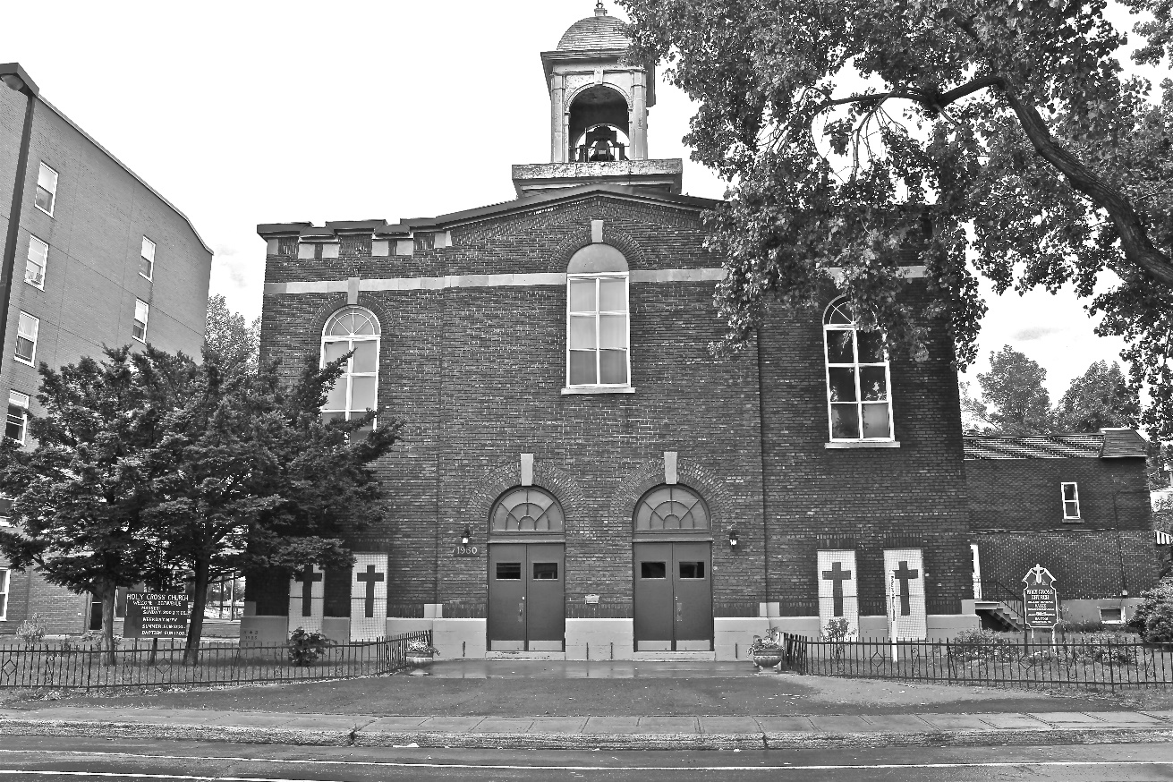
Holy Cross Parish Church
“The cross stands before us in these days as an eloquent symbol of God’s love for humanity.”
John Paul II

*9am mass is cancelled until further notice

