Pastoral Staff  Fr. Raymond LaFontaine E.V.  Parochial Administrator  Parish Wardens  James Potter  514-733-7016 | Holy Cross Parish  1960 Jolicoeur street  Montreal, Quebec H4E 1X5  TEL.: 514-769-2717; FAX: 514-769-8852  Email: holycross.montreal60@gmail.com  Parish Office Hours  Wednesdays |  | Parish Wardens  Norlita Galdones  514-733-7016  Teresa Gomes  514-291-2591  Ruby Johnson  514-761-3242
The month of December is dedicated to Immaculate Conception celebrated on December 8th.
The Saint for December 4th, 2022 is St. John of Damascus.
Today, December 4th, 2022 is the 2nd Sunday of Advent.
The 2nd purple candle represents Faith and is called the Bethlehem’s Candle;
It symbolizes the preparation for the coming King.

THOUGHT OF THE DAY:

“Don’t compare yourself to others. Be like the sun and the moon and shine when it is your time.”

unknown
POPE’S MONTHLY PRAYER INTENTION FOR DECEMBER 2022:
VOLUNTEER NOT-FOR-PROFIT ORGANIZATIONS
“We pray that volunteer not-for-profit organizations committed to human development find people dedicated to the common good and ceaselessly seek out new paths to international cooperation.”
NOTE: Church support envelopes can be collected at the office.
Missals for 2023 can be purchased at the office. ($7.00 exact change)
Thank you!
NOTE: Christmas Eve mass will be at 9:00pm on December 24th, 2022.
The Grapevine is a good informative weekly Newsletter to keep you up to date on what is happening within and around our communities.
thegrapevine@diocesemontreal.org
IMPORTANT NOTICE: Please sit in the pews with yellow tape.
Please keep social distance when you are receiving communion.
Please use hand sanitizer on entering and leaving the church. Thank you!
“LIFE IS WONDERFUL” CHRISTMAS CONCERT:
UPDATED: NEW STARTING TIME AND NEW FEATURE
You are invited by Pillars Trust to their concert on Tuesday, December 6th in the former Grand Séminaire de Montréal, 2065 Sherbrooke St. West. NEW SHOW TIME: 7:00 – 9:00 p.m. That is 30 mins earlier than stated in previous bulletins. Instrumentalists from F.A.C.E School of Montreal will now perform along with choirs: Newman Centre, Sacred Heart School, St. Ignatius Music Ministry, Bernadette Short Irish Dancers followed by Wine and Cheese Reception, POINSETTIA AND 50/50 DRAW.
Cost: 30$ In Person, 20$ Students, 20$ Virtual. Reserve Online at www.pillarstrust.org or buy tickets at door – (opens at 6:30).
Or enjoy the show from your own home. For more information call: Carol McCormick 514-386-8082
WHAT’S HAPPENING:
We will be having a Christmas Luncheon on Dec 18th, 2022 in the Church hall. Tickets are $20.00.
Please purchase your tickets from Norlita. Tickets will not be sold at the door.
SUNDAY COLLECTION
November 20th, 2022 |  | Amount in CAD
Church Support Envelopes |  | $253.00
Parish Charities |  | $145.00
Basket |  | $42.70
Masses |  | $75.00
Donations |  | $30.00
Rent Mediation Judgement |  | $1 224.00
Honorarium |  | (minus) $10.00
TOTAL |  | $1 759.70
Thank you for your generosity!
Please remember to write your name on your church support envelope.

“Prayer makes us understand our vulnerability”, but the Lord “gives us strength and closeness”
MASS INTENTIONS
December 4th, 2022  ENRICO PICCIONI Req’d by His Family  KATHLEEN SENCHEY Req’d by Raymond Senchey  VINCE MacGILLIVRAY Req’d by Laurell MacGILLIVRAY | December 4th, 2022  GARY JOHNSON Req’d by Ruby Johnson
Pope Francis
Please turn off cell phones.
PLEASE REMEMBER THE CHURCH IN YOUR WILL
THIS CHURCH MAY BE USED AS A RESTING VISITATION LOCALE FOR YOUR DEARLY
DEPARTED.
IF YOU DESIRE THIS SERVICE, PLEASE CALL 514-769-2717

Holy Cross Parish Church
1960 Jolicoeur Street
Montreal, QC H4E 1X5
Tel: 514-769-2717
holycross.montreal60@gmail.com
https:/Holycrossmontreal.weebly.com
Facebook: HOLY CROSS PARISH MONTREAL
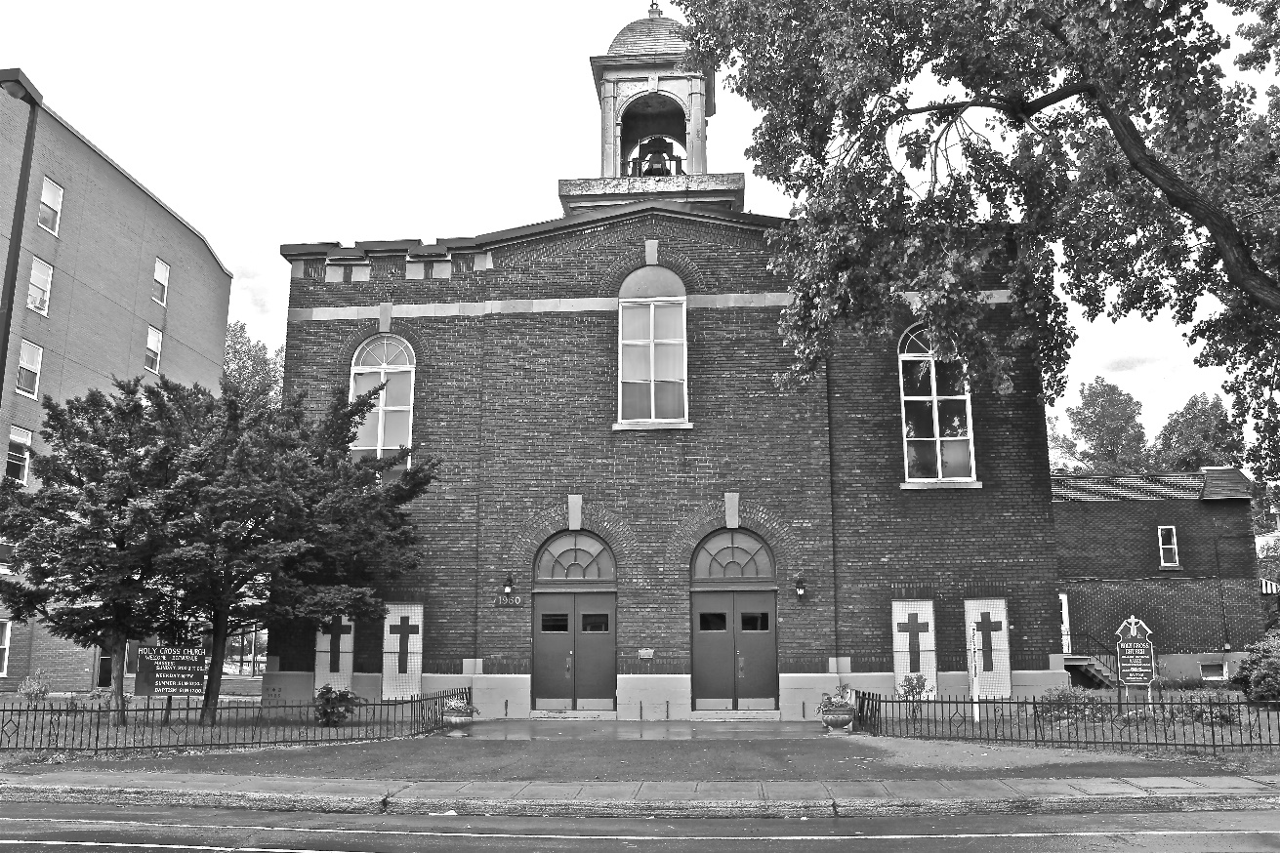
Holy Cross Parish Church
“The cross stands before us in these days as an eloquent symbol of God’s love for humanity.”
John Paul II

*9am mass is cancelled until further notice

