Pastoral Staff  Fr. Raymond LaFontaine E.V.  Parochial Administrator  Parish Office Hours  Wednesdays | Holy Cross Parish  1960 Jolicoeur street  Montreal, Quebec H4E 1X5  TEL.: 514-769-2717; FAX: 514-769-8852  Email: holycross.montreal60@gmail.com  https://holycrossmontreal.weebly.com/  Facebook: HOLY CROSS PARISH MONTREAL |  | Parish Wardens  Divya Siby: 514-655-6442  James Potter: 514-733-7016  Norlita Galdones: 514-733-7016  Ruby Johnson: 514-761-3242  Aldo Piccioni: 514-769-6369  Francis Van Oordt: 438-226-2126

MONTH OF APRIL 2024

2024 has been marked as the “Year of Prayer” by Pope Francis.

As our Lenten journey comes to a close we prepare to follow Christ all the way to the cross and to witness His glorious Resurrection. Hopefully we have sacrificed and prayed so that we are now able to more fully reap the fruits of a well spent Lent.
SECOND SUNDAY OF EASTER - APRIL 7th,2024
On April 7th, the Catholic Church celebrates the liturgical memorial of Saint John Baptist de La Salle. He instituted the process of dividing students into grades; established the first teacher's school, started high schools and trade schools, and was proclaimed the patron of all teachers of all youth by Pope Pius XII in 1950.

Mass Readings for the second Sunday of Easter, Cycle B:

The First Reading is taken from Acts 4:32-35. In this passage from the Acts of the Apostles, St. Luke highlights the spirit of unity and generosity within the early Christian community in Jerusalem. While we may not be called to the same degree of communal living, the lesson remains relevant: as stewards of God's gifts, we are called to share with those in need, recognizing that our possessions ultimately belong to God.

The Second Reading is from 1 John 5:1-7. St. John's profound philosophy asserts that while humans share basic instincts with animals, they uniquely possess faculties for perceiving truth and beauty, desiring eternal possession of transcendent goods beyond the material world.

The Gospel is from John 20:19-31. Last Sunday's gospel, from St. John, depicted the Apostles' initial encounter with evidence of the resurrection, where some, like Peter and John, began to believe upon seeing the empty tomb, while others remained skeptical, including Thomas, despite the testimony of his fellow disciples.
POPE’S MONTHLY PRAYER INTENTION FOR THE MONTH OF APRIL 2024:
FOR THE ROLE OF WOMEN:

“Let us pray that the dignity and worth of women be recognized in every culture, and for an end to the discrimination they face in various parts of the world”
REMINDER:  “CELEBRATE OUR LORD”  Please join us at 8:00PM on Sundays at ST. WILLIBRORD PARISH  351 WILLIBRORD ST, VERDUN, QC. |  | NOTE:  Please remember to write your name on your church support envelope.  There are only a few Sunday missals left for sale. Hurry up and get yours. The price is $7.00. Exact change is required please!
A Great Symphony of Prayer: The Our Father as a Programme of Life
The CCCB Ad hoc Committee for the Preparation for the Jubilee 2025 is hosting a two-part series titled, “A Great Symphony of Prayer” with Dr. Josephine Lombardi which will enable the faithful one meaningful way to participate in the Year of Prayer which was announced by Pope Francis on 21st January 2024. The webinar series will be every Tuesdays in April 2024, 1:00-2:30 pm EDT.
April 9th, 2024: Seeking God’s Kingdom and Knowing God’s Will
April 23rd, 2024: Daily Bread and the Gift of Forgiveness
April 30th, 2024: Managing trials and Resisting Evil
Your Voice Matters: Imagining new ways of “being” church starts with your voice.
Pope Francis initiated a worldwide three-year process in 2021 dedicated to listening and dialogue, calling all faithful to take part in discerning the path forward for the Church. In this process, we intend to create space for diverse voices here in Montreal, encouraging teamwork and wider consultation. Your input is vital as we address challenges and spiritual growth in changing times. Join your local network of faith communities and organizations for a Saturday morning dedicated to consultation and shared leadership.
Open to all; admission is free.
When: Saturday, April 6th, 2024, from 9 a.m. to 12 noon
Location: St. Thomas à Becket Parish, Pierrefonds
Please see the secretary for more details or visit https://bit.ly/Your_Voice_Matters_PVC2024
You can also fill up a questionnaire that would be beneficial so that they can have the feedback from all parishes.
HOLY WEEK COLLECTION
March 29th, 2024 |  | Amount in CAD
TOTAL |  | 3106.00$
March 31st, 2024 |  | Amount in CAD
TOTAL |  | 1603.00$
Thank you for your generosity!
MASS INTENTIONS
April 7th, 2024  RAYMONDE FOURNIER  Req’d by the Fournier family  THE HAINEY FAMILY  Req’d by the Ada Hainey | April 14th, 2024  THE PARISHIONERS OF HOLY CROSS
“Prayer makes us understand our vulnerability”, but the Lord “gives us strength and closeness” Pope Francis
THIS CHURCH MAY BE USED AS A RESTING VISITATION LOCALE FOR YOUR DEARLY
DEPARTED.
IF YOU DESIRE THIS SERVICE, PLEASE CALL 514-769-2717

Holy Cross Parish Church
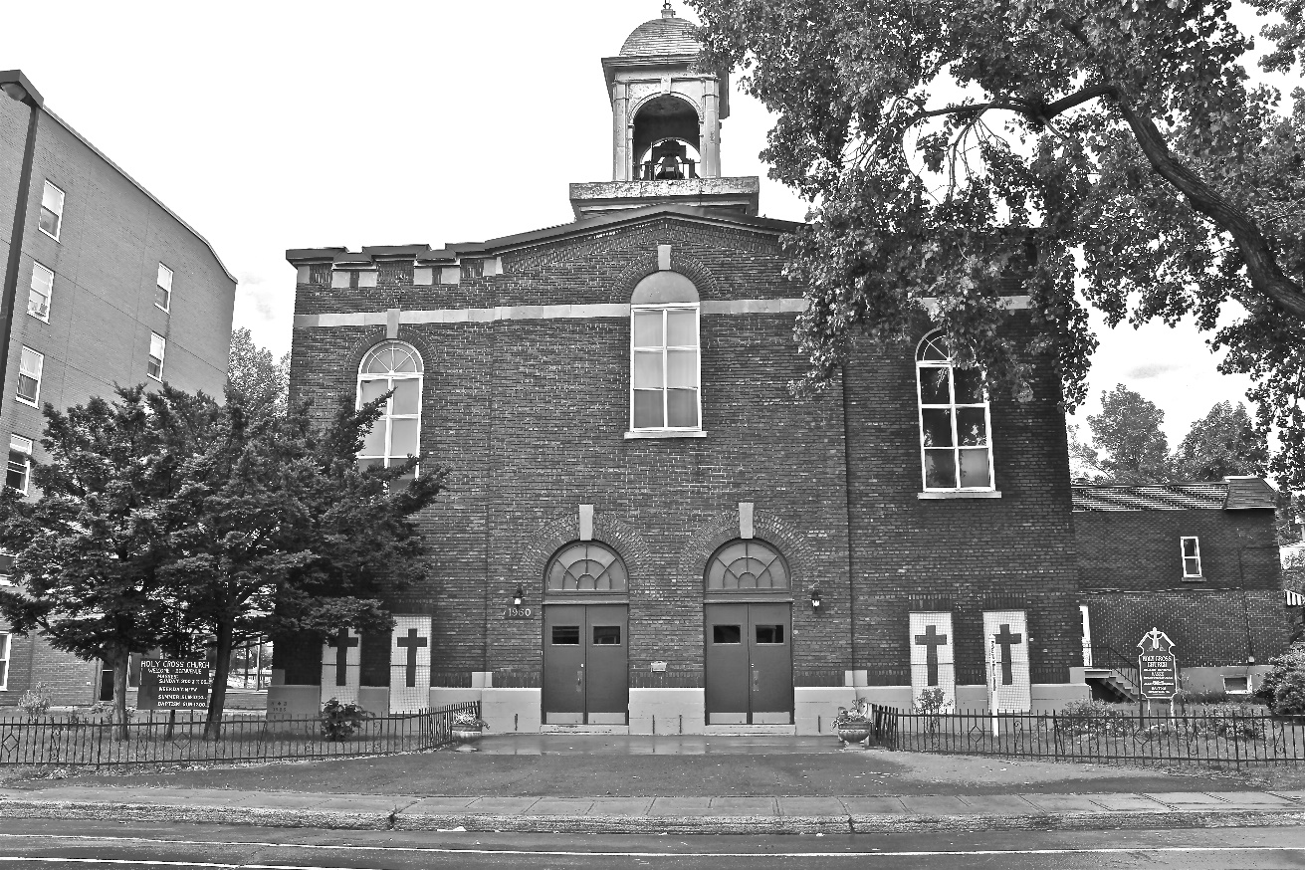

“The cross stands before us in these days as an eloquent symbol of God’s love for humanity.”
John Paul II

*9am mass is cancelled until further notice

