Pastoral Staff  Fr. Raymond LaFontaine E.V.  Parochial Administrator  Parish Wardens  Aldo Piccioni  514-769-6369  Divya Siby  514-655-6442 | Holy Cross Parish  1960 Jolicoeur street  Montreal, Quebec H4E 1X5  TEL.: 514-769-2717; FAX: 514-769-8852  Email: holycross.montreal60@gmail.com  Parish Office Hours  Wednesdays |  | Parish Wardens  Genfu Sun  514-568-9866  James Potter  514-733-7016  Norlita Galdones  514-733-7016  Ruby Johnson  514-761-3242
The month of April is dedicated to the Holy Spirit and the Eucharist.
The saint for April 30th, is Saint Pius V, (POPE).
Sunday April 30th, 2023 is the 4th Sunday of Easter, sometimes called Good Shepherd Sunday.
“The Lord is my Shepherd, I shall not want...”  PSALM 23  Prayer based on PSALM 23  HEAVENLY FATHER, YOU are my Shepherd, and I am Your beloved sheep,  You guide me through the ups and downs of life, and I trust in Your care.  You provide for me in every way. You quench my thirst with your loving water, and You restore my soul when I am weary. |  | When I am facing difficulties, You provide solutions for me. You bless me and draw me closer to You.  Thank You for Your unfailing love and faithfulness, may I continue to follow You all the days of my life, and may Your name be praised forevermore.  Amen  Young Catholics.com

THOUGHT OF THE DAY:

“Every day may not be good, but there is something good in every day.”
UNKNOWN
The Grapevine is a good informative weekly Newsletter to keep you up to date on what is happening within and around our communities.

thegrapevine@diocesemontreal.org
POPE’S MONTHLY PRAYER INTENTION FOR APRIL 2023:
FOR A CULTURE OF PEACE AND NONVIOLENCE
“We pray for the spread of peace and nonviolence, by decreasing the use of weapons by state and citizens”
IMPORTANT NOTICE:
Please sit in the pews with blue tape.
Please keep social distance when you are receiving communion.
Please use hand sanitizer on entering and leaving the church. Thank you!
NOTE:
The Notre-Dame-des-Neiges cemetery will be closed for the next few days.
Cleanup from ice storm is taking place.
INFO: 514-841-7990
REMINDER:  “CELEBRATE OUR LORD”  Please join us at 8:00PM on Sundays at  ST. WILLIBRORD PARISH  351 WILLIBRORD ST  VERDUN, QC. |  | SAVE THE DATE: April 30th, 2023 / World Day of Prayer for vocations  FAMILY & LIFE WEEK:  May 7th – 14th 2023  MORE INFO: Karolina Bozelko  (514) 925-4300 #206  CentreDMVF@diocesemontreal.org
VOLUNTEERS NEEDED:
We are searching for someone to takeover the input of our parish bulletin. Please contact the office.
Thank you
SUNDAY COLLECTION
April 23th, 2023 |  | Amount in CAD
TOTAL |  | $924.35
Thank you for your generosity!
Please remember to write your name on your church support envelope.
PLEASE TURN OFF CELL PHONES
THIS CHURCH MAY BE USED AS A RESTING VISITATION LOCALE FOR YOUR DEARLY
DEPARTED.
IF YOU DESIRE THIS SERVICE, PLEASE CALL 514-769-2717

“Prayer makes us understand our vulnerability”, but the Lord “gives us strength and closeness”
MASS INTENTIONS
April 30th, 2023  KATHLEEN SENCHEY  Req’d by The Senchey Family  RAYMONDE FOURNIER  Req’d by Francine Forget and Andrew Gorham  RAYMONDE FOURNIER  Req’d by Susie Raciot  WILFREDO ORPILLA  Req’d by Jose Rillera and Family  Sr. IMELDA STRACHAN  Req’d by Ada Hainey | May 7th, 2023  JEANNETTE BLOTSKY  Req’d by Jim and Vera Blotsky
Pope Francis

Holy Cross Parish Church
1960 Jolicoeur Street
Montreal, QC H4E 1X5
Tel: 514-769-2717
holycross.montreal60@gmail.com
https://holycrossmontreal.weebly.com/
Facebook: HOLY CROSS PARISH MONTREAL
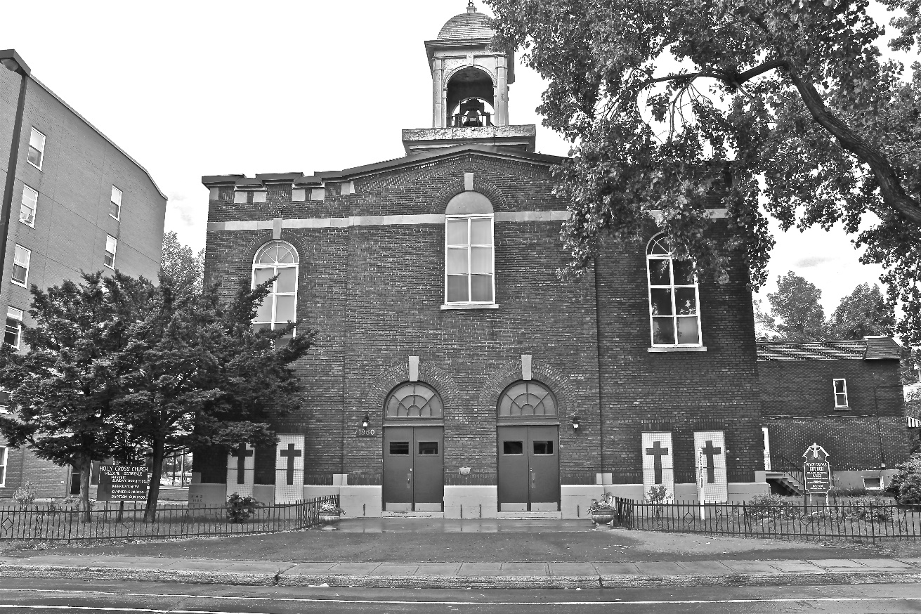
Holy Cross Parish Church
“The cross stands before us in these days as an eloquent symbol of God’s love for humanity.”
John Paul II

*9am mass is cancelled until further notice

