Pastoral Staff  Fr. Raymond LaFontaine E.V.  Parochial Administrator  Parish Wardens  Aldo Piccioni  514-769-6369  Divya Siby  514-655-6442 | Holy Cross Parish  1960 Jolicoeur street  Montreal, Quebec H4E 1X5  TEL.: 514-769-2717; FAX: 514-769-8852  Email: holycross.montreal60@gmail.com  Parish Office Hours  Wednesdays |  | Parish Wardens  Genfu Sun  514-568-9866  James Potter  514-733-7016  Norlita Galdones  514-733-7016  Ruby Johnson  514-761-3242
The month of April is dedicated to the Holy Spirit and the Eucharist
The saint for April 2nd, is St Francis of Paola
Palm Sunday is the final Sunday of Lent. The beginning of the Holy Week

THOUGHT OF THE DAY:

“Blessed is the king who comes in the name of the Lord! Peace in heaven and glory in the highest!”
Luke 9:38
PALM SUNDAY PRAYER:
“Gracious God, in my heart, I thank you for sending your son Jesus into the world so that I may know forgiveness and eternal life.”
POPE’S MONTHLY PRAYER INTENTION FOR APRIL 2023:
FOR A CULTURE OF PEACE AND NONVIOLENCE
“We pray for the spread of peace and nonviolence, by decreasing the use of weapons by state and citizens”
The Grapevine is a good informative weekly Newsletter to keep you up to date on what is happening within and around our communities.
thegrapevine@diocesemontreal.org
IMPORTANT NOTICE:
Please sit in the pews with blue tape.
Please keep social distance when you are receiving communion.
Please use hand sanitizer on entering and leaving the church. Thank you!
NOTE:
The Notre-Dame-des-Neiges cemetery has re-opened as of March 31st, 2023.
Save the date:
Blood Drive / Friday April 7th, 2023
Honorary Chairperson/Mgr. Christian Lepine
By Appointment: hema-quebec.qc.ca Mary Queen of The World Cathedral
1(800) 343-7264 1100 Mansfield
Montreal, Quebec
Location: Basement
WHAT’S HAPENNING:
April 7th, 2023 @9:30AM-12:00PM / Good Friday
@Notre-Dame-de-Bon-Secours Chapel
The way of the cross; Guided by Archbishop Christian Lepine

Easter Sunday Luncheon
After Mass in the church hall/price $10.00
See Norlita for details
SUNDAY COLLECTION
March 19th, 2023 |  | Amount in CAD
TOTAL |  | $641.00
Thank you for your generosity!
Please remember to write your name on your church support envelope.
PLEASE TURN OFF CELL PHONES
THIS CHURCH MAY BE USED AS A RESTING VISITATION LOCALE FOR YOUR DEARLY
DEPARTED.
IF YOU DESIRE THIS SERVICE, PLEASE CALL 514-769-2717

“Prayer makes us understand our vulnerability”, but the Lord “gives us strength and closeness”
MASS INTENTIONS
April 2nd, 2023  KATHLEEN SENCHEY  Req’d by The Senchey Family  MARGARET STREDDER  Req’d by Linda and Susan Waters | April 9th, 2023  HAINEY FAMILY  Req’d by Ada Hainey
A copy of the Holy week schedule is attached to the bulletin!
Pope Francis

Holy Cross Parish Church
1960 Jolicoeur Street
Montreal, QC H4E 1X5
Tel: 514-769-2717
holycross.montreal60@gmail.com
https://holycrossmontreal.weebly.com/
Facebook: HOLY CROSS PARISH MONTREAL
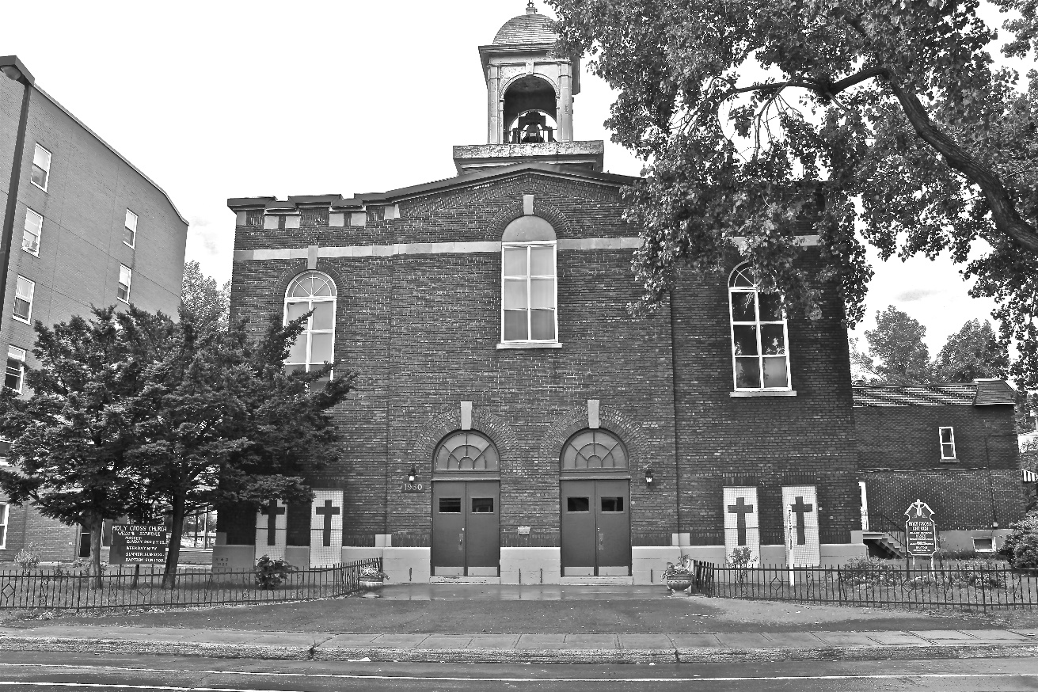
Holy Cross Parish Church
“The cross stands before us in these days as an eloquent symbol of God’s love for humanity.”
John Paul II

*9am mass is cancelled until further notice

