Pastoral Staff  Fr. Raymond LaFontaine E.V.  Parochial Administrator  Parish Office Hours  Wednesdays | Holy Cross Parish  1960 Jolicoeur street  Montreal, Quebec H4E 1X5  TEL.: 514-769-2717; FAX: 514-769-8852  Email: holycross.montreal60@gmail.com  https://holycrossmontreal.weebly.com/  Facebook: HOLY CROSS PARISH MONTREAL |  | Parish Wardens  Divya Siby: 514-655-6442  James Potter: 514-733-7016  Norlita Galdones: 514-733-7016  Ruby Johnson: 514-761-3242  Aldo Piccioni: 514-769-6369  Francis Van Oordt: 438-226-2126

MONTH OF APRIL 2024

2024 has been marked as the “Year of Prayer” by Pope Francis.

As our Lenten journey comes to a close we prepare to follow Christ all the way to the cross and to witness His glorious Resurrection. Hopefully we have sacrificed and prayed so that we are now able to more fully reap the fruits of a well spent Lent.
FOURTH SUNDAY OF EASTER - APRIL 21st,2024
On April 21st, the Catholic Church celebrates the liturgical memorial of Saint Anselm of Canterbury. He would become one of the Church’s greatest thinkers and philosophers. He is known as the “father of scholasticism.” He is also said to be the most prolific and gifted writer between Saint Augustine (d. 430) and Saint Thomas Aquinas (d. 1274). He was canonized a saint by Pope Alexander III in 1163 and declared a Doctor of the Church by Pope Clement XI in 1720.

Mass Readings for the fourth Sunday of Easter, Cycle B:

The First Reading is taken from the Acts of the Apostles 4:8-12. This excerpt is a sequence of what was described in last Sunday's first reading. Peter had cured a cripple-from-birth and told the people that it was not by his own power that he did this, but through the power of Jesus of Nazareth, whom the Jews had crucified.

The Second Reading is from the First Letter of John 3:1-2 in which he sets out in a couple of sentences the basic effect of the Incarnation. Already in this life men are made children of God. Because we are God's children here below we shall see him as he is in the future life.

The Gospel is from St. John 10:11-18. The imagery of Christ as our Good Shepherd has long resonated with humanity, depicted even in early paintings found in the Roman catacombs, where Christ is portrayed carrying an injured sheep on his shoulders. This symbolizes a profound love. Despite the comparison to sheep many find solace in this representation.
POPE’S MONTHLY PRAYER INTENTION FOR THE MONTH OF APRIL 2024:
FOR THE ROLE OF WOMEN:

“Let us pray that the dignity and worth of women be recognized in every culture, and for an end to the discrimination they face in various parts of the world”
REMINDER:  “CELEBRATE OUR LORD”  Please join us at 8:00PM on Sundays at ST. WILLIBRORD PARISH  351 WILLIBRORD ST, VERDUN, QC. |  | NOTE:  Please remember to write your name on your church support envelope.  There are only a few Sunday missals left for sale. Hurry up and get yours. The price is $7.00. Exact change is required please!
A Great Symphony of Prayer: The Our Father as a Programme of Life
The CCCB Ad hoc Committee for the Preparation for the Jubilee 2025 is hosting a two-part series titled, “A Great Symphony of Prayer” with Dr. Josephine Lombardi which will enable the faithful one meaningful way to participate in the Year of Prayer which was announced by Pope Francis on January 21st 2024. The webinar series will be every Tuesdays in April 2024, 1:00-2:30 pm EDT.
April 23rd, 2024: Daily Bread and the Gift of Forgiveness
April 30th, 2024: Managing trials and Resisting Evil
Training Future Parish Priests: The Archdiocese of Montreal organized a series of three meetings for its newly ordained priests and for those who have recently arrived from other local churches and may be called upon to assume the role of pastor/administrator for a Christian community in the Archdiocese. Their aim was to equip members of our clergy, i.e. newly appointed parish priests, those newly arrived from abroad, and those who may eventually become parish priests, with the necessary tools to carry out their mission of pastoral care and ministering to a Christian community ways that can be more fulfilling and fruitful.
HOT DOG SUNDAY, April 21^{st,} 2024, Price: 7.00$
1) Large all beef wiener, all dressed 2)French fries 3) Soft drinks, water
4) Coffee, Tea (free refill) 5) Ice cream, cookies
By popular demand, the Palm Saturday Walk, made its grand return Saturday, March 23rd, 2024, organized by Mission Jeunesse MTL! Despite the storm that hit Montreal after many sunny days, 450 pilgrims and more than 900 people showed up and participated at the Palm Saturday Walk & Mass.
SUNDAY COLLECTION
April 14th, 2024 |  | Amount in CAD
TOTAL |  | 897.25$
Thank you for your generosity!
MASS INTENTIONS
Please note that a mass intention is 15$ per person
April 21st, 2024  SR. IMELDA STRACHAN CND  Req’d by Ada Hainey  RAYMONDE FOURNIER  Req’d by Connie | April 28th, 2024  RAYMONDE FOURNIER  Req’d by the Fournier Family
“Prayer makes us understand our vulnerability”, but the Lord “gives us strength and closeness” Pope Francis
THIS CHURCH MAY BE USED AS A RESTING VISITATION LOCALE FOR YOUR DEARLY
DEPARTED.
IF YOU DESIRE THIS SERVICE, PLEASE CALL 514-769-2717

Holy Cross Parish Church
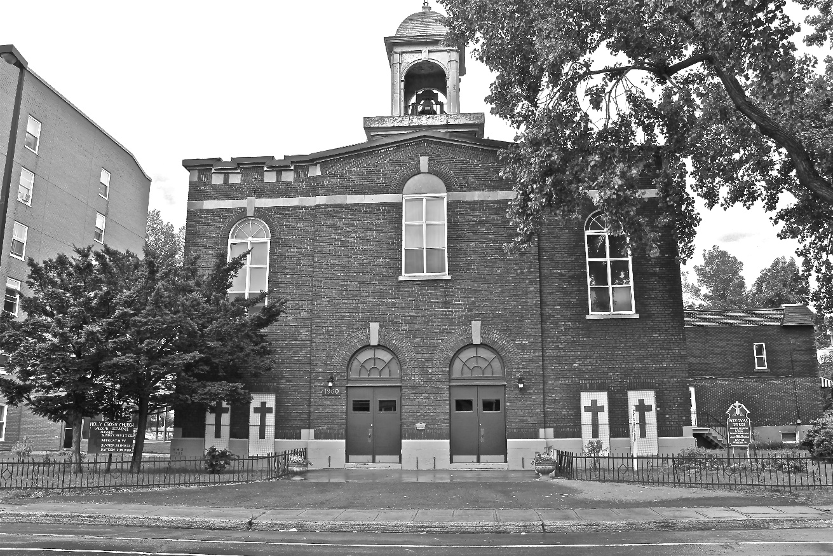

“The cross stands before us in these days as an eloquent symbol of God’s love for humanity.”
John Paul II

*9am mass is cancelled until further notice

