Pastoral Staff  Fr. Raymond LaFontaine E.V.  Parochial Administrator  Parish Wardens  Aldo Piccioni  514-769-6369  Divya Siby  514-655-6442 | Holy Cross Parish  1960 Jolicoeur street  Montreal, Quebec H4E 1X5  TEL.: 514-769-2717; FAX: 514-769-8852  Email: holycross.montreal60@gmail.com  Parish Office Hours  Wednesdays |  | Parish Wardens  Genfu Sun  514-568-9866  James Potter  514-733-7016  Norlita Galdones  514-733-7016  Ruby Johnson  514-761-3242
The month of April is dedicated to the Holy Spirit and the Eucharist
The saint for April 16th, is Saint Bernadette.
Sunday April 16th, 2023 is the second Sunday of Easter or the Sunday of divine mercy.

THOUGHT OF THE DAY:

“Just one small positive thought in the morning, can change your whole day.”
Dalai Lama
POPE’S MONTHLY PRAYER INTENTION FOR APRIL 2023:
FOR A CULTURE OF PEACE AND NONVIOLENCE
“We pray for the spread of peace and nonviolence, by decreasing the use of weapons by state and citizens”
The Grapevine is a good informative weekly Newsletter to keep you up to date on what is happening within and around our communities.
thegrapevine@diocesemontreal.org
IMPORTANT NOTICE:
Please sit in the pews with blue tape.
Please keep social distance when you are receiving communion.
Please use hand sanitizer on entering and leaving the church. Thank you!
NOTE:
The Notre-Dame-des-Neiges cemetery will be closed for the next few days.
Cleanup from ice storm is taking place.
INFO: 514-841-7990
SAVE THE DATE:
April 30th, 2023 / World Day of Prayer for vocations
VOLUNTEERS NEEDED:
We are searching for someone to takeover the input of our parish bulletin. Please contact the office.
Thank you
SUNDAY COLLECTION
April 9th, 2023 |  | Amount in CAD
TOTAL |  | $599.50
Thank you for your generosity!
Please remember to write your name on your church support envelope.
PLEASE TURN OFF CELL PHONES
THIS CHURCH MAY BE USED AS A RESTING VISITATION LOCALE FOR YOUR DEARLY
DEPARTED.
IF YOU DESIRE THIS SERVICE, PLEASE CALL 514-769-2717

“Prayer makes us understand our vulnerability”, but the Lord “gives us strength and closeness”
MASS INTENTIONS
April 16th, 2023  FRANCES HAMEL COCHRANE  Req’d by The Family  KATHLEEN SENCHEY  Req’d by The Senchey Family | April 23rd, 2023  The Parishioners of Holy Cross
Pope Francis

Holy Cross Parish Church
1960 Jolicoeur Street
Montreal, QC H4E 1X5
Tel: 514-769-2717
holycross.montreal60@gmail.com
https://holycrossmontreal.weebly.com/
Facebook: HOLY CROSS PARISH MONTREAL
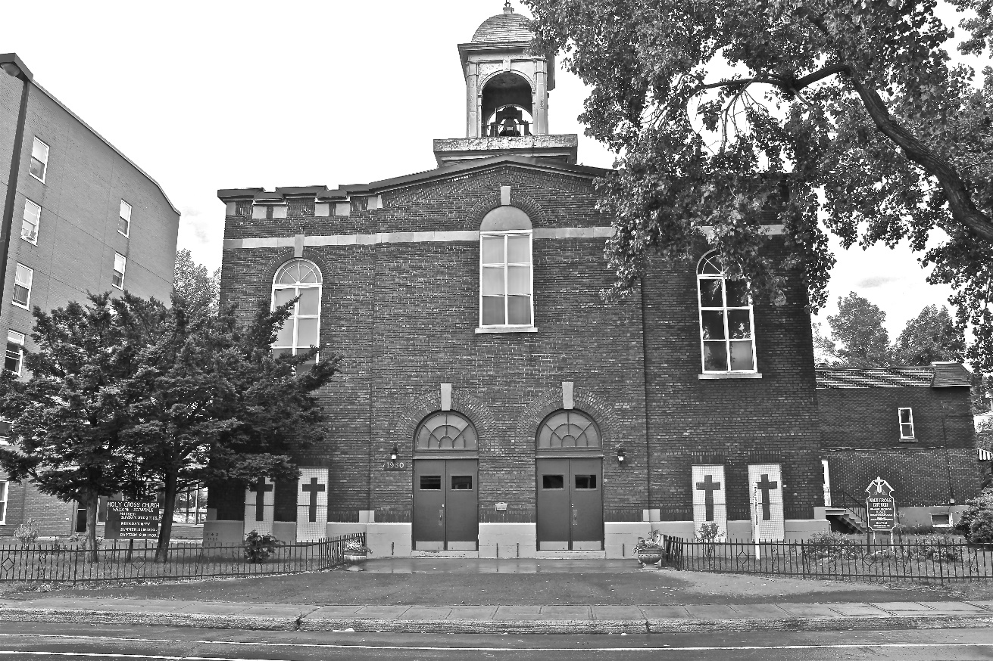
Holy Cross Parish Church
“The cross stands before us in these days as an eloquent symbol of God’s love for humanity.”
John Paul II

*9am mass is cancelled until further notice

