Pastoral Staff  Fr. Raymond LaFontaine E.V.  Parochial Administrator  Parish Wardens  Aldo Piccioni  514-769-6369  Divya Siby  514-655-6442 | Holy Cross Parish  1960 Jolicoeur street  Montreal, Quebec H4E 1X5  TEL.: 514-769-2717; FAX: 514-769-8852  Email: holycross.montreal60@gmail.com  Parish Office Hours  Wednesdays |  | Parish Wardens  Genfu Sun  514-568-9866  James Potter  514-733-7016  Norlita Galdones  514-733-7016  Ruby Johnson  514-761-3242
Sunday September 24th, 2023 is dedicated to The Blessed Virgin Mary of Mercy
September is the month of Our Lady of Sorrows.
The Seven Sorrows of Mary are:
1: The prophecy of Simeon (Luke 2:25-35)
2: The Flight into Egypt (Mathew 2:13-15)
3: Loss of the Child Jesus for three days (Luke 2:41-50)
4: Mary meets Jesus on His way to Calvary (Luke 23:27-31)
5: The Crucifixion and death of Jesus (John 19:25-30)
6: The Body of Jesus being taken from the cross (Psalm 130. Luke 23:50-54)
7: The burial of Jesus (Isaiah 53:8, Luke 23:50-56, John 19:38-42)

THOUGHT OF THE DAY:
“Thousands of candles can be ignited from a single candle, and the candle will not be shortened. Happiness never decreases by being shared.”
Buddha
The Grapevine is a good informative weekly Newsletter to keep you up to date on what is happening within and around our communities.

thegrapevine@diocesemontreal.org
POPE’S MONTHLY PRAYER INTENTION FOR THE MONTH OF SEPTEMBER 2023:
FOR PEOPLE LIVING ON THE MARGINS
“We pray for those persons living on the margins of society, in inhumane life conditions; may they not be overlooked by institutions and never considered of lesser importance.”
IMPORTANT NOTICE:
Please sit in the pews with blue tape.
Please keep social distance when you are receiving communion.
Please use hand sanitizer on entering and leaving the church. Thank you!
REMINDER:  “CELEBRATE OUR LORD”  Please join us at 8:00PM on Sundays at ST. WILLIBRORD PARISH  351 WILLIBRORD ST  VERDUN, QC. |  | Save the Date:  Luncheon on October 29th, 2023 / Tickets $15.00  See notice on Bulletin Board
VOLUNTEERS NEEDED:
We are searching for someone to takeover the input of our parish bulletin. Please contact the office.
Please note that we are in need of someone to take care of the candles in the church.
(Altar candles and vigil candles)
Contact the office if you are able to help.
Thank you!
IMPORTANT DATES IN SEPTEMBER 2023
Monday September 24th, 2023 – 109th World Day of Migrants and Refugees.
Sunday September 26th, 2023 – St John de Brebeuf and St Issac Joques, Priests and Companions martyrs the Feast.
Thank you!
SUNDAY COLLECTION
September 17th, 2023 |  | Amount in CAD
TOTAL |  | $ 817.83
Thank you for your generosity!
Please remember to write your name on your church support envelope.
PLEASE TURN OFF CELL PHONES
THIS CHURCH MAY BE USED AS A RESTING VISITATION LOCALE FOR YOUR DEARLY
DEPARTED.
IF YOU DESIRE THIS SERVICE, PLEASE CALL 514-769-2717
“Prayer makes us understand our vulnerability”, but the Lord “gives us strength and closeness”
MASS INTENTIONS
September 24th, 2023  KATHLEEN SENCHEY  Req’d by Ray Senchey | October 1st, 2023  RAYMONDE FOURNIER  Req’d by The Fournier Family
Pope Francis

Holy Cross Parish Church
1960 Jolicoeur Street
Montreal, QC H4E 1X5
Tel: 514-769-2717
holycross.montreal60@gmail.com
https://holycrossmontreal.weebly.com/
Facebook: HOLY CROSS PARISH MONTREAL
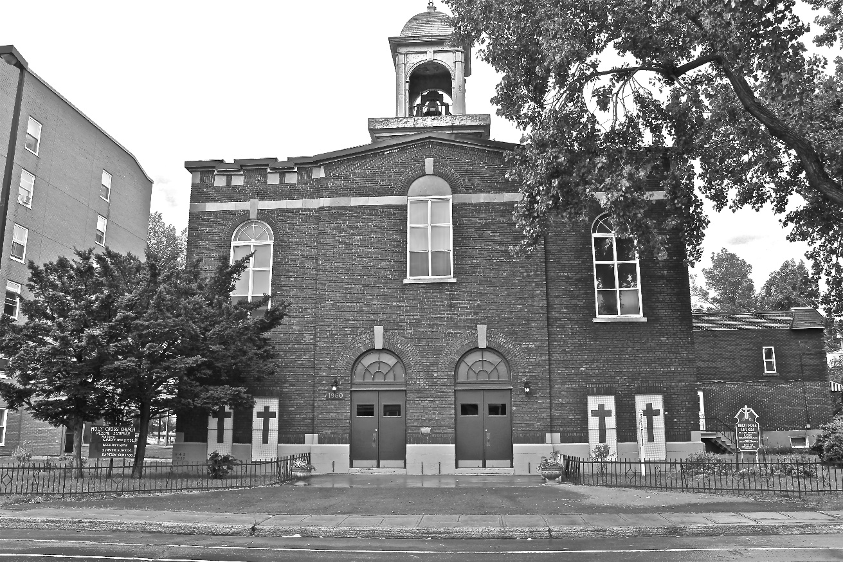
Holy Cross Parish Church
“The cross stands before us in these days as an eloquent symbol of God’s love for humanity.”
John Paul II

*9am mass is cancelled until further notice

