Pastoral Staff  Fr. Raymond LaFontaine E.V.  Parochial Administrator  Parish Wardens  Aldo Piccioni  514-769-6369  Divya Siby  514-655-6442 | Holy Cross Parish  1960 Jolicoeur street  Montreal, Quebec H4E 1X5  TEL.: 514-769-2717; FAX: 514-769-8852  Email: holycross.montreal60@gmail.com  Parish Office Hours  Wednesdays |  | Parish Wardens  Genfu Sun  514-568-9866  James Potter  514-733-7016  Norlita Galdones  514-733-7016  Ruby Johnson  514-761-3242
The saint for October 29th, 2023 is Saint Narcisaus
October is the month of the Most Holy Rosary
October is also Clergy Appreciation Month

THOUGHT OF THE DAY:
“Happiness is the only thing that multiplies when you share it.”
Albert Schwietzer
The Grapevine is a good informative weekly Newsletter to keep you up to date on what is happening within and around our communities.

thegrapevine@diocesemontreal.org
POPE’S MONTHLY PRAYER INTENTION FOR THE MONTH OF OCTOBER 2023:
FOR THE SYNOD
“We pray for the Church, that she may adopt listening and dialogue as a lifestyle at every level, and allow herself to be guided by the Holy Spirit towards the peripheries of the World.”
IMPORTANT NOTICE:
Please sit in the pews with blue tape.
Please keep social distance when you are receiving communion.
Please use hand sanitizer on entering and leaving the church. Thank you!
REMINDER:  “CELEBRATE OUR LORD”  Please join us at 8:00PM on Sundays at ST. WILLIBRORD PARISH  351 WILLIBRORD ST  VERDUN, QC. |  | Save the Date:  Luncheon on October 29th, 2023 / Tickets $15.00  See notice on Bulletin Board
WHAT’S HAPPENING:
Conference: Come Forth! The Promise of Jesus’ Greatest Miracle

November 11th from 7:00 pm to 8:30 pm (zoom)

https://diocesemontreal.org/en/lets-connect/coming-events/come-forth-promise-jesus-greatest-miracle
Saint Micheal’s and Saint Anthony’s parish invites you to their fall bazaar.

558 St Urbain Street, Montreal, Qc, H2T 2X3
Saturday - Sunday October 28th - 29th
10:00 am - 4:00 pm

Enjoy a Polish bazaar and tasty lunch with dessert prepared by our volunteers.
Many interesting and practical stuff, books, clothes and other items are waiting for you.
Mass for peace @5:00 pm at Mary Queen of The World Basilica

Thank you!
SUNDAY COLLECTION
October 22nd, 2023 |  | Amount in CAD
TOTAL |  | $ 439.50
Thank you for your generosity!
Please remember to write your name on your church support envelope.
PLEASE TURN OFF CELL PHONES
Holy Cross Parish Church
1960 Jolicoeur Street
Montreal, QC H4E 1X5
Tel: 514-769-2717
holycross.montreal60@gmail.com
https://holycrossmontreal.weebly.com/
Facebook: HOLY CROSS PARISH MONTREAL
“Prayer makes us understand our vulnerability”, but the Lord “gives us strength and closeness”
MASS INTENTIONS
October 29th, 2023  DECEASED MEMBERS OF THE MINIWGAT AND RAMOS FAMILY  Req’d by Grace Ramos  RAYMONDE FOURNIER  Req’d by The Fournier Family  KATHLEEN SENCHEY  Req’d by Raymond Senchey  THE SOULS OF THE HANDINERO FAMILY  Req’d by The Handinero Family  MR AND MRS HIGINO GALDONES  Req’d by Norlita Galdones  THE SOUL OF SIMPLICIA GALDONES  Req’d by Norlita Galdones  DOLORES AND JUAN FERRER AND DIGNA BORJA  Req’d by Elsie Ferrer  DOLORES AND JEAN MARIE PARE  Req’d by The Piccioni Family and The Chen Family  ENRICO AND SANTINA PICCIONI  Req’d by The Piccioni Family and The Chen Family | November 5th, 2023  RAYMONDE FOURNIER  Req’d by The Fournier Family
Pope Francis
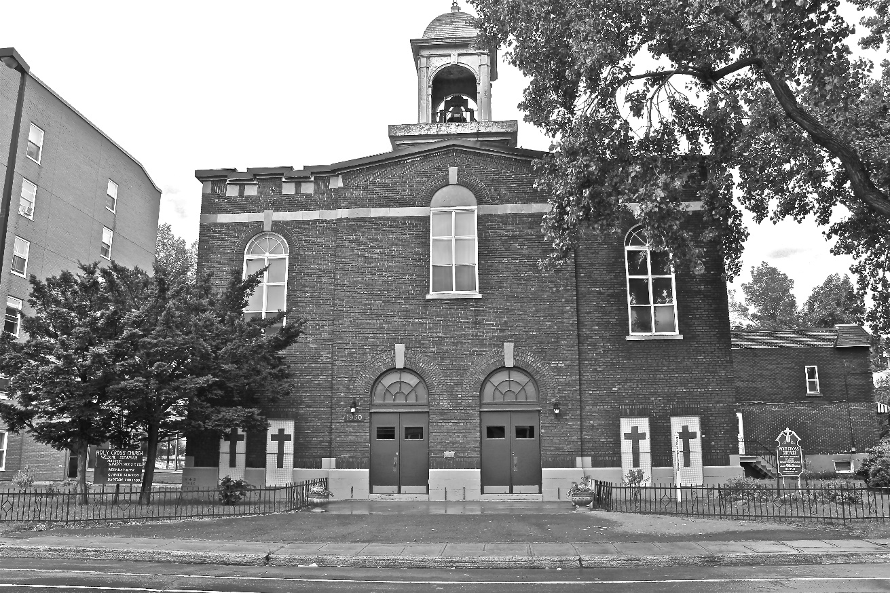
Holy Cross Parish Church
“The cross stands before us in these days as an eloquent symbol of God’s love for humanity.”
John Paul II

*9am mass is cancelled until further notice

