Pastoral Staff  Fr. Raymond LaFontaine E.V.  Parochial Administrator  Parish Wardens  James Potter  514-733-7016 | Holy Cross Parish  1960 Jolicoeur street  Montreal, Quebec H4E 1X5  TEL.: 514-769-2717; FAX: 514-769-8852  Email: holycross.montreal60@gmail.com  Parish Office Hours  Wednesdays |  | Parish Wardens  Norlita Galdones  514-733-7016  Teresa Gomes  514-291-2591  Ruby Johnson  514-761-3242
The month of November is dedicated to THE SOULS IN PURGATORY.
The Saint for November 27th, 2022 is Saint Auxilius Of Antioch.
Today is the First Sunday of Advent.
The first purple candle also called the Prophet’s candle, symbolizing HOPE will be lit on the Advent Wreath.

THOUGHT OF THE DAY:

“Don’t cry because it is over, smile because it happened.”

Dr. Seuss
POPE’S MONTHLY PRAYER INTENTION FOR NOVEMBER 2022:
FOR CHILDREN WHO SUFFER:
“We pray for children who are suffering, especially those who are homeless, orphans, and victims of war, may they be guaranteed access to education and the opportunity to experience family affection.”
NOTE:
Church support envelopes can be collected at the office.
Missals for 2023 can be purchased at the office. ($7.00 exact change)
Thank you!
NOTE:
There is an Advent calendar included with Today’s bulletin.
The Grapevine is a good informative weekly Newsletter to keep you up to date on what is happening within and around our communities.
thegrapevine@diocesemontreal.org
IMPORTANT NOTICE:
Please sit in the pews with yellow tape.
Please keep social distance when you are receiving communion.
Please use hand sanitizer on entering and leaving the church. Thank you!
TIME TO GET THOSE TICKETS!
“LIFE IS WONDERFUL” CHRISTMAS CONCERT:
Hosted by Pillars Trust to mark the end of its 50th Anniversary Year. Tuesday, December 6th in the former Grand Séminaire de Montréal, 2065 Sherbrooke St. West. Montréal.
DOORS OPEN: 7:00PM, CONCERT in the beautiful chapel 7:30 – 9:00PM
Will feature: Choirs from The McGill Newman Centre; The Sacred Heart School; St. Ignatius Music Ministry; The Bernadette Short Irish Dancers; a Wine and Cheese Reception and more.
Cost: In Person: $30.00, Students $20.00, Virtual: $20.00
Tickets: Reserve Online at www.pillarstrust.org or Purchase at the door.
For more information call: Carol McCormick (514) 386-8082
WHAT’S HAPPENING:
We will be having a Christmas Luncheon on Dec 18th, 2022 in the Church hall.
Tickets are $20.00. Please purchase your tickets from Norlita. Tickets will not be sold at the door.
SUNDAY COLLECTION
November 20th, 2022 |  | Amount in CAD
Church Support Envelopes |  | $292.00
Basket |  | $34.00
Masses |  | $15.00
Donations |  | $300.00
Honorarium |  | (minus) $5.00
TOTAL |  | $636.00
Thank you for your generosity! Please remember to write your name on your church support envelope.
Please turn off cell phones.
PLEASE REMEMBER THE CHURCH IN YOUR WILL
THIS CHURCH MAY BE USED AS A RESTING VISITATION LOCALE FOR YOUR DEARLY DEPARTED.
IF YOU DESIRE THIS SERVICE, PLEASE CALL 514-769-2717

“Prayer makes us understand our vulnerability”, but the Lord “gives us strength and closeness”
MASS INTENTIONS
November 27th, 2022  IN THANKSGIVING Req’d by Ada Hainey  KATHLEEN SENCHEY Req’d by Raymond Senchey  MABEL FITZGERALD Req’d by Marilyn and Jim Coleman | December 4th, 2022  ENRICO PICCIONI Req’d by His Family
Pope Francis
Holy Cross Parish Church
1960 Jolicoeur Street
Montreal, QC H4E 1X5
Tel: 514-769-2717
holycross.montreal60@gmail.com
https:/Holycrossmontreal.weebly.com
Facebook: HOLY CROSS PARISH MONTREAL
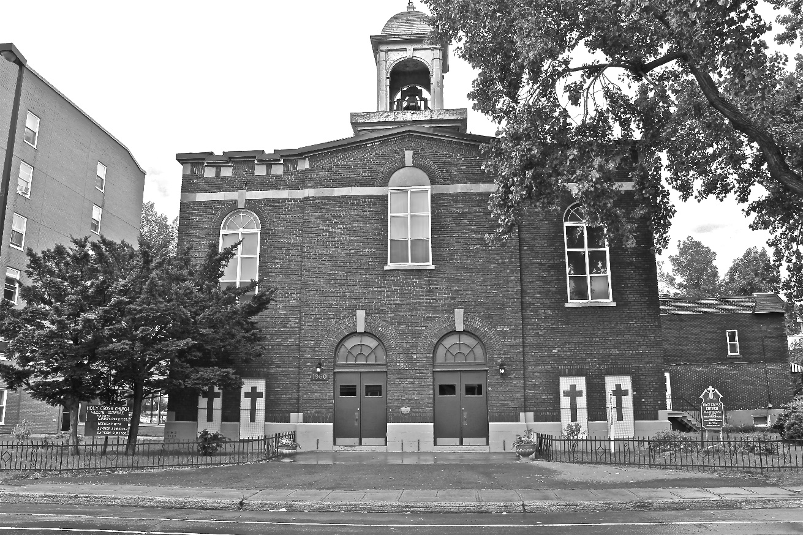
Holy Cross Parish Church
“The cross stands before us in these days as an eloquent symbol of God’s love for humanity.”
John Paul II

*9am mass is cancelled until further notice

