Pastoral Staff  Fr. Raymond LaFontaine E.V.  Parochial Administrator  Parish Wardens  James Potter  514-733-7016 | Holy Cross Parish  1960 Jolicoeur street  Montreal, Quebec H4E 1X5  TEL.: 514-769-2717; FAX: 514-769-8852  Email: holycross.montreal60@gmail.com  Parish Office Hours  Wednesdays |  | Parish Wardens  Norlita Galdones  514-733-7016  Teresa Gomes  514-291-2591  Ruby Johnson  514-761-3242
The month of November is dedicated to THE SOULS IN PURGATORY.
The Saint for November 20th, 2022 is St Edmund The Martyr.
Today, we celebrate the feast of Christ The King.

THOUGHT OF THE DAY:

“Everything in your life is dedicated by you. Be who you want to be. Think positive thoughts and great things will happen to you.”

Anonymous
POPE’S MONTHLY PRAYER INTENTION FOR NOVEMBER 2022:
FOR CHILDREN WHO SUFFER:
“We pray for children who are suffering, especially those who are homeless, orphans, and victims of war, may they be guaranteed access to education and the opportunity to experience family affection.”
CHURCH SUPPORT ENVELOPES:
Church support envelopes for 2023 can be collected at the back of the church starting October 30th, 2022. If you do not find your number, please come to the office.
Missals 2022-2023 may be purchased after Sunday Mass at the office. Please have exact change of $7.00 Thank you!
The Grapevine is a good informative weekly Newsletter to keep you up to date on what is happening within and around our communities.
thegrapevine@diocesemontreal.org
IMPORTANT NOTICE:
Please sit in the pews with yellow tape.
Please keep social distance when you are receiving communion.
Please use hand sanitizer on entering and leaving the church. Thank you!
TIME TO GET THOSE TICKETS!
“LIFE IS WONDERFUL” CHRISTMAS CONCERT:
Hosted by Pillars Trust to mark the end of his 50th Anniversary Year. Tuesday, December 6th in the former Grand Séminaire de Montréal, 2065 Sherbrooke St. West. Montréal.
DOORS OPEN: 7:00PM, CONCERT in the beautiful chapel 7:30 – 9:00PM
Will feature: Choirs from The McGill Newman Centre; The Sacred Heart School; St. Ignatius Music Ministry; The Bernadette Short Irish Dancers; a Wine and Cheese Reception and more.
Cost: In Person: $30.00, Students $20.00, Virtual: $20.00
Tickets: Reserve Online at www.pillarstrust.org or Purchase at the door.
For more information call: Carol McCormick (514) 386-8082
BAPTISM:
Correction for baptism on Nov 6th, 2022. Arya is the daughter of Tara McBrine and Michael Hachey.
SUNDAY COLLECTION
November 13th, 2022 |  | Amount in CAD
Church Support Envelopes |  | $305.00
Basket |  | $29.25
Masses |  | $30.00
Vigil Lights |  | $35.40
Missals |  | $70.00
Donations |  | $300.00
TOTAL |  | $769.65
Thank you for your generosity! Please remember to write your name on your church support envelope.
Please turn off cell phones.
PLEASE REMEMBER THE CHURCH IN YOUR WILL
THIS CHURCH MAY BE USED AS A RESTING VISITATION LOCALE FOR YOUR DEARLY DEPARTED.
IF YOU DESIRE THIS SERVICE, PLEASE CALL 514-769-2717

“Prayer makes us understand our vulnerability”, but the Lord “gives us strength and closeness”
MASS INTENTIONS
November 20th, 2022  EVELYNE GILCHRIST Req’d by Ray and Raye  KATHLEEN SENCHEY Req’d by Raymond Senchey | November 27th, 2022  IN THANKSGIVING Req’d by Ada Hainey
Pope Francis
Holy Cross Parish Church
1960 Jolicoeur Street
Montreal, QC H4E 1X5
Tel: 514-769-2717
holycross.montreal60@gmail.com
https:/Holycrossmontreal.weebly.com
Facebook: HOLY CROSS PARISH MONTREAL
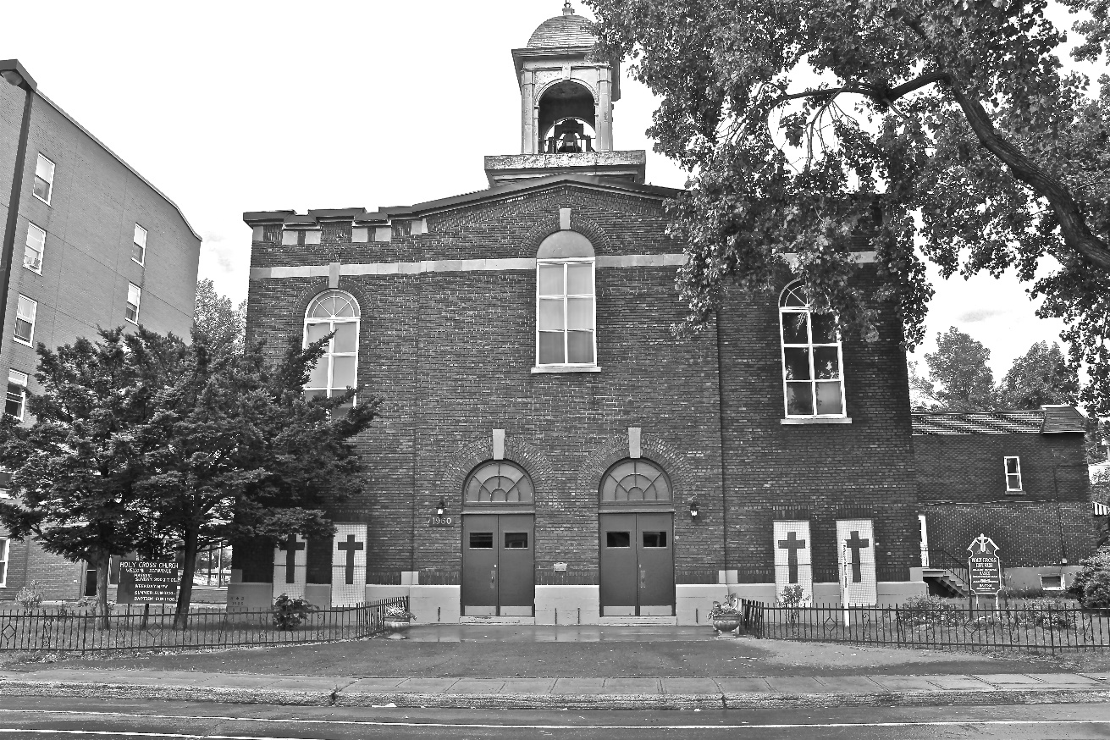
Holy Cross Parish Church
“The cross stands before us in these days as an eloquent symbol of God’s love for humanity.”
John Paul II

*9am mass is cancelled until further notice

