Pastoral Staff  Fr. Raymond LaFontaine E.V.  Parochial Administrator  Parish Office Hours  Wednesdays | Holy Cross Parish  1960 Jolicoeur street  Montreal, Quebec H4E 1X5  TEL.: 514-769-2717; FAX: 514-769-8852  Email: holycross.montreal60@gmail.com  https://holycrossmontreal.weebly.com/  Facebook: HOLY CROSS PARISH MONTREAL |  | Parish Wardens  Divya Siby: 514-655-6442  James Potter: 514-733-7016  Norlita Galdones: 514-733-7016  Ruby Johnson: 514-761-3242  Aldo Piccioni: 514-769-6369  Francis Van Oordt: 438-226-2126

MONTH OF MAY 2024

2024 has been marked as the “Year of Prayer” by Pope Francis.

The Easter season ends on Pentecost, May 20th, which is represented by the liturgical color white — the color of light, a symbol of joy, purity and innocence.
SIXTH SUNDAY OF EASTER – MAY 5th,2024
On May 5th, the Catholic Church celebrates the liturgical memorial of Saint Hilary of Arles, a fifth-century bishop who gave up wealth and privilege in favor of austerity and sacrifice for the sake of the Church. Hilary helped to establish monasteries in his diocese, and strengthened the discipline and orthodoxy of the local Church through a series of councils. He sold Church property in order to pay the ransoms of those who had been kidnapped, and is said to have worked miracles during his lifetime.

Mass Readings for the sixth Sunday of Easter, Cycle B:

The First Reading is taken from the Acts of the Apostles 10:25-26, 34-35, 44-48 and describes the reception of the first Gentiles into the Christian Church.

The Second Reading is from the First Letter of John 4:7-10 in which he urges us to love one another, for we are sons of God whose very essence is love.

The Gospel is from St. John 15:9-17. It is only a few weeks since Good Friday when we commemorated the agonizing death of Christ on Mount Calvary. This was an excruciating, shameful death even for hardened criminals who deserved it. But for our loving Savior, the innocent lamb of God, one who had never offended God or neighbor, it was something of which the whole human race should be ashamed forever. What caused Christ that torment and death on the cross was our sins, the sins of all mankind and not the spite and hatred of his Jewish opponents, who were only instruments in the tragedy. Atonement had to be made to God for the sins of the world, so that men could reach the eternal inheritance which the incarnation made available to them.
POPE’S MONTHLY PRAYER INTENTION FOR THE MONTH OF MAY 2024:
FOR THE FORMATIONS OF REGILIOUS AND SEMINARIANS:
“We pray that religious women and men, and seminarians, grow in their own vocations through their human, pastoral, spiritual and community formation, leading them to be credible witnesses to the Gospel.”
REMINDER:  “CELEBRATE OUR LORD”  Please join us at 8:00PM on Sundays at ST. WILLIBRORD PARISH  351 WILLIBRORD ST, VERDUN, QC. |  | NOTE:  Please remember to write your name on your church support envelope.  There are only a few Sunday missals left for sale. Hurry up and get yours. The price is $7.00. Exact change is required please!
Saint Joseph's Oratory of Mount Royal, Montreal, Saturday May 11th, 2024: There will be conferences by John Sullivan III, International Coordinator of The Flame of Love of the Immaculate Heart of Mary. The Schedule for the day is noted on the bulletin board near the stairs. Donation for enter : $10,00.
National Family and Life Week (NFLW): We are very pleased to share with you the CCCB Pastoral Toolkit for the upcoming National Family and Life Week (NFLW), which will take place from 13th – 19th May 2024. The theme of NFLW 2024 is “Love hopes all things”. The NFLW2024 Toolkit is now available on the CCCB website.
First World Children's Day: For the first time, a World Children's Day will be held in Rome on May 25th and 26th, 2024, in the presence of the Pope and children from all over the world. The theme will be: "Behold, I make all things new". Prepare for the event, share your desires and hopes for a better world, awaiting the meeting with Pope Francis. Submit your drawings!
26th National March for Life: On May 9th join thousands of students, families and Canadians from all walks of life as we gather on Parliament Hill in Ottawa for the 2024 National March for Life. Our theme for the 2024 National March for Life is “I Will Never Forget You.” (Isaiah 49:15-16)
2024 SHERLOCK LECTURE: "WALKING TOGETHER" on May 29th: Join the Newman Centre of McGill University, Canadian Catholic Campus Ministry, and The Congrégation de Notre-Dame for the lecture, "Walking Together: How are we learning to become a Synodal Church?" Keynote speaker is Canadian Synod Delegate Linda Staudt. The lecture will be in English, but a simultaneous French.
SUNDAY COLLECTION
April 28th, 2024 |  | Amount in CAD
TOTAL |  | 462.75$
Thank you for your generosity!
MASS INTENTIONS
Please note that a mass intention is 15$ per person
May 5th, 2024  THE PARISHIONERS OF HOLY CROSS | May 12th, 2024  THE PARISHIONERS OF HOLY CROSS
“Prayer makes us understand our vulnerability”, but the Lord “gives us strength and closeness” Pope Francis
THIS CHURCH MAY BE USED AS A RESTING VISITATION LOCALE FOR YOUR DEARLY
DEPARTED.
IF YOU DESIRE THIS SERVICE, PLEASE CALL 514-769-2717

Holy Cross Parish Church
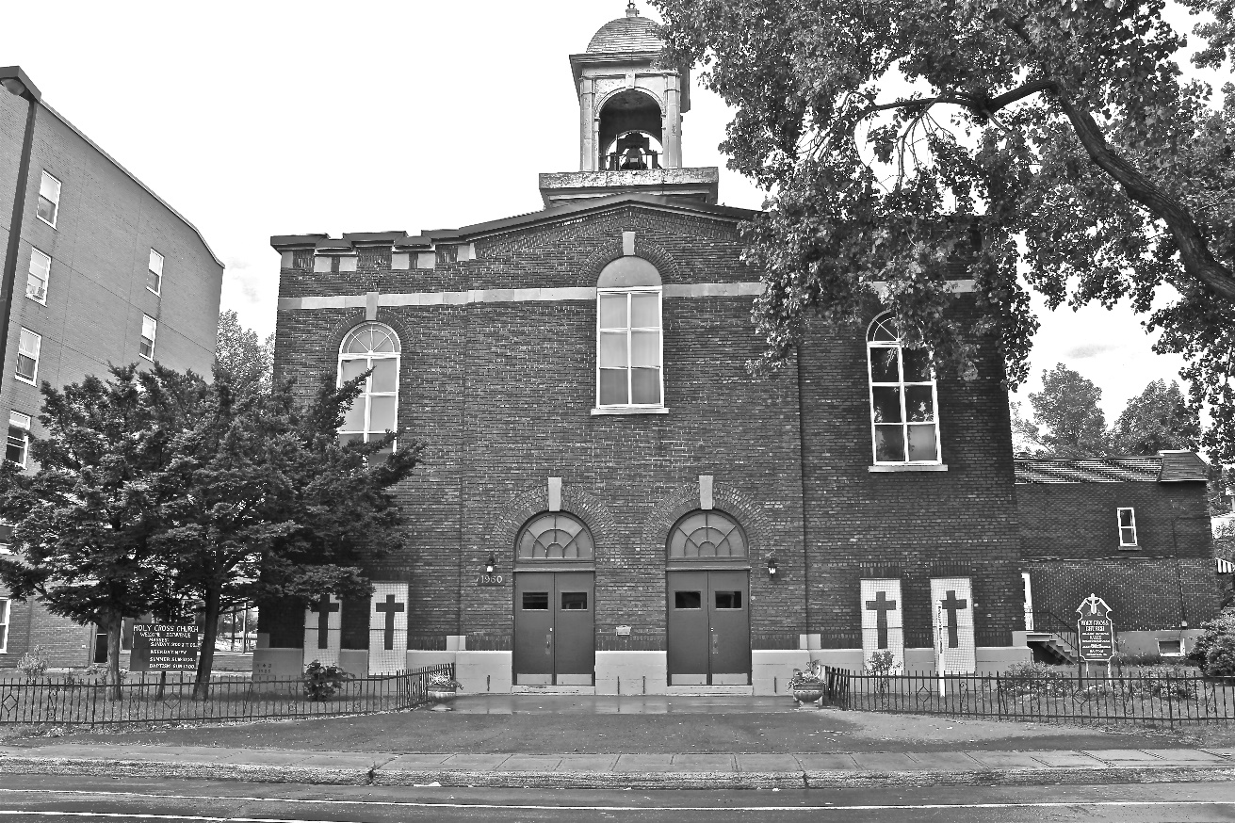

“The cross stands before us in these days as an eloquent symbol of God’s love for humanity.”
John Paul II

*9am mass is cancelled until further notice

