Pastoral Staff  Fr. Raymond LaFontaine E.V.  Parochial Administrator  Parish Wardens  Aldo Piccioni  514-769-6369  Divya Siby  514-655-6442 | Holy Cross Parish  1960 Jolicoeur street  Montreal, Quebec H4E 1X5  TEL.: 514-769-2717; FAX: 514-769-8852  Email: holycross.montreal60@gmail.com  Parish Office Hours  Wednesdays |  | Parish Wardens  Genfu Sun  514-568-9866  James Potter  514-733-7016  Norlita Galdones  514-733-7016  Ruby Johnson  514-761-3242
The month of March is dedicated to Saint Joseph; Celebrated on March 19th, 2023.
The Saint for Sunday March 5th, 2023 is Saint Joseph of the Cross.
Sunday March 5th, 2023 is the Second Sunday of Lent.
PALM SUNDAY IS APRIL 2ND, 2023
HOLY WEEK IS APRIL 2ND - APRIL 8TH, 2023
HOLY THURSDAY IS APRIL 6TH, 2023
GOOD FRIDAY IS APRIL 7TH, 2023
EASTER SUNDAY IS APRIL 9TH, 2023

THOUGHT OF THE DAY:

“We have so much to learn about prayer, fasting and intercession.”

PHILIPPIANS 4:6-7

ISAIAH 58: 6-8
POPE’S MONTHLY PRAYER INTENTION FOR MARCH 2023:
FOR VICTIMS OF ABUSE
“We pray for those who have suffered harm from members of the church; may they find within the church herself a concrete response to their pain and suffering”
The Grapevine is a good informative weekly Newsletter to keep you up to date on what is happening within and around our communities.
thegrapevine@diocesemontreal.org
IMPORTANT NOTICE:
Please sit in the pews with blue tape.
Please keep social distance when you are receiving communion.
Please use hand sanitizer on entering and leaving the church.
Thank you!
VOLUNTEERS NEEDED:
We are looking for parishioners to help out with various tasks within the church. There is a clip board on the table at the back of the church. We require help with maintenance of the candles, church linens, etc.
There are other areas where help is also needed. Please consider helping with your time! Thank you!
WHAT’S HAPENNING:
“THE CHOSEN”
Fr Raymond is hosting ZOOM sessions to discuss this series.
It gives the New Testament a human feel for us to understand.
The sessions will be on Friday evenings from 7:00PM-9:3PM on March 10th, 17th, 24th, and 31st. If you would like to participate contact:
parishvitality@diocesemontreal.org
SUNDAY COLLECTION
February 26th, 2023 |  | Amount in CAD
Church Support Envelopes |  | $257.00
Charities |  | $78.00
Basket |  | $75.25
Masses |  | $30.00
Table Rentals |  | $300.00
TOTAL |  | $740.25
Thank you for your generosity!
Please remember to write your name on your church support envelope.
PLEASE TURN OFF CELL PHONES
PLEASE REMEMBER THE CHURCH IN YOUR WILL
THIS CHURCH MAY BE USED AS A RESTING VISITATION LOCALE FOR YOUR DEARLY
DEPARTED.
IF YOU DESIRE THIS SERVICE, PLEASE CALL 514-769-2717

“Prayer makes us understand our vulnerability”, but the Lord “gives us strength and closeness”
MASS INTENTIONS
March 5th, 2023  KATHLEEN SENCHEY  Req’d by The Senchey Family  HELEN AND MARC PANERIO  Req’d byFelix Panerio | March 12th, 2023  EDITH CAVANAUGH  Req’d by Marilyn Coleman
Pope Francis

Holy Cross Parish Church
1960 Jolicoeur Street
Montreal, QC H4E 1X5
Tel: 514-769-2717
holycross.montreal60@gmail.com
https://holycrossmontreal.weebly.com/
Facebook: HOLY CROSS PARISH MONTREAL
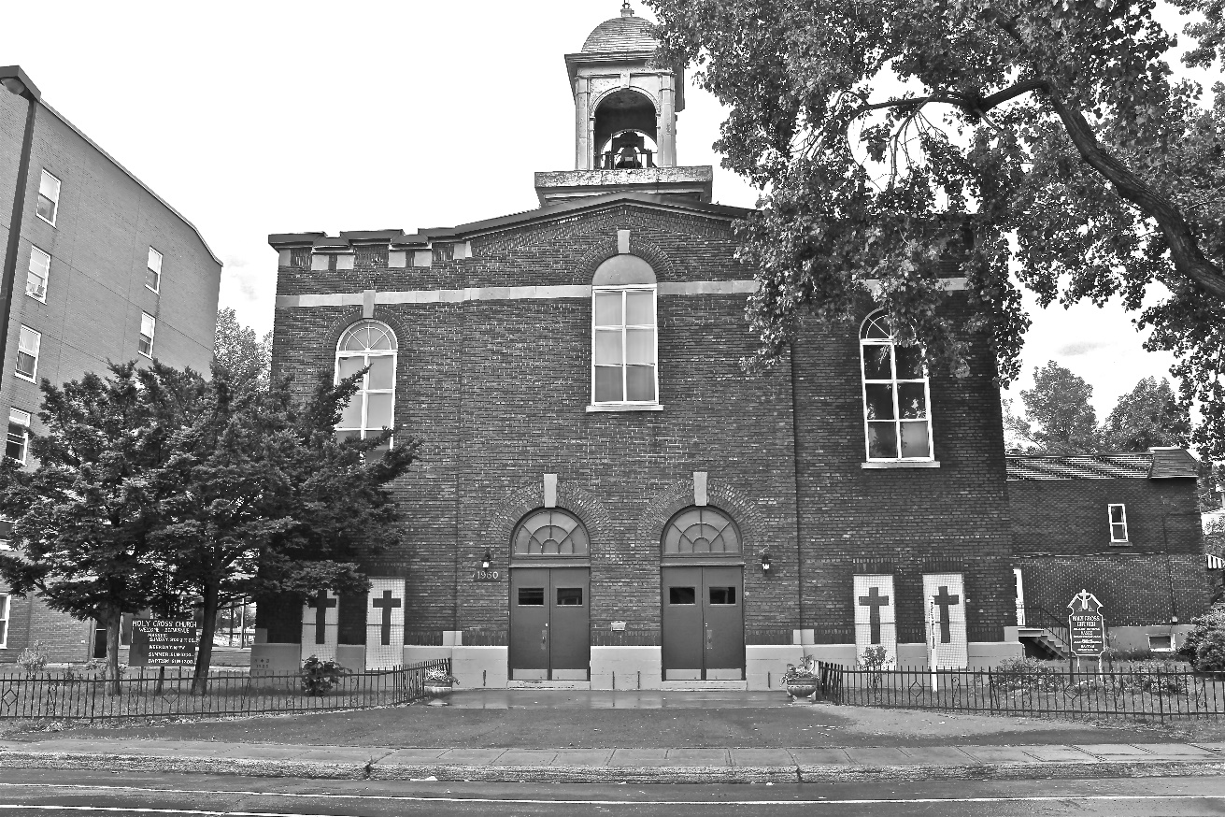
Holy Cross Parish Church
“The cross stands before us in these days as an eloquent symbol of God’s love for humanity.”
John Paul II

*9am mass is cancelled until further notice

