Pastoral Staff  Fr. Raymond LaFontaine E.V.  Parochial Administrator  Parish Office Hours  Wednesdays |  | Holy Cross Parish  1960 Jolicoeur street  Montreal, Quebec H4E 1X5  TEL.: 514-769-2717; FAX: 514-769-8852  Email: holycross.montreal60@gmail.com  https://holycrossmontreal.weebly.com/  Facebook: HOLY CROSS PARISH MONTREAL |  | Parish Wardens  Divya Siby: 514-655-6442  James Potter: 514-733-7016  Norlita Galdones: 514-733-7016  Ruby Johnson: 514-761-3242  Aldo Piccioni: 514-769-6369  Francis Van Oordt: 438-226-2126

MONTH OF MARCH 2024

2024 has been marked as the “Year of Prayer” by Pope Francis.

The month of March is dedicated to St. Joseph. The entire month falls during the liturgical season of Lent which is represented by the liturgical color purple — a symbol of penance, mortification and the sorrow of a contrite heart.
THIRD SUNDAY OF LENT- MARCH 3rd,2024
On March 3rd, the Church celebrates the Feast Day for Saint Katharine Drexel, an American heiress, philanthropist, religious sister and educator. She was the second person born in what is now the United States to be canonized as a saint and the first one born a U.S. citizen.

Mass Readings for the third Sunday of lent, Cycle B:

The First Reading is taken from the Book of Exodus 20:1-17. When God had freed the Chosen People from the slavery of Egypt, He led them to Mount Sinai. There he made a Covenant with the Israelites through which He promised to make them His own people, to lead them into the Promised Land, and to protect them from their enemies there. The Israelites were to reverence Him and Him only as their Lord, and they were to obey the moral and cultic laws which He laid down for them.

The Second Reading is from the Letter of St. Paul to the Corinthians 1:22-25. In these few sentences St. Paul gives us the basic reasons which motivated opposition to the gospel message on the part of Jews and Gentiles. The Jews because Christ did not fit the preconceived ideas they had formed of the Messiah and the Gentiles because they looked to philosophy or human "wisdom" for the solution of man's problems.

The Gospel is from St. John 2:13-25. In this passage Jesus points to his own body as the new temple that would bring people into God's presence through his own death and resurrection. The gospel of John uniquely highlights the various Jewish feasts like Passover, Tabernacle and Booths.
 | Consider spending your Lenten season with THE CHOSEN over four Friday evenings Mar. 8th – Mar. 15th, 7 p.m. EST online via Zoom. Register!
 | Lenten Mission begins Monday led by Jesuit Father Kevin Kelly, Director of the Ignatian Spirituality Centre of Montreal, on Monday evening, March 4th from 7 p.m.-8:30 p.m. at St. Luke Parish. Open to all. Livestream available.
Lenten Activities at Mary Queen of the World Cathedral – 2024
1) Way of the Cross: Every Friday during Lent at 5:30 p.m. (after the 5 p.m. mass)

2) Lenten retreat 2024 on the theme "FOLLOWING JESUS": preaching, confessions, solemn vespers, rosary and Sunday mass from 3:30 p.m.: March 3rd and March 10th
 | The Palm Saturday Walk, is making its grand return this year, organized by Mission Jeunesse MTL on March 23rd, 2024, starting at 2:30pm. The blessing of the Palms at the Mount Royal Cross will mark the 100th anniversary of the current cross. Youth, proudly carrying their Palms, will walk through the streets to conclude this memorable event at the Cathedral for the Palm Saturday Mass, animated by the youth and for the youth. This event will mark the beginning of Holy Week, highlighting Jesus’ triumphant entry into Jerusalem and anticipating the crucial moments of the Passion leading up to Good Friday. For more info contact the office.
POPE’S MONTHLY PRAYER INTENTION FOR THE MONTH OF MARCH 2024:
FOR THE MARTYRS OF OUR DAY, WITNESSES TO CHIRST:
“Let us pray to those who risk their lives for the Gospel in various parts of the world might imbue the Church with their courage and missionary drive."
 | LENT SEASON SCHEDULE FOR 2024  PALM SUNDAY IS ON MARCH 24TH AT 11AM  HOLY THURSDAY IS ON MARCH 28TH AT 7PM  GOOD FRIDAY IS ON MARCH 29TH AT 3PM  EASTER SUNDAY IS ON MARCH 31ST AT 11AM |  | NOTE:  Please remember to write your name on your church support envelope.  There are only a few Sunday missals left for sale. Hurry up and get yours. The price is $7.00. Exact change is required please!
NEW CHURCH WARDEN APPOINTED
We would like to welcome Francis Van Oordt as our new warden who was elected by the parishioners on Feb. 25th and will serve his first 3 year-term. Furthermore, our current warden, James Potter, was re-elected for a second 3 year-term. Congratulation to all!
 | SUNDAY COLLECTION
 | February 25th, 2024 |  | Amount in CAD
 | TOTAL |  | 4070.90$
 | Thank you for your generosity!
MASS INTENTIONS
March 3rd, 2024  RAYMONDE FOURNIER  Req’d by the Fournier family | March 10th, 2024  THE PARISHIONERS OF HOLY CROSS
“Prayer makes us understand our vulnerability”, but the Lord “gives us strength and closeness” Pope Francis
THIS CHURCH MAY BE USED AS A RESTING VISITATION LOCALE FOR YOUR DEARLY
DEPARTED.
IF YOU DESIRE THIS SERVICE, PLEASE CALL 514-769-2717

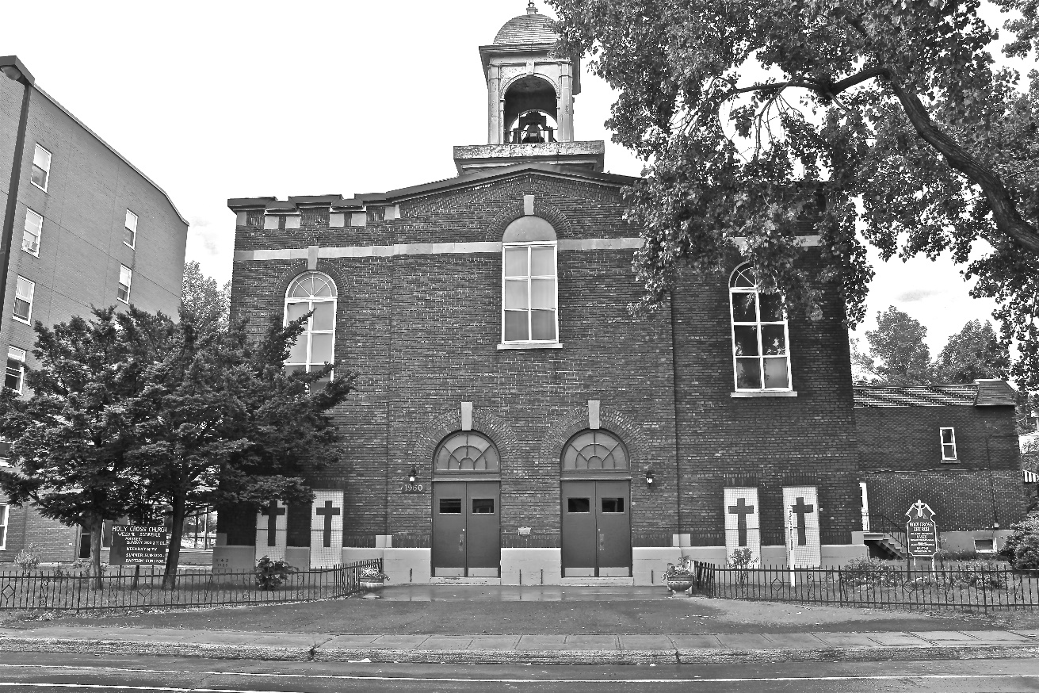
Holy Cross Parish Church
“The cross stands before us in these days as an eloquent symbol of God’s love for humanity.”
John Paul II

*9am mass is cancelled until further notice

