Pastoral Staff  Fr. Raymond LaFontaine E.V.  Parochial Administrator  Parish Wardens  Aldo Piccioni  514-769-6369  Divya Siby  514-655-6442 | Holy Cross Parish  1960 Jolicoeur street  Montreal, Quebec H4E 1X5  TEL.: 514-769-2717; FAX: 514-769-8852  Email: holycross.montreal60@gmail.com  Parish Office Hours  Wednesdays |  | Parish Wardens  Genfu Sun  514-568-9866  James Potter  514-733-7016  Norlita Galdones  514-733-7016  Ruby Johnson  514-761-3242
The month of March is dedicated to Saint Joseph; Celebrated on March 19th, 2023.
Today, March 19th, we celebrate The Feast of Saint Joseph.
Sunday March 19th, 2023 is the Fourth Sunday of Lent.
WHAT TO GIVE UP FOR LENT:  Give up complaining… Focus on gratitude.  Give up pessimism… Become an optimist.  Give up worry… Trust divine providence.  Give up bitterness… Turn to forgiveness.  Give up hatred… Return good for evil.  Give up negativism… Be positive.  Give up anger… Be more patient. |  | WHAT TO GIVE UP FOR LENT:  Give up pettiness… Become mature.  Give up gloom… Enjoy the beauty all around you.  Give up jealousy… Pray for trust.  Give up gossiping… Control your tongue.  Give up sin… Turn to virtue.  Give up giving up… Hang in there!
HOW TO CELEBRATE LENT THIS YEAR:
- Participate in the sacraments
- Help those in need
- Sacrifice something that is hard for you

THOUGHT OF THE DAY:

“During Lent, let us find concrete ways to overcome our indifferences.”

Pope Francis
POPE’S MONTHLY PRAYER INTENTION FOR MARCH 2023:
FOR VICTIMS OF ABUSE
“We pray for those who have suffered harm from members of the church; may they find within the church herself a concrete response to their pain and suffering”
The Grapevine is a good informative weekly Newsletter to keep you up to date on what is happening within and around our communities.
thegrapevine@diocesemontreal.org
IMPORTANT NOTICE:
Please sit in the pews with blue tape.
Please keep social distance when you are receiving communion.
Please use hand sanitizer on entering and leaving the church. Thank you!
WHAT’S HAPENNING: “THE CHOSEN”
Fr Raymond is hosting ZOOM sessions to discuss this series.
It gives the New Testament a human feel for us to understand.
The sessions will be on Friday evenings from 7:00PM-9:3PM on March 10th, 17th, 24th, and 31st. If you would like to participate contact:
parishvitality@diocesemontreal.org
SUNDAY COLLECTION
March 12th, 2023 |  | Amount in CAD
Church Support Envelopes |  | $360.00
Basket |  | $46.60
Masses |  | $15.00
Charities |  | $5.00
Honorarium |  | (MINUS) $5.00
TOTAL |  | $421.60
Thank you for your generosity!
Please remember to write your name on your church support envelope.
PLEASE TURN OFF CELL PHONES
PLEASE REMEMBER THE CHURCH IN YOUR WILL
THIS CHURCH MAY BE USED AS A RESTING VISITATION LOCALE FOR YOUR DEARLY
DEPARTED.
IF YOU DESIRE THIS SERVICE, PLEASE CALL 514-769-2717

“Prayer makes us understand our vulnerability”, but the Lord “gives us strength and closeness”
MASS INTENTIONS
March 19th, 2023  KATHLEEN SENCHEY  Req’d by The Senchey Family | March 26th, 2023  THE PARISHIONERS OF HOLY CROSS
PALM SUNDAY IS APRIL 2ND, 2023
HOLY WEEK IS APRIL 2ND - APRIL 8TH, 2023
HOLY THURSDAY IS APRIL 6TH, 2023
GOOD FRIDAY IS APRIL 7TH, 2023
EASTER SUNDAY IS APRIL 9TH, 2023
Pope Francis

Holy Cross Parish Church
1960 Jolicoeur Street
Montreal, QC H4E 1X5
Tel: 514-769-2717
holycross.montreal60@gmail.com
https://holycrossmontreal.weebly.com/
Facebook: HOLY CROSS PARISH MONTREAL
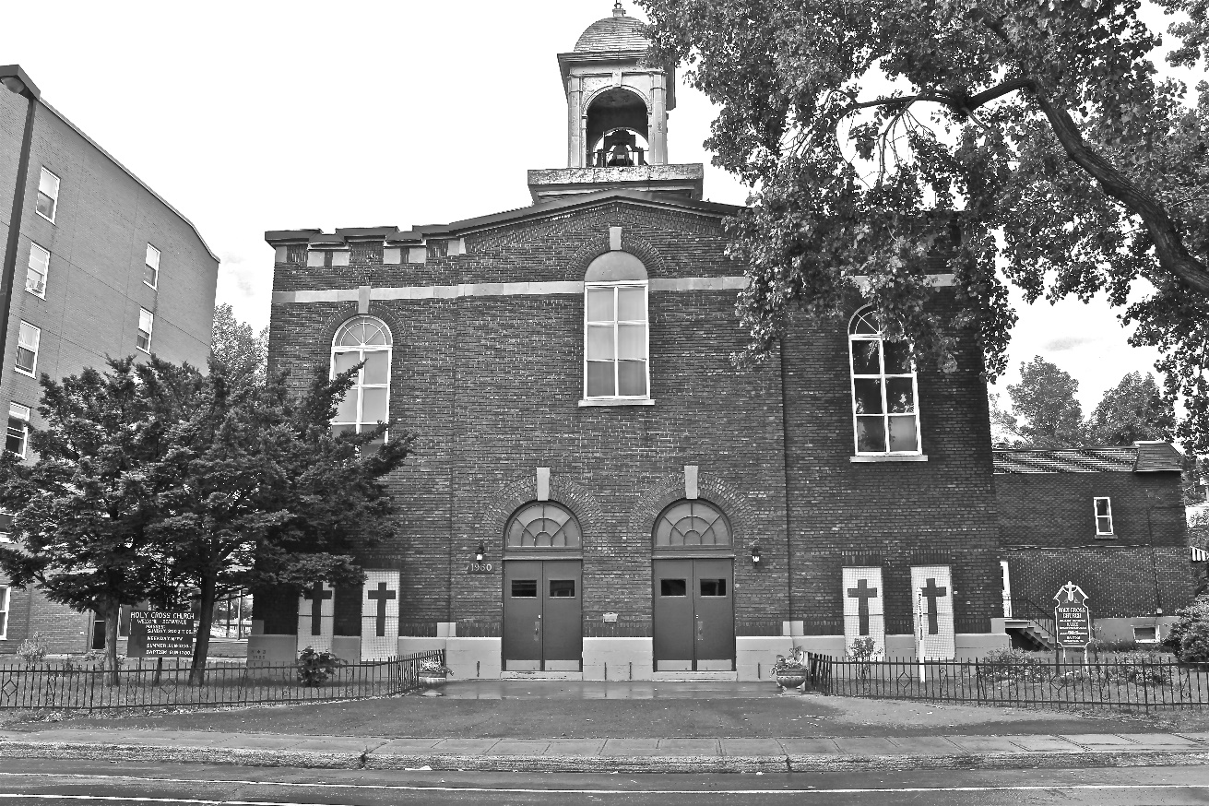
Holy Cross Parish Church
“The cross stands before us in these days as an eloquent symbol of God’s love for humanity.”
John Paul II

*9am mass is cancelled until further notice

