Pastoral Staff  Fr. Raymond LaFontaine E.V.  Parochial Administrator  Parish Wardens  Aldo Piccioni  514-769-6369 | Holy Cross Parish  1960 Jolicoeur street  Montreal, Quebec H4E 1X5  TEL.: 514-769-2717; FAX: 514-769-8852  Email: holycross.montreal60@gmail.com  Parish Office Hours  Wednesdays |  | Parish Wardens  Divya Siby  514-655-6442James Potter  514-733-7016  Norlita Galdones  514-733-7016  Ruby Johnson  514-761-3242
The saint for January 14th is St. Felix of Nola.
2024 has been marked as the “Year of Prayer” by Pope Francis.
The month of January is dedicated to Holy Name of Jesus which was celebrated on January 3rd. In the name of Jesus, every knee should bow of those that are in heaven, on earth and under the earth”. (Phil 2:10)

THOUGHT OF THE DAY:
“Having faith does not mean having no difficulties, but having the strength to face them, knowing we are not alone.”
-Pope Francis
The Grapevine is a good informative weekly Newsletter to keep you up to date on what is happening within and around our communities.

thegrapevine@diocesemontreal.org
POPE’S MONTHLY PRAYER INTENTION FOR THE MONTH OF JANUARY 2024:
FOR THE GIFT OF DIVERSITY IN THE CHURCH:
“Let us pray that the Spirit helps us recognize the gift of different cultures within the Christian community, and to discover the richness of different ritual traditions in the heart of the Catholic Church.”
IMPORTANT NOTICE:
Please sit in the pews with blue tape.
Please keep social distance when you are receiving communion.
Please use hand sanitizer on entering and leaving the church. Thank you!
REMINDER:  “CELEBRATE OUR LORD”  Please join us at 8:00PM on Sundays at ST. WILLIBRORD PARISH  351 WILLIBRORD ST, VERDUN, QC. |  | NOTE:  Last week to pick up Church support envelopes at the back of the church.  Thank you!
There are only a few Sunday missals left for sale. Hurry up and get yours.
The price is $7.00. Exact change is required please!
Congratulations!
To Jim and Marilyn Coleman who celebrated their 60th Diamond Wedding Anniversary on January 11th, 2024.
We wish you many more years of Happiness and Good Health.
SUNDAY COLLECTION
January 7th, 2024 |  | Amount in CAD
TOTAL |  | $ 4 263.31
Thank you for your generosity!
Please remember to write your name on your church support envelope.
PLEASE TURN OFF CELL PHONES
THIS CHURCH MAY BE USED AS A RESTING VISITATION LOCALE FOR YOUR DEARLY
DEPARTED.
IF YOU DESIRE THIS SERVICE, PLEASE CALL 514-769-2717

“Prayer makes us understand our vulnerability”, but the Lord “gives us strength and closeness”
MASS INTENTIONS
January 14th, 2024  IN THANKSGIVING FOR BLESSING  Req’d by The Handinero Family | January 21st, 2024  THE PARISHIONERS OF HOLY CROSS
Pope Francis

Holy Cross Parish Church
1960 Jolicoeur Street
Montreal, QC H4E 1X5
Tel: 514-769-2717
holycross.montreal60@gmail.com
https://holycrossmontreal.weebly.com/
Facebook: HOLY CROSS PARISH MONTREAL

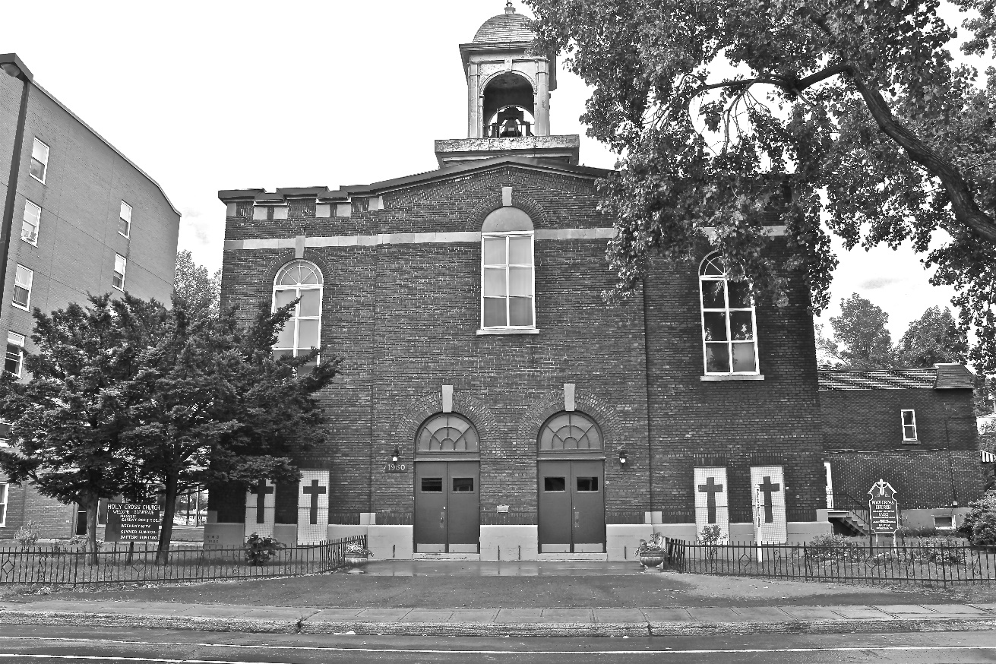
Holy Cross Parish Church
“The cross stands before us in these days as an eloquent symbol of God’s love for humanity.”
John Paul II

*9am mass is cancelled until further notice

