Pastoral Staff  Fr. Raymond LaFontaine E.V.  Parochial Administrator  Parish Office Hours  Wednesdays | Holy Cross Parish  1960 Jolicoeur street  Montreal, Quebec H4E 1X5  TEL.: 514-769-2717; FAX: 514-769-8852  Email: holycross.montreal60@gmail.com  https://holycrossmontreal.weebly.com/  Facebook: HOLY CROSS PARISH MONTREAL |  | Parish Wardens  Divya Siby  514-655-6442  James Potter  514-733-7016  Norlita Galdones  514-733-7016  Ruby Johnson  514-761-3242  Aldo Piccioni  514-769-6369

MONTH OF FEBRUARY 2024

2024 has been marked as the “Year of Prayer” by Pope Francis.

The liturgical color for Lent changes to violet or purple — a symbol of penance, mortification and the sorrow of a contrite heart. Today's Mass places before us the transfigured Lord and the model toward Whom we must tend, and our own transfiguration as the goal we must attain.
SECOND SUNDAY OF LENT- FEBRUARY 25th,2024
On Feb. 25th, the Church celebrates the feast day of Blessed Sebastian of Aparicio. He is the patron saint of road builders and travelers. Whether as a single person, a married man, or a Franciscan, Sebastian always worked for the good of others, helping to make their lives better.

Mass Readings for the second Sunday of lent, Cycle B:

The First Reading is taken from the Book of Genesis 22:1-2, 9-13, 15-18. God tested Abraham's faith by asking him to sacrifice Isaac, his beloved son. At the moment of sacrifice, an angel stopped him, providing a ram instead. Abraham's obedience led to God's promise of countless descendants and blessings for all nations.

The Second Reading is from the Letter of St. Paul to the Romans 8:31-34. If God is for us, no one can oppose us. He gave His Son for us and will freely give us all things. God declares us righteous, and Christ intercedes for us, ensuring no condemnation.

The Gospel is from St. Mark 9:2-10. And after six days Jesus took with him Peter and James and John, and led them up a high mountain by themselves. And he was transfigured before them, and his clothes became radiant, intensely white, as no one on earth could bleach them.

Consider spending your Lenten season with THE CHOSEN over four Friday evenings starting Feb. 23rd – Mar. 15th, 7 p.m. EST online via Zoom. Register!

Lenten Mission begins Monday led by Jesuit Father Kevin Kelly, Director of the Ignatian Spirituality Centre of Montreal, over three Monday evenings, Feb. 19, 26 and Mar. 4 from 7 p.m.-8:30 p.m. at St. Luke Parish. Open to all. Livestream available.

Lenten Mission "Rejoice in Hope"at Holy Name of Jesus Parish, Feb. 25-26 7:00- 8:30 PM. We will delve into understanding hope and how embracing it can transform us. With our guest speaker, Fr. Anthony Chukwuemeka Atansi, accompanied by music and witnesses, we will explore practical ways to infuse hope into our lives.
Lenten Activities at Mary Queen of the World Cathedral – 2024
1) Way of the Cross: Every Friday during Lent at 5:30 p.m. (after the 5 p.m. mass)
2) Lenten retreat 2024 on the theme "FOLLOWING JESUS": preaching, confessions, solemn vespers, rosary and Sunday mass from 3:30 p.m.: February 25, March 3,
And March 10
INCOME TAX RECEIPTs
Income tax receipts are available on the table at the back of the table. They are place in alphabetical order. If you do not find yours, please come to the office.
Thanks!
REMINDER:  **Mass canceled for Lent***  Please join us at 7:00PM on Sundays at ST. WILLIBRORD PARISH  351 WILLIBRORD ST, VERDUN, QC. |  | NOTE:  Please remember to write your name on your church support envelope.  There are only a few Sunday missals left for sale. Hurry up and get yours. The price is $7.00. Exact change is required please!
Dear Holy Cross Parishioners,
Consequently, immediately following the 11:00 AM Mass on February 25th, 2024, a general assembly will be held for the purpose of electing two church wardens. Wardens assume responsibility for the temporal goods of the parish and oversee its buildings and finances. We hope you will be open to considering serving the parish in this most important way. Wardens are generally elected for a three-year term, and may be re-elected once. It is a great way to take responsibility for the future of our community. If interested, please speak to one of the currently serving wardens (James, Norlita, Divya, Aldo, and Rubina), our secretary Teresa, or myself.
Blessings in the Lord, Fr. Raymond
SUNDAY COLLECTION
February 18th, 2024 |  | Amount in CAD
TOTAL |  | 4407.46$
Thank you for your generosity!
MASS INTENTIONS
February 25th, 2024  ENRICO AND SANTINA PICCIONI  Req’d by the Piccioni family | March 3rd, 2024  RAYMONDE FOURNIER  Req’d by the Fournier family
“Prayer makes us understand our vulnerability”, but the Lord “gives us strength and closeness” Pope Francis
THIS CHURCH MAY BE USED AS A RESTING VISITATION LOCALE FOR YOUR DEARLY
DEPARTED.
IF YOU DESIRE THIS SERVICE, PLEASE CALL 514-769-2717

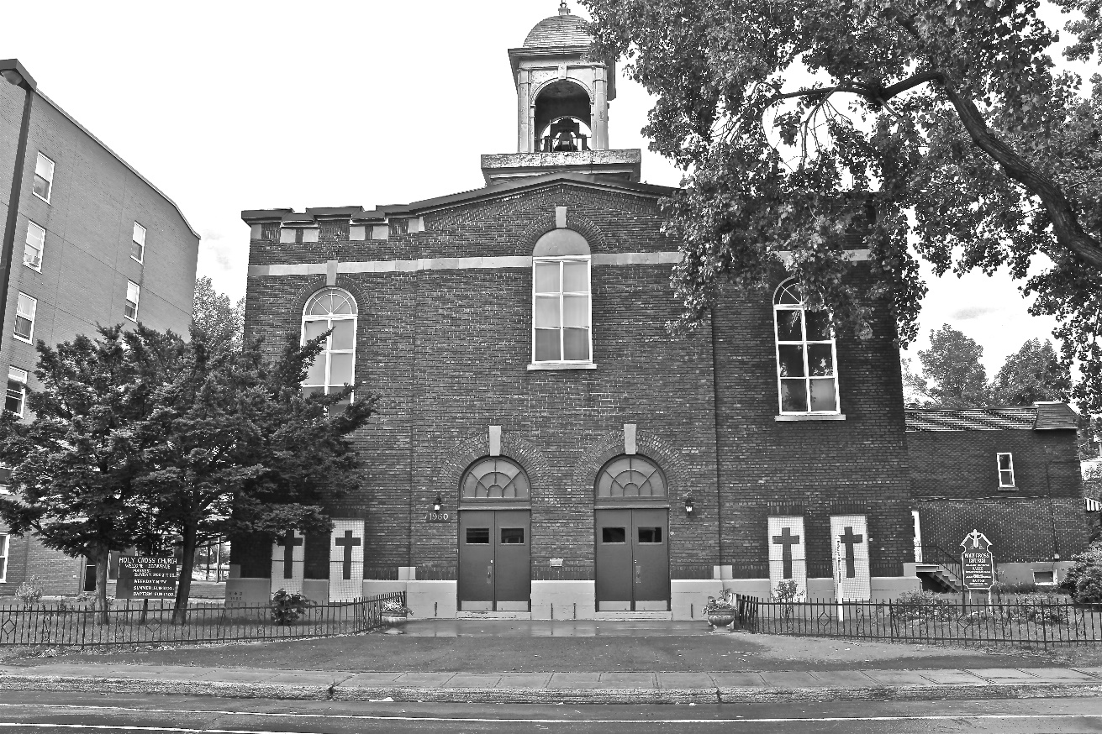
Holy Cross Parish Church

“The cross stands before us in these days as an eloquent symbol of God’s love for humanity.”
John Paul II

*9am mass is cancelled until further notice

