Pastoral Staff  Fr. Raymond LaFontaine E.V.  Parochial Administrator  Parish Office Hours  Wednesdays | Holy Cross Parish  1960 Jolicoeur street  Montreal, Quebec H4E 1X5  TEL.: 514-769-2717; FAX: 514-769-8852  Email: holycross.montreal60@gmail.com  https://holycrossmontreal.weebly.com/  Facebook: HOLY CROSS PARISH MONTREAL |  | Parish Wardens  Divya Siby  514-655-6442  James Potter  514-733-7016  Norlita Galdones  514-733-7016  Ruby Johnson  514-761-3242  Aldo Piccioni  514-769-6369

MONTH OF FEBRUARY 2024

2024 has been marked as the “Year of Prayer” by Pope Francis.

The month of February is traditionally dedicated to the Holy Family. February 7th -14th marks the National Marriage Week and today is World Marriage Day.
SIXTH SUNDAY IN ORDINARY TIMES- FEBRUARY 11th,2024
On Feb. 11th, the Catholic Church celebrates the liturgical memorial of Our Lady of Lourdes, recalling a series of 18 appearances that the Blessed Virgin Mary made to a 14-year-old French peasant girl, Saint Bernadette Soubirous. Due to the number of people gathering at the site, the mayor of Lourdes barricaded the grotto and stationed guards to prevent public access; and Bernadette saw the last appearance of the Lady from outside the barricade. The grotto was re-opened to the public by order of Emperor Louis Napoleon III, and the pilgrims have not stopped coming since.

Mass Readings for the sixth Sunday in Ordinary Time, Cycle B:

The First Reading is taken from the Book of Leviticus 13:1-2, 44-46 and concerns the regulations enforced by the priests regarding certain bodily diseases which made a person unclean and a menace to the health of his neighbors.

The Second Reading is from the First Letter of St. Paul to the Corinthians 10:31, 11:1 and speaks of our imitation of Paul as he imitates Christ for the sake of the Gospel, as well as of the unity of the Church of God.

The Gospel is from St. Mark 1:40-45. The gospel tells us Jesus' act of mercy and love toward the leper. Jesus takes up himself to our lowly situation to raise us up to his divine dignity. Only Mercy and love can touch such woundedness and risk.

ASH WESNESDAY MASS

There will a mass for Ash Wednesday on February 14th, 2024 at 7pm, marking the beginning of the Lenten season. Please join us for the day of ashes.

THOUGHT OF THE DAY:
“O Jesus, I would rather die a thousand deaths than be unfaithful to you!”
-Saint Bernadette
The Grapevine is a good informative weekly Newsletter to keep you up to date on what is happening within and around our communities.

thegrapevine@diocesemontreal.org
POPE’S MONTHLY PRAYER INTENTION FOR THE MONTH OF FEBRUARY 2024:
FOR THE GIFT TERMINALLY ILL:
“Let us pray that the sick who are in the final stages of life, and their family, receive the necessary medical and human care and accompaniment.”
REMINDER:  “CELEBRATE OUR LORD”  Please join us at 8:00PM on Sundays at ST. WILLIBRORD PARISH  351 WILLIBRORD ST, VERDUN, QC. |  | NOTE:  Last week to pick up Church support envelopes at the back of the church.  Please remember to write your name on your church support envelope.
Dear Holy Cross Parishioners:
For a variety of scheduling reasons, it proved difficult to find time for a general assembly of parishioners to elect church wardens in December 2023. Under Fabrique Law, we are under the obligation to fill two positions by the end of February at the very latest. Consequently, immediately following the 11:00 AM Mass on February 25th, 2024, a general assembly will be held for the purpose of electing two church wardens. Wardens assume responsibility for the temporal goods of the parish and oversee its buildings and finances. We hope you will be open to considering serving the parish in this most important way. Wardens are generally elected for a three-year term, and may be re-elected once. It is a great way to take responsibility for the future of our community. For further information or to indicate your interest, please speak to one of the currently serving wardens (James, Norlita, Divya, Aldo, and Rubina), our secretary Teresa, or myself.
Blessings in the Lord,
Fr. Raymond
SPEND YOUR LENTEN SEASON WITH “THE CHOSEN”: A synodal discussion, inspired by the popular series based on the life of Jesus, continues with Season Three over four Friday evenings (Feb. 23rd – Mar. 15th), 7 p.m. EST online via Zoom. Register today!
SUNDAY COLLECTION
February 4th, 2024 |  | Amount in CAD
TOTAL |  | 335.05$
Thank you for your generosity!
“Prayer makes us understand our vulnerability”, but the Lord “gives us strength and closeness”
MASS INTENTIONS
February 11th, 2024  GINO GALDONES  THE PASSING ANNIVERSARY  Req’d by the Norlita Galdones | February 18th, 2024  RAYMONDE FOURNIER  Req’d by the Fournier family  THE THANKSGIVING BIRTHDAY  Req’d by Elsie Ferrer  MARY HAINEY  Req’d by Ada Hainey
Pope Francis
THIS CHURCH MAY BE USED AS A RESTING VISITATION LOCALE FOR YOUR DEARLY
DEPARTED.
IF YOU DESIRE THIS SERVICE, PLEASE CALL 514-769-2717

Holy Cross Parish Church
1960 Jolicoeur Street
Montreal, QC H4E 1X5
Tel: 514-769-2717
holycross.montreal60@gmail.com
https://holycrossmontreal.weebly.com/
Facebook: HOLY CROSS PARISH MONTREAL

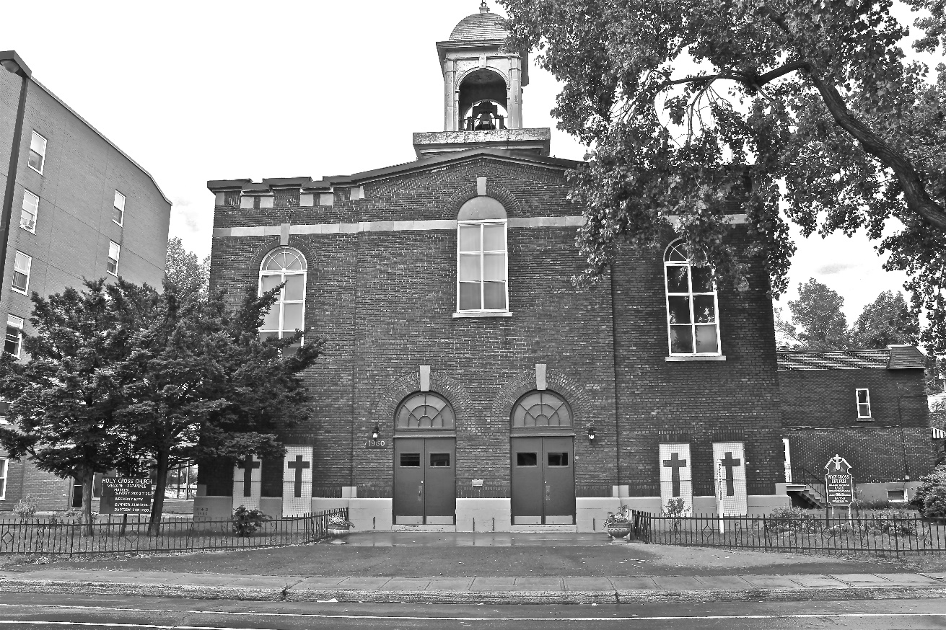
Holy Cross Parish Church
“The cross stands before us in these days as an eloquent symbol of God’s love for humanity.”
John Paul II

*9am mass is cancelled until further notice

