Pastoral Staff  Fr. Raymond LaFontaine E.V.  Parochial Administrator  Parish Wardens  Aldo Piccioni  514-769-6369 | Holy Cross Parish  1960 Jolicoeur street  Montreal, Quebec H4E 1X5  TEL.: 514-769-2717; FAX: 514-769-8852  Email: holycross.montreal60@gmail.com  Parish Office Hours  Wednesdays |  | Parish Wardens  Divya Siby  514-655-6442James Potter  514-733-7016  Norlita Galdones  514-733-7016  Ruby Johnson  514-761-3242
The saint for Sunday December 3rd, 2023 is St Francis Xavier.
The month of December is dedicated to the Immaculate Conception.
December 3rd is the first Sunday of Advent.
Advent is a time of joyful anticipation as we prepare our hearts for the Christmas season.

The first candle on the Advent wreath represents hope. The first Sunday of Advent not only leads us to anticipate the birth of Christ but celebrates the beginning of a new liturgical season as well. It is purple the primary color of Advent and a color symbolizing royalty.

Sometimes called the “Prophecy Candle”, the first candle harkens us back to Isaiah’s foretelling of the birth of Christ and all the promises God gave us in the Old Testament that would be fulfilled by the birth of Christ.

THOUGHT OF THE DAY:
“Advent is a journey towards Bethlehem. May we let ourselves be drawn by the light of God made man.”
Pope Francis
The Grapevine is a good informative weekly Newsletter to keep you up to date on what is happening within and around our communities.

thegrapevine@diocesemontreal.org
POPE’S MONTHLY PRAYER INTENTION FOR THE MONTH OF DECEMBER 2023:
FOR PERSONS WITH DISABILITIES:
“We pray that people living with disabilities: May they be at the center of attention in society and that institutions may offer inclusive programs which value their active participation..”
IMPORTANT NOTICE:
Please sit in the pews with blue tape.
Please keep social distance when you are receiving communion.
Please use hand sanitizer on entering and leaving the church. Thank you!
REMINDER:  “CELEBRATE OUR LORD”  Please join us at 8:00PM on Sundays at ST. WILLIBRORD PARISH  351 WILLIBRORD ST  VERDUN, QC. |  | NOTE:  Parish support envelopes for the year 2024-2025 are available at the back of the church.  Thank you!
Sunday Missals will be sold after mass starting December 3rd, 2023.
The price is $7.00. Exact change is required please!
SUNDAY COLLECTION
November 26th, 2023 |  | Amount in CAD
TOTAL |  | $ 816.55
Thank you for your generosity!
Please remember to write your name on your church support envelope.
PLEASE TURN OFF CELL PHONES
THIS CHURCH MAY BE USED AS A RESTING VISITATION LOCALE FOR YOUR DEARLY
DEPARTED.
IF YOU DESIRE THIS SERVICE, PLEASE CALL 514-769-2717

“Prayer makes us understand our vulnerability”, but the Lord “gives us strength and closeness”
MASS INTENTIONS
December 3rd, 2023  KATHLEEN SENCHEY  Req’d by Ray Senchey  RAYMONDE FOURNIER  Req’d by The Fournier Family | December 10th, 2023  RAYMONDE FOURNIER  Req’d by The Fournier Family
Pope Francis

Holy Cross Parish Church
1960 Jolicoeur Street
Montreal, QC H4E 1X5
Tel: 514-769-2717
holycross.montreal60@gmail.com
https://holycrossmontreal.weebly.com/
Facebook: HOLY CROSS PARISH MONTREAL

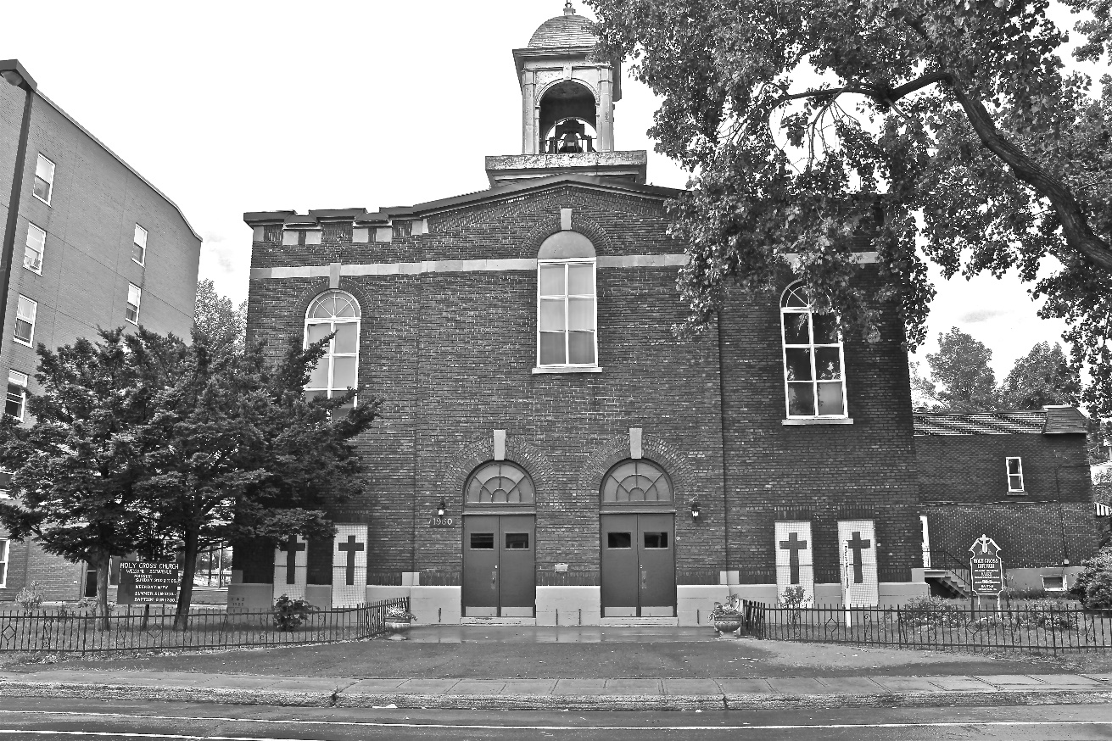
Holy Cross Parish Church
“The cross stands before us in these days as an eloquent symbol of God’s love for humanity.”
John Paul II

*9am mass is cancelled until further notice

