Pastoral Staff  Fr. Raymond LaFontaine E.V.  Parochial Administrator  Parish Wardens  Aldo Piccioni  514-769-6369 | Holy Cross Parish  1960 Jolicoeur street  Montreal, Quebec H4E 1X5  TEL.: 514-769-2717; FAX: 514-769-8852  Email: holycross.montreal60@gmail.com  Parish Office Hours  Wednesdays |  | Parish Wardens  Divya Siby  514-655-6442James Potter  514-733-7016  Norlita Galdones  514-733-7016  Ruby Johnson  514-761-3242
The saint for Sunday December 17th, 2023 is Saint John of Matha.
The month of December is dedicated to the Immaculate Conception.
December 17th is the third Sunday of Advent.
The third candle of Advent symbolizes Joy. The third candle takes us back to the joyful anticipation of the shepherds who journeyed to see Jesus in Bethlehem, even before the wise men.
As we continue to approach Christmas Day, our joy grows more and more. On this third Sunday of Advent, which the Church calls “Gaudete Sunday,” meaning rejoice or praise, we light the third candle and rejoice like the shepherds. For this reason, the third candle of Advent is called the “Shepherd’s Candle,” and its color is pink, the liturgical color of joy.

THOUGHT OF THE DAY:
“Joy, with peace, is the sister of charity. Serve the Lord with laughter.”
-Saint Padre Pio
The Grapevine is a good informative weekly Newsletter to keep you up to date on what is happening within and around our communities.

thegrapevine@diocesemontreal.org
POPE’S MONTHLY PRAYER INTENTION FOR THE MONTH OF DECEMBER 2023:
FOR PERSONS WITH DISABILITIES:
“We pray that people living with disabilities: May they be at the center of attention in society and that institutions may offer inclusive programs which value their active participation.”
IMPORTANT NOTICE:
Please sit in the pews with blue tape.
Please keep social distance when you are receiving communion.
Please use hand sanitizer on entering and leaving the church. Thank you!
REMINDER:  “CELEBRATE OUR LORD”  Please join us at 8:00PM on Sundays at ST. WILLIBRORD PARISH  351 WILLIBRORD ST  VERDUN, QC. |  | NOTE:  Parish support envelopes for the year 2024-2025 are available at the back of the church.  Thank you!
HOLYDAY SCHEDULE FOR THE MASSES  Dec 24th, 4th Sunday of Advent at 11:00AM  Dec 24th, Christmas Eve Mass at 8:00PM  Dec 25th, No Mass  Dec 31st, Holy Family at 11:00AM  Jan 1st, Mary Mother of God at 11:00AM |  | There are only a few Sunday missals left for sale. Hurry up and get yours.  The price is $7.00. Exact change is required please!
A big thank you to those who helped make the Christmas bazaar a success.
Your prayers are requested for the repose of the soul of Fr. Jospeh Patrick Sullivan who was called home to the Father Monday morning, December 11th, 2023 at Montreal’s St. Mary’s Hospital, following a brief illness. He was 83 years old.

On December 10th, on the second Sunday of Advent, Auxiliary Bishop Emeritus Jude St-Antoine of Montreal died at Montreal’s Santa Cabrini Hospital at the age of 93.

Heartfelt prayers and condolences to Fr. Sullivan and Bishop St-Antoine’s Families, close friends, their brother priests, and all those who were touched by his ministry.
SUNDAY COLLECTION
December 10th, 2023 |  | Amount in CAD
TOTAL |  | $ 5 296.76
Thank you for your generosity!
Please remember to write your name on your church support envelope.
PLEASE TURN OFF CELL PHONES
THIS CHURCH MAY BE USED AS A RESTING VISITATION LOCALE FOR YOUR DEARLY
DEPARTED.
IF YOU DESIRE THIS SERVICE, PLEASE CALL 514-769-2717
“Prayer makes us understand our vulnerability”, but the Lord “gives us strength and closeness”
MASS INTENTIONS
December 17th, 2023  20TH ANNIVERSARY OF THE PASSING OF INCORONOTA CIOCCA AMOROSA  Req’d by The Amorosa Family  GARY JOHNSON  Req’d by Ruby Johnson  EMILIA MAIELLO  Req’d by her daughter Catherine Maiello, all her children, grand-children, and great-grand-children.  GERARD POTTER  Req’d by Mary Surowaniec | December 24th, 2023  THE HAINEY FAMILY  Req’d by Ada Hainey
Pope Francis

Holy Cross Parish Church
1960 Jolicoeur Street
Montreal, QC H4E 1X5
Tel: 514-769-2717
holycross.montreal60@gmail.com
https://holycrossmontreal.weebly.com/
Facebook: HOLY CROSS PARISH MONTREAL

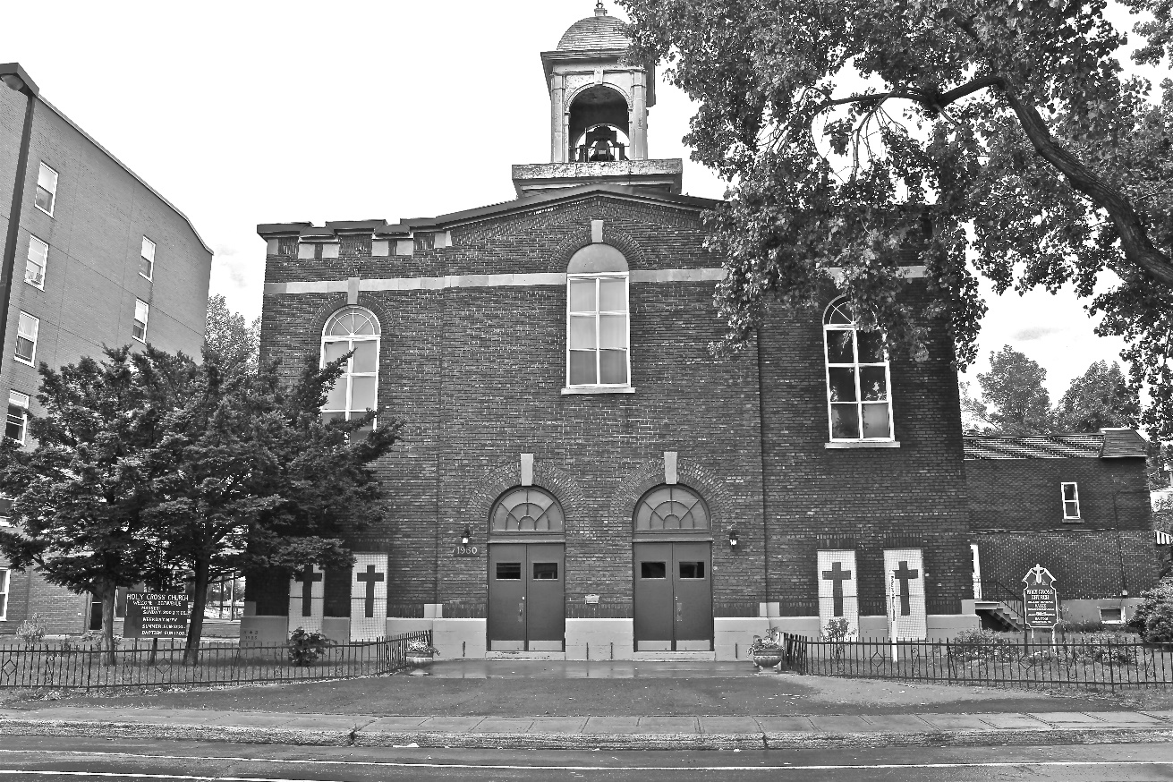
Holy Cross Parish Church
“The cross stands before us in these days as an eloquent symbol of God’s love for humanity.”
John Paul II

*9am mass is cancelled until further notice

