Pastoral Staff  Fr. Raymond LaFontaine E.V.  Parochial Administrator  Parish Wardens  James Potter  514-733-7016 | Holy Cross Parish  1960 Jolicoeur street  Montreal, Quebec H4E 1X5  TEL.: 514-769-2717; FAX: 514-769-8852  Email: holycross.montreal60@gmail.com  Parish Office Hours  Wednesdays |  | Parish Wardens  Norlita Galdones  514-733-7016  Teresa Gomes  514-291-2591  Ruby Johnson  514-761-3242
The month of December is dedicated to the Immaculate Conception celebrated on December 8th.
“BLESSINGS FOR THE HOLIDAY SEASON”
“FOR UNTO YOU IS BORN THIS DAY IN THE CITY OF DAVID
A SAVIOR, WHICH IS CHRIST THE LORD”
LUKE 2:11
Today, we light the white candle on the advent wreath also known as the “Christ’s Candle” it represents “light and purity.”

THOUGHT OF THE DAY:

“Gifts of time and love are surely the basic ingredients of a truly Merry Christmas”

Peg Bracken
POPE’S MONTHLY PRAYER INTENTION FOR DECEMBER 2022:
VOLUNTEER NOT-FOR-PROFIT ORGANIZATIONS
“We pray that volunteer not-for-profit organizations committed to human development find people dedicated to the common good and ceaselessly seek out new paths to international cooperation.”
REMINDER: Please note if you have a church support envelope and have not completed a Parish Register Form, an income Tax receipt for 2022 can not be issued. We require your address. Thank you!
The Grapevine is a good informative weekly Newsletter to keep you up to date on what is happening within and around our communities.
thegrapevine@diocesemontreal.org
IMPORTANT NOTICE: Please sit in the pews with yellow tape.
Please keep social distance when you are receiving communion.
Please use hand sanitizer on entering and leaving the church.
Thank you!
REMINDER: There is no Christmas Day Mass at 11 am on December 25th, 2022. There will be an 11 am Mass on January 1st, 2023.
Fr. Raymond’s Christmas greetings is an insert with today’s bulletin.
Pope’s Christmas Message:
Dear brothers and sister’s,
“I wish you a Happy Christmas, a Christmas rich in Surprises of Jesus. They may seem to be uncomfortable Surprises, but they are God’s tastes. If we espouse them, we offer ourselves a splendid Surprise. Each one of us has concealed in his heart the capacity to Surprise.
Let us allow ourselves to be Surprised by Jesus this Christmas.”
† Francis
SUNDAY COLLECTION
December 18th, 2022 |  | Amount in CAD
Church Support Envelopes |  | $250.00
Basket |  | $64.95
Christmas Flowers |  | $87.00
Masses |  | $30.00
Charities |  | $10.00
Honorarium |  | (minus) $5.00
TOTAL |  | $436.95
Thank you for your generosity!
Please remember to write your name on your church support envelope.

Please turn off cell phones.
PLEASE REMEMBER THE CHURCH IN YOUR WILL
THIS CHURCH MAY BE USED AS A RESTING VISITATION LOCALE FOR YOUR DEARLY
DEPARTED.
IF YOU DESIRE THIS SERVICE, PLEASE CALL 514-769-2717

“Prayer makes us understand our vulnerability”, but the Lord “gives us strength and closeness”
MASS INTENTIONS
December 24th, 2022  KATHLEEN SENCHEY  Req’d by Raymond Senchey  THE HAINEY FAMILY  Req’d by Ada Hainey  DIEGO HANDINERO  Req’d by The Piccioni Family  VICTOR AND JAYNE TUCCI  Req’d by FR. V. Tucci  BLESSINGS RECEIVED AND THE GIFT OF HEALING  Req’d by The Handinero Family | January 1st, 2023  THE PARISHIONERS OF HOLY CROSS
Pope Francis

Holy Cross Parish Church
1960 Jolicoeur Street
Montreal, QC H4E 1X5
Tel: 514-769-2717
holycross.montreal60@gmail.com
https:/Holycrossmontreal.weebly.com
Facebook: HOLY CROSS PARISH MONTREAL
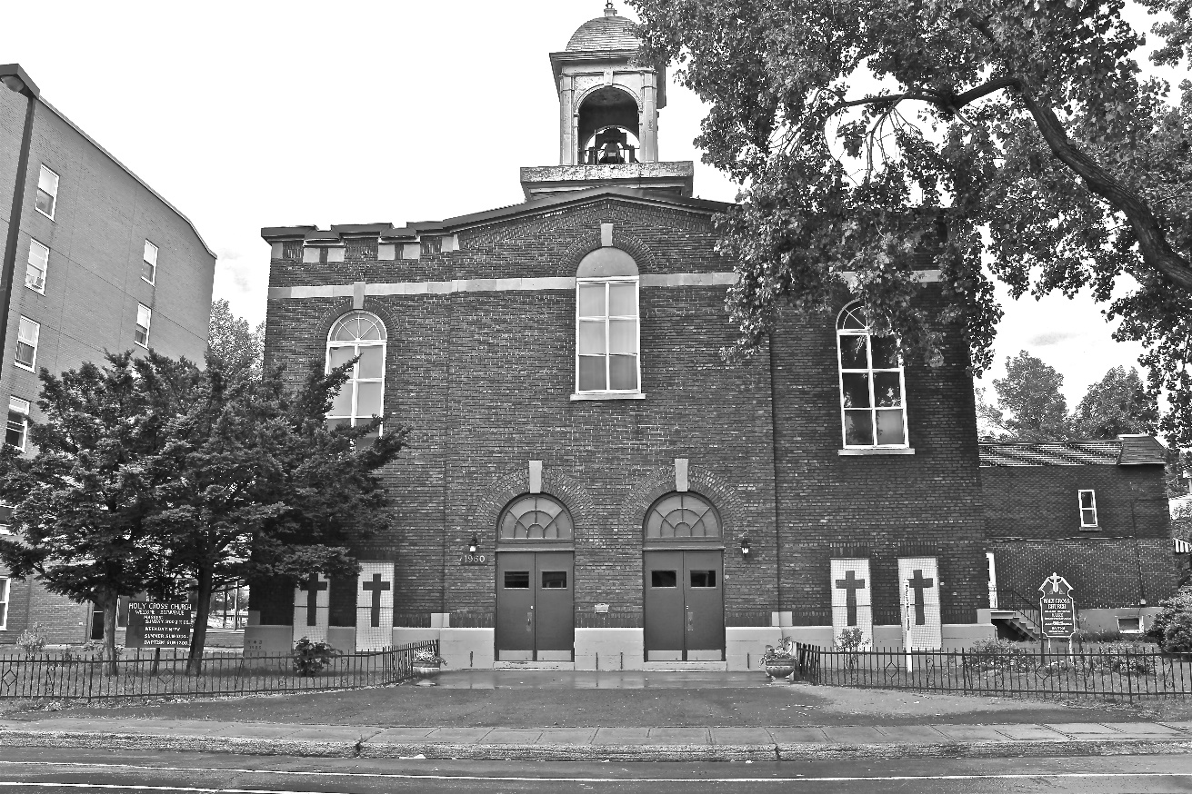
Holy Cross Parish Church
“The cross stands before us in these days as an eloquent symbol of God’s love for humanity.”
John Paul II

*9am mass is cancelled until further notice

