Pastoral Staff  Fr. Raymond LaFontaine E.V.  Parochial Administrator  Parish Wardens  James Potter  514-733-7016 | Holy Cross Parish  1960 Jolicoeur street  Montreal, Quebec H4E 1X5  TEL.: 514-769-2717; FAX: 514-769-8852  Email: holycross.montreal60@gmail.com  Parish Office Hours  Wednesdays |  | Parish Wardens  Norlita Galdones  514-733-7016  Teresa Gomes  514-291-2591  Ruby Johnson  514-761-3242
The month of December is dedicated to the Immaculate Conception celebrated on December 8th.
The Saint for December 18th, 2022 is Saint Michael the Confessor of Constantinople.
December 18th, 2022 is the Fourth Sunday of Advent.
Today, we light the third purple candle on the Advent wreath known as The “Angel’s Candle” it symbolizes PEACE.

THOUGHT OF THE DAY:

“Happiness is a state of mind. It’s just according to the way you look at things.”

Walt Disney
POPE’S MONTHLY PRAYER INTENTION FOR DECEMBER 2022:
VOLUNTEER NOT-FOR-PROFIT ORGANIZATIONS
“We pray that volunteer not-for-profit organizations committed to human development find people dedicated to the common good and ceaselessly seek out new paths to international cooperation.”
REMINDER: Please note if you have a church support envelope and have not completed a Parish Register Form, an income Tax receipt for 2022 can not be issued. We require your address.
Thank you!
The Grapevine is a good informative weekly Newsletter to keep you up to date on what is happening within and around our communities.
thegrapevine@diocesemontreal.org
IMPORTANT NOTICE: Please sit in the pews with yellow tape.
Please keep social distance when you are receiving communion.
Please use hand sanitizer on entering and leaving the church.
Thank you!
NOTE: Christmas Eve Mass will be celebrated @9:00pm on December 24th, 2022.
NOTE: There will be no Mass on Christmas Day December 25th, 2022.
COME JOIN US!!!
For all of you that have purchased tickets, our Xmas Luncheon will take place after today’s Mass.
SUNDAY COLLECTION
December 11th, 2022 |  | Amount in CAD
Church Support Envelopes |  | $260.00
Basket |  | $47.65
Flowers |  | $50.00
Masses |  | $30.00
Honorarium |  | (minus) $5.00
TOTAL |  | $382.65
Thank you for your generosity!
Please remember to write your name on your church support envelope.

Please turn off cell phones.
PLEASE REMEMBER THE CHURCH IN YOUR WILL
THIS CHURCH MAY BE USED AS A RESTING VISITATION LOCALE FOR YOUR DEARLY
DEPARTED.
IF YOU DESIRE THIS SERVICE, PLEASE CALL 514-769-2717

“Prayer makes us understand our vulnerability”, but the Lord “gives us strength and closeness”
MASS INTENTIONS
December 18th, 2022  KATHLEEN SENCHEY  Req’d by Raymond Senchey and Family  DIEGO HANDINERO  Req’d by The Handinero Family  VICTOR AND JAYNE TUCCI  Req’d by FR. V. Tucci  BOB AND DOREEN RICHARDS  Req’d by Ruby Johnson  INCORONATA CIOCCO AMOROSA  Req’d by The Family | December 24th, 2022  THE HAINEY FAMILY  Req’d by Ada Hainey  VICTOR AND JAYNE TUCCI  Req’d by FR. V. Tucci
Pope Francis

Holy Cross Parish Church
1960 Jolicoeur Street
Montreal, QC H4E 1X5
Tel: 514-769-2717
holycross.montreal60@gmail.com
https:/Holycrossmontreal.weebly.com
Facebook: HOLY CROSS PARISH MONTREAL
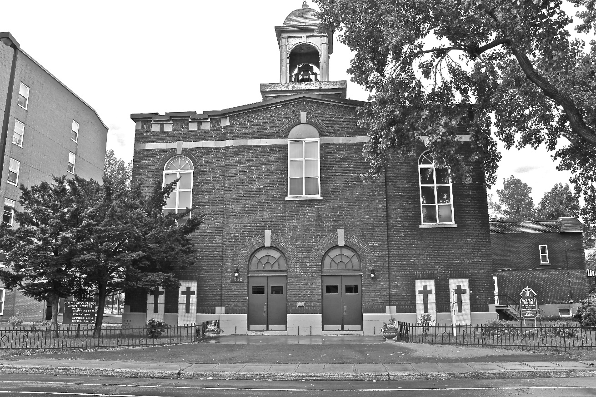
Holy Cross Parish Church
“The cross stands before us in these days as an eloquent symbol of God’s love for humanity.”
John Paul II

*9am mass is cancelled until further notice

