Pastoral Staff  Fr. Raymond LaFontaine E.V.  Parochial Administrator  Parish Wardens  Aldo Piccioni  514-769-6369  Divya Siby  514-655-6442 | Holy Cross Parish  1960 Jolicoeur street  Montreal, Quebec H4E 1X5  TEL.: 514-769-2717; FAX: 514-769-8852  Email: holycross.montreal60@gmail.com  Parish Office Hours  Wednesdays |  | Parish Wardens  Genfu Sun  514-568-9866  James Potter  514-733-7016  Norlita Galdones  514-733-7016  Ruby Johnson  514-761-3242
The Saint for Sunday August 20th, 2023 is Saint Bernard of Clairvaux.
The month of August is dedicated to The Immaculate Heart of Mary.

THOUGHT OF THE DAY:
“Life does not have to be perfect to be wonderful.”
Annette Funicello
The Grapevine is a good informative weekly Newsletter to keep you up to date on what is happening within and around our communities.

thegrapevine@diocesemontreal.org
POPE’S MONTHLY PRAYER INTENTION FOR THE MONTH OF AUGUST 2023:
FOR WORLD YOUTH DAY
“We pray that the World Youth Day in Lisbon will help young people to live and witness the Gospel in their own lives.”
IMPORTANT NOTICE:
Please sit in the pews with blue tape.
Please keep social distance when you are receiving communion.
Please use hand sanitizer on entering and leaving the church. Thank you!
REMINDER:
“CELEBRATE OUR LORD”
Please join us at 8:00PM on Sundays at
ST. WILLIBRORD PARISH
351 WILLIBRORD ST
VERDUN, QC.
VOLUNTEERS NEEDED:
We are searching for someone to takeover the input of our parish bulletin. Please contact the office.

Please note that we are in need of someone to take care of the candles in the church.
(Altar candles and vigil candles)
Contact the office if you are able to help.

Thank you!
SAVE THE DATE:
MARCH for PEACE and RECONCILIATION and MASS for PEACE in the WORLD
August 26th, 2023 8:45 AM TILL 1:15 PM
2455 Lariviere street
Montreal, Quebec

Contact: Akouete 438 995 3758
Following the March, a mass will take place at Marie-Reine-du-Monde Catheral
Celebrated by his excellency Monsignor Christian Lepine, Archbishop of Montreal.

Thank you!
SUNDAY COLLECTION
August 13th, 2023 |  | Amount in CAD
TOTAL |  | $ 1 723.33
Thank you for your generosity!
Please remember to write your name on your church support envelope.
PLEASE TURN OFF CELL PHONES
THIS CHURCH MAY BE USED AS A RESTING VISITATION LOCALE FOR YOUR DEARLY
DEPARTED.
IF YOU DESIRE THIS SERVICE, PLEASE CALL 514-769-2717

“Prayer makes us understand our vulnerability”, but the Lord “gives us strength and closeness”
MASS INTENTIONS
August 20th, 2023  KATHLEEN SENCHEY  Req’d by The Senchey Family | August 27th, 2023  THE PARISHIONERS OF HOLY CROSS PARISH
Pope Francis

Holy Cross Parish Church
1960 Jolicoeur Street
Montreal, QC H4E 1X5
Tel: 514-769-2717
holycross.montreal60@gmail.com
https://holycrossmontreal.weebly.com/
Facebook: HOLY CROSS PARISH MONTREAL
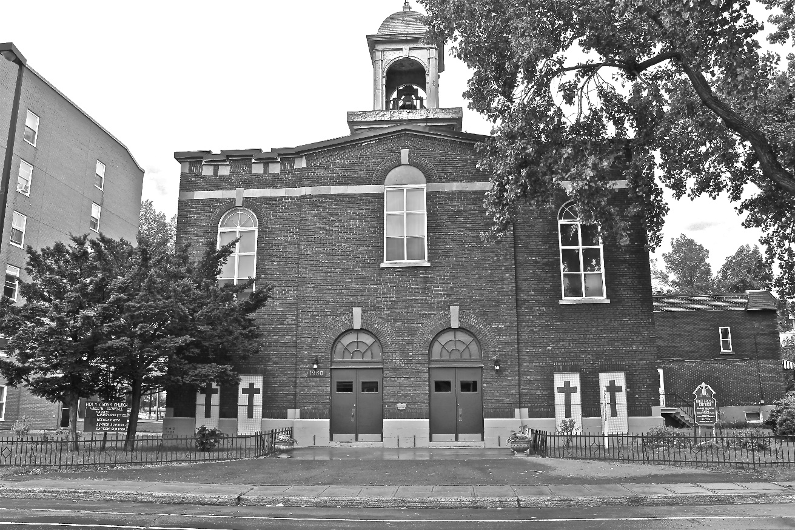
Holy Cross Parish Church
“The cross stands before us in these days as an eloquent symbol of God’s love for humanity.”
John Paul II

*9am mass is cancelled until further notice

