Pastoral Staff  Fr. Raymond LaFontaine E.V.  Parochial Administrator  Parish Office Hours  Wednesdays | Holy Cross Parish  1960 Jolicoeur street  Montreal, Quebec H4E 1X5  TEL.: 514-769-2717; FAX: 514-769-8852  Email: holycross.montreal60@gmail.com  https://holycrossmontreal.weebly.com/  Facebook: HOLY CROSS PARISH MONTREAL |  | Parish Wardens  Divya Siby: 514-655-6442  James Potter: 514-733-7016  Norlita Galdones: 514-733-7016  Ruby Johnson: 514-761-3242  Aldo Piccioni: 514-769-6369  Francis Van Oordt: 438-226-2126

MONTH OF APRIL 2024

2024 has been marked as the “Year of Prayer” by Pope Francis.

As our Lenten journey comes to a close we prepare to follow Christ all the way to the cross and to witness His glorious Resurrection. Hopefully we have sacrificed and prayed so that we are now able to more fully reap the fruits of a well spent Lent.
FIFTH SUNDAY OF EASTER - APRIL 28th,2024
On April 28th, the Catholic Church celebrates the liturgical memorial of Saint Peter Chanel. Peter was declared a martyr and beatified in 1889. Pope Pius XII canonized him in 1954. Within a few years of Saint Peter Chanel’s death, most of the island of Futuna had converted to Catholicism. St Peter Chanel exemplifies a life of the Spirit's gifts of courage and fruit of kindness required of all young people, but especially young priests.

Mass Readings for the fifth Sunday of Easter, Cycle B:

The First Reading taken from the Acts of the Apostles 9:26-31 is about St. Paul's first visit to Jerusalem after his conversion.

The Second Reading is from the First Letter of John 3:18-24. In today's verses the Beloved Disciple is urging his readers to believe firmly in Jesus Christ the Son of God, and to love their neighbor with a practical love, a love which will help him in his corporal and spiritual needs.

The Gospel is from St. John 15:1-8. The words of consolation and encouragement which our Lord spoke to his Apostles on Holy Thursday night were intended to console and encourage all his followers for all time. They encourage and console us today, and we need encouragement to persevere on the road to heaven. Living a truly Christian life is never easy. We have always the attraction of the world, and the temptations by the agents of evil, to make that life less easy still. But in our own day these difficulties have increased a hundredfold.
POPE’S MONTHLY PRAYER INTENTION FOR THE MONTH OF APRIL 2024:
FOR THE ROLE OF WOMEN:

“Let us pray that the dignity and worth of women be recognized in every culture, and for an end to the discrimination they face in various parts of the world”
REMINDER:  “CELEBRATE OUR LORD”  Please join us at 8:00PM on Sundays at ST. WILLIBRORD PARISH  351 WILLIBRORD ST, VERDUN, QC. |  | NOTE:  Please remember to write your name on your church support envelope.  There are only a few Sunday missals left for sale. Hurry up and get yours. The price is $7.00. Exact change is required please!
A Great Symphony of Prayer: The Our Father as a Programme of Life
The CCCB Ad hoc Committee for the Preparation for the Jubilee 2025 is hosting a two-part series titled, “A Great Symphony of Prayer” with Dr. Josephine Lombardi which will enable the faithful one meaningful way to participate in the Year of Prayer which was announced by Pope Francis on 21st January 2024. The webinar series will be every Tuesdays in April 2024, 1:00-2:30 pm EDT.
April 30th, 2024: Managing trials and Resisting Evil
National Family and Life Week (NFLW): We are very pleased to share with you the CCCB Pastoral Toolkit for the upcoming National Family and Life Week (NFLW), which will take place from 13th – 19th May 2024. The theme of NFLW 2024 is “Love hopes all things,” which is taken from Saint Paul’s hymn on love in 1 Corinthians 13.7: “[Love] bears all things, believes all things, hopes all things, endures all things.” The NFLW2024 Toolkit is now available on the CCCB website.
First World Children's Day: For the first time, a World Children's Day will be held in Rome on May 25th and 26th, 2024, in the presence of the Pope and children from all over the world. The theme will be: "Behold, I make all things new". Prepare for the event, share your desires, and hopes for a better world, awaiting the meeting with Pope Francis. Submit your drawings!
The Fondation du Grand Séminaire de Montréal is delighted to invite you to the panel discussion it is organizing on May 4th, 2024, starting at 1:30 p.m. at 6895 rue Boyer, Montréal QC, H2S 2J6. This panel promises to be a unique opportunity to exchange ideas and discover new perspectives on the proposed theme: "In Church, meeting contemporary challenges".
SUNDAY COLLECTION
April 21st, 2024 |  | Amount in CAD
TOTAL |  | 445.30$
Thank you for your generosity!
MASS INTENTIONS
Please note that a mass intention is 15$ per person
April 28th, 2024  1) RAYMONDE FOURNIER  Req’d by the Fournier Family | May 5th, 2024  THE PARISHIONERS OF HOLY CROSS
“Prayer makes us understand our vulnerability”, but the Lord “gives us strength and closeness” Pope Francis
THIS CHURCH MAY BE USED AS A RESTING VISITATION LOCALE FOR YOUR DEARLY
DEPARTED.
IF YOU DESIRE THIS SERVICE, PLEASE CALL 514-769-2717

Holy Cross Parish Church
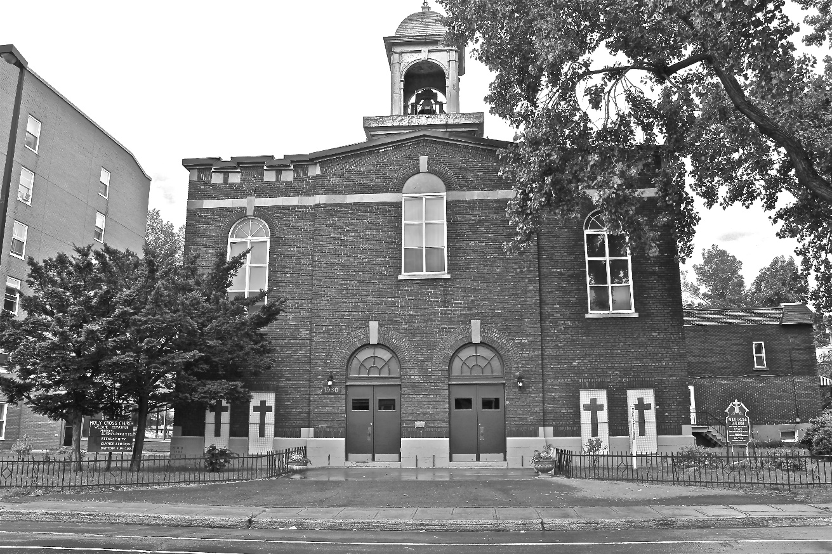

“The cross stands before us in these days as an eloquent symbol of God’s love for humanity.”
John Paul II

*9am mass is cancelled until further notice

