Pastoral Staff  Fr. Raymond LaFontaine E.V.  Parochial Administrator  Parish Wardens  Aldo Piccioni  514-769-6369  Divya Siby  514-655-6442 | Holy Cross Parish  1960 Jolicoeur street  Montreal, Quebec H4E 1X5  TEL.: 514-769-2717; FAX: 514-769-8852  Email: holycross.montreal60@gmail.com  Parish Office Hours  Wednesdays |  | Parish Wardens  Genfu Sun  514-568-9866  James Potter  514-733-7016  Norlita Galdones  514-733-7016  Ruby Johnson  514-761-3242
The month of April is dedicated to the Holy Spirit and the Eucharist.
The saint for April 23rd, is Saint George.
Sunday April 23rd, 2023 is the third Sunday of Easter.
“Lord, you will show us the path of life.”  PSALM 16  Prayer to the God of goodness – Based on PSALM 16  Keep me safe God  You always shelter me from harm  You are my Lord  You provide so many good things to me  Don’t let me forget that  My happiness does not come from things  I don’t want to get distracted and forget about you |  | I know you are the source of goodness  I see all you have given me  I am secure in your care  Blessed are you Lord!  You are always with me  You never forget me  You bring me peace  So I am filled with joy  You will always protect me from evil  You show me the way to live  You are my joy!  Amen  2021 YOUNG -CATHOLICS.COM

THOUGHT OF THE DAY:

“We are here to add to life, not to get what we can from life.”
William Osler
The Grapevine is a good informative weekly Newsletter to keep you up to date on what is happening within and around our communities.

thegrapevine@diocesemontreal.org
POPE’S MONTHLY PRAYER INTENTION FOR APRIL 2023:
FOR A CULTURE OF PEACE AND NONVIOLENCE
“We pray for the spread of peace and nonviolence, by decreasing the use of weapons by state and citizens”
IMPORTANT NOTICE:
Please sit in the pews with blue tape.
Please keep social distance when you are receiving communion.
Please use hand sanitizer on entering and leaving the church. Thank you!
NOTE:
The Notre-Dame-des-Neiges cemetery will be closed for the next few days.
Cleanup from ice storm is taking place.
INFO: 514-841-7990
REMINDER: “CELEBRATE OUR LORD”  Please join us at 8:00PM on Sundays at  ST. WILLIBRORD PARISH  351 WILLIBRORD ST  VERDUN, QC. |  | SAVE THE DATE:  April 30th, 2023 / World Day of Prayer for vocations
VOLUNTEERS NEEDED:
We are searching for someone to takeover the input of our parish bulletin. Please contact the office.
Thank you
SUNDAY COLLECTION
April 16th, 2023 |  | Amount in CAD
TOTAL |  | $4 587.15
Thank you for your generosity!
Please remember to write your name on your church support envelope.
PLEASE TURN OFF CELL PHONES
THIS CHURCH MAY BE USED AS A RESTING VISITATION LOCALE FOR YOUR DEARLY
DEPARTED.
IF YOU DESIRE THIS SERVICE, PLEASE CALL 514-769-2717

“Prayer makes us understand our vulnerability”, but the Lord “gives us strength and closeness”
MASS INTENTIONS
April 23rd, 2023  KATHLEEN SENCHEY  Req’d by The Senchey Family  RAYMONDE FOURNIER  Req’d by Anna Mancini  PAUL AND SHEILA BABRAUKAS  Req’d by Dalia and Family | April 30th, 2023  Sr. IMELDA STRACHAN  Req’d by Ada Hainey
Pope Francis

Holy Cross Parish Church
1960 Jolicoeur Street
Montreal, QC H4E 1X5
Tel: 514-769-2717
holycross.montreal60@gmail.com
https://holycrossmontreal.weebly.com/
Facebook: HOLY CROSS PARISH MONTREAL
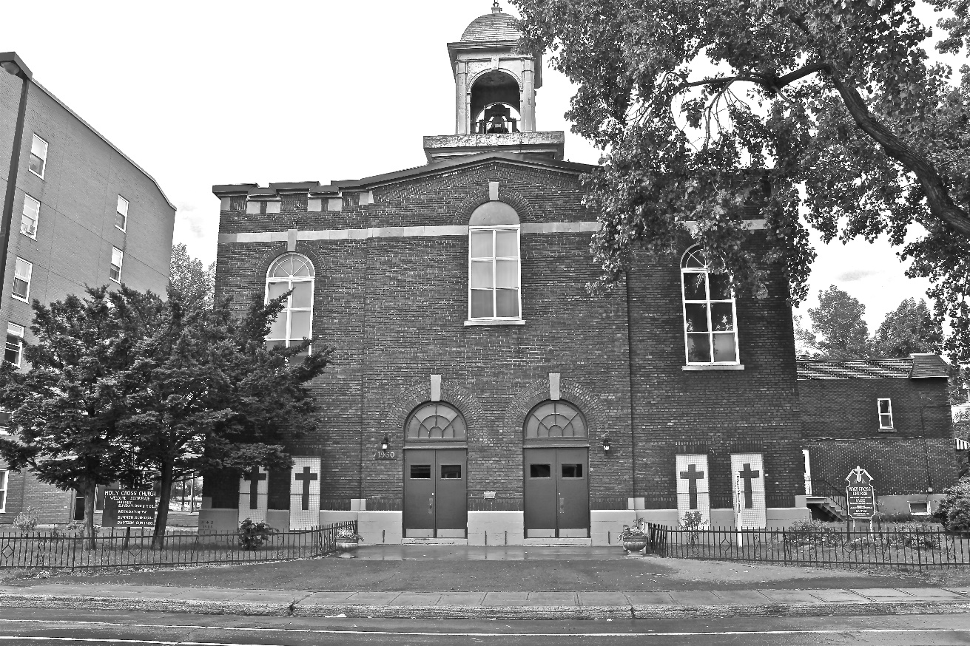
Holy Cross Parish Church
“The cross stands before us in these days as an eloquent symbol of God’s love for humanity.”
John Paul II

*9am mass is cancelled until further notice

