Pastoral Staff  Fr. Raymond LaFontaine E.V.  Parochial Administrator  Parish Office Hours  Wednesdays | Holy Cross Parish  1960 Jolicoeur street  Montreal, Quebec H4E 1X5  TEL.: 514-769-2717; FAX: 514-769-8852  Email: holycross.montreal60@gmail.com  https://holycrossmontreal.weebly.com/  Facebook: HOLY CROSS PARISH MONTREAL |  | Parish Wardens  Divya Siby: 514-655-6442  James Potter: 514-733-7016  Norlita Galdones: 514-733-7016  Ruby Johnson: 514-761-3242  Aldo Piccioni: 514-769-6369  Francis Van Oordt: 438-226-2126

MONTH OF APRIL 2024

2024 has been marked as the “Year of Prayer” by Pope Francis.

As our Lenten journey comes to a close we prepare to follow Christ all the way to the cross and to witness His glorious Resurrection. Hopefully we have sacrificed and prayed so that we are now able to more fully reap the fruits of a well spent Lent.
THIRD SUNDAY OF EASTER - APRIL 14th,2024
On April 14th, the Catholic Church celebrates the liturgical memorial of Saint Lidwina was a Dutch mystic who is honored as a saint by the Catholic Church. She is the patroness saint of the town of Schiedam, of chronic pain, and of ice skating. Lidwina is also thought to be one of the first documented cases of multiple sclerosis. She fasted frequently and acquired a reputation as a healer and holy woman. Upon her death in 1433, her grave became a place of pilgrimage.

Mass Readings for the third Sunday of Easter, Cycle B:

The First Reading is taken from the Acts of the Apostles 3:13-15, 17-19, relates the story of Peter and John's meeting with a man crippled from birth who asked them for alms. Peter said he had neither gold nor silver, but he would give him something better and proceeded to heal him.

The Second Reading is from the First Letter of John 2:1-5. In this passage, the Apostle urges Christians to refrain from sinning and emphasizes the importance of confessing and seeking forgiveness for any wrongdoing, contrasting this with the beliefs of Gnostic heretics who disregarded God's commandments.

The Gospel is from St. Luke 24:35-48. The resurrection of Jesus Christ is highlighted as the ultimate miracle, affirming his divinity and serving as the cornerstone of Christianity. His death demonstrated his humanity, while his resurrection validated his claims of deity. Through his sacrifice, he atoned for humanity's sins, and through his resurrection, he offered the promise of eternal life to all.
POPE’S MONTHLY PRAYER INTENTION FOR THE MONTH OF APRIL 2024:
FOR THE ROLE OF WOMEN:

“Let us pray that the dignity and worth of women be recognized in every culture, and for an end to the discrimination they face in various parts of the world”
REMINDER:  “CELEBRATE OUR LORD”  Please join us at 8:00PM on Sundays at ST. WILLIBRORD PARISH  351 WILLIBRORD ST, VERDUN, QC. |  | NOTE:  Please remember to write your name on your church support envelope.  There are only a few Sunday missals left for sale. Hurry up and get yours. The price is $7.00. Exact change is required please!
A Great Symphony of Prayer: The Our Father as a Programme of Life
The CCCB Ad hoc Committee for the Preparation for the Jubilee 2025 is hosting a two-part series titled, “A Great Symphony of Prayer” with Dr. Josephine Lombardi which will enable the faithful one meaningful way to participate in the Year of Prayer which was announced by Pope Francis on 21st January 2024. The webinar series will be every Tuesdays in April 2024, 1:00-2:30 pm EDT.
April 23rd, 2024: Daily Bread and the Gift of Forgiveness
April 30th, 2024: Managing trials and Resisting Evil
7th edition of Archives Day | Diffusion – Innovation on Friday, April 19th, 2024, from 9 a.m. to 4 p.m. The Archives Committee is pleased to announce that the program for its next Archives Day is available on the CPRQ website. Entitled “Diffusion – Innovation”, this day aims to bring together several actors and actresses from various backgrounds in order to reflect on the promotion of religious archives. To do this, two conferences, a round table and workshops linked to dissemination and innovation will allow you to discover all the valorization possibilities offered to religious archives.
HOT DOG SUNDAY, April 21^{st,} 2024, Price: 7.00$
1) Large all beef wiener, all dressed 2)French fries 3) Soft drinks, water
4) Coffee, Tea (free refill) 5) Ice cream, cookies
On St. Patrick's Day, a meeting/celebration with our Archbishop Msgr. Christian Lépine was held at Marie-Reine-du-Monde Cathedral for adult confirmands and for those requesting full communion. A record high number of 142 adult confirmands answered the call!
SUNDAY COLLECTION
April 7th, 2024 |  | Amount in CAD
TOTAL |  | 4259.16$
Thank you for your generosity!
MASS INTENTIONS
Note: All mass intentions are 15$ per person
April 14th, 2024  CAROLINA JORDAN (DEATH ANNIVERSARY)  Req’d by Irene La Hoz  HUMBERTO LA HOZ (DEATH ANNIVERSARY)  Req’d by Irene La Hoz  RAYMONDE FOURNIER  Req’d by the Fournier family  FRANCES COCHRANE  Req’d by the Cochrane family  ELEISER G. JUMERAS  Req’d by Yolanda Panerio Jumeras | April 21st, 2024  SISTER IMELDA STRACHAN CND  Req’d by Ada Hainey  FRANCES COCHRANE  Req’d by the Cochrane family  RAYMONDE FOURNIER  Req’d by Connie
“Prayer makes us understand our vulnerability”, but the Lord “gives us strength and closeness” Pope Francis
THIS CHURCH MAY BE USED AS A RESTING VISITATION LOCALE FOR YOUR DEARLY
DEPARTED.
IF YOU DESIRE THIS SERVICE, PLEASE CALL 514-769-2717

Holy Cross Parish Church
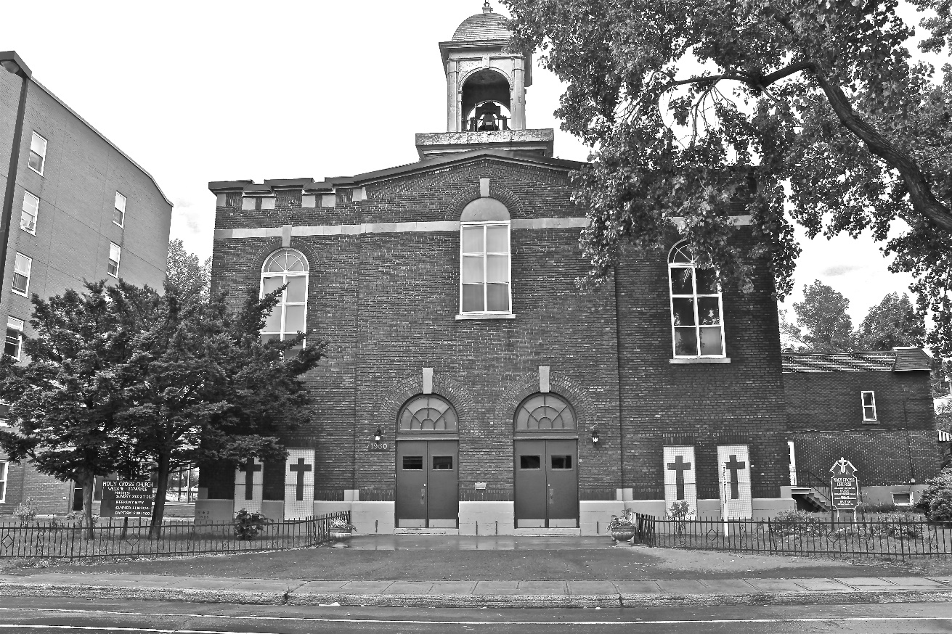
“The cross stands before us in these days as an eloquent symbol of God’s love for humanity.”
John Paul II

*9am mass is cancelled until further notice

